Task 1
Structures of the heart
Please label as many structures of the heart as you can.
You can use the AQA A-level PE textbook (or another suitable resource) to help you.

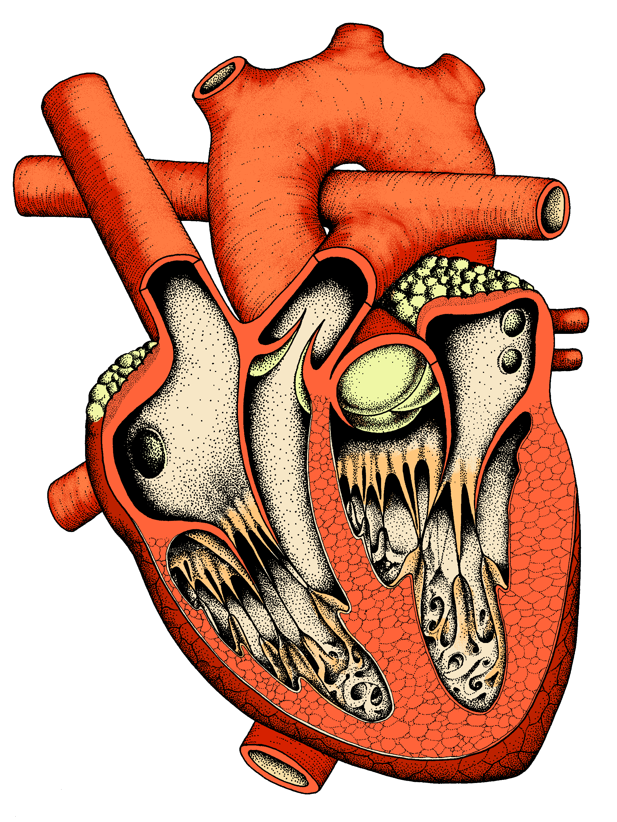

Task 2
Cardiac conduction system
Please use the AQA A-level PE textbook (or another suitable resource) to define the following terms.

Term | Definition
Myogenic

SA Node / Sino Atrial Node / SAN

AV Node / Atrioventricular Node / AVN

Systole

Bundles of His

Purkinje fibres

Please print out and complete both tasks. You need to bring them to your first lesson in September.

Task 3
Non examined assessment – Practical evidence commentary
Sport / Activity:
Time | Area of assessment (1, 2 or 3) | Skill

