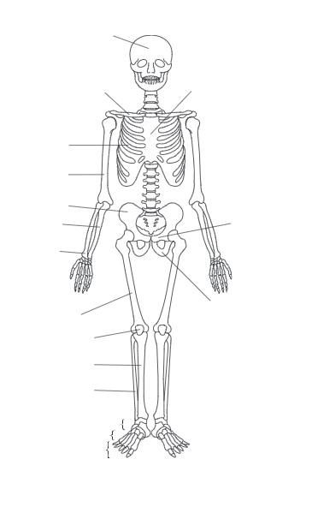

**Task 3**

Label the two diagrams (anterior and posterior) of the skeletal system with the correct anatomical names.

**Level 2 Sport and Physical Activity (Assistant Fitness Instructor pathway)**

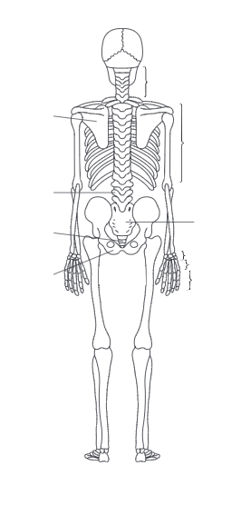

**Task 4**

|  |  |  |
| --- | --- | --- |
| **Functions of the skeletal system** | **Explanation** | **Examples of bone(s)** |
|  |  |  |
|  |  |  |
|  |  |  |
|  |  |  |
|  |  |  |