A-level English Language and Literature
Transition activities

Task 1
Read the two passages below, then
Either
Write 400-500 words on how Viv Albertine describes her first encounter with the music of the Beatles. Comment on her use of language and any contextual factors that may be significant.

Or
Write 400-500 words on how Beatrice Grimshaw describes her first experience of diving. Comment on her use of language and any contextual factors that may be significant.

Task 2
Write an article or blog post of 400-500 words about your first experience of something that made a big impression on you.
(One of the things you will be asked to do on the English Language and Literature course is to write a piece of ‘creative non-fiction’ – that is, to write about something real in a creative way. Try to use a range of techniques to make your writing vivid and engaging.)

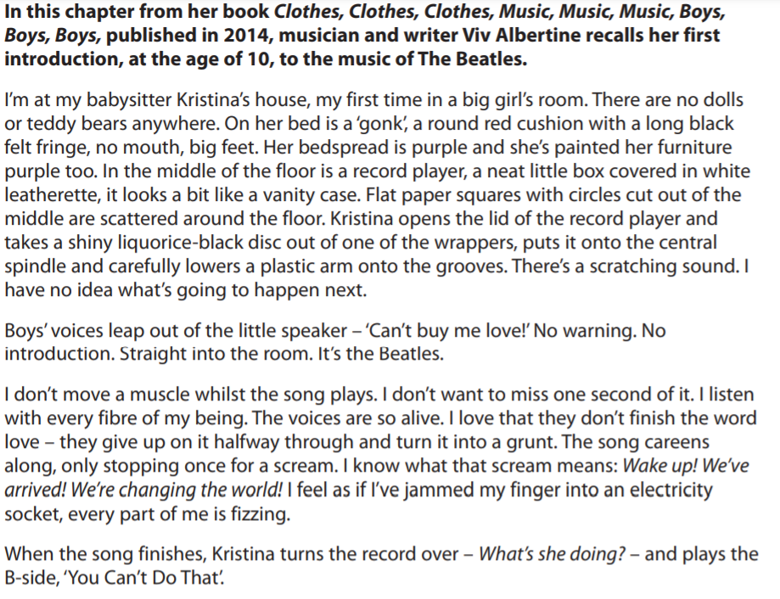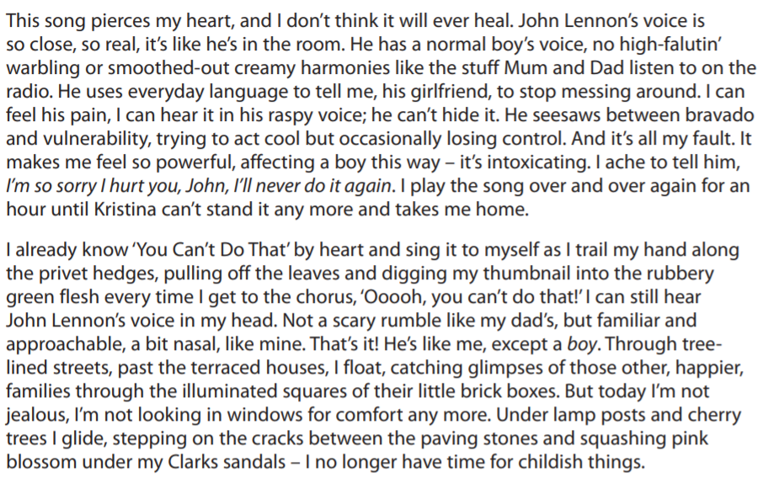
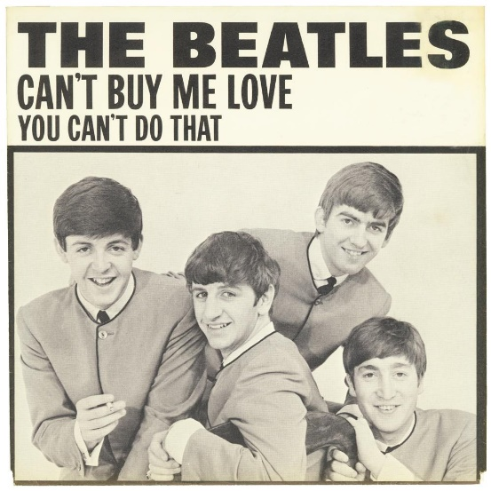
Viv Albertine

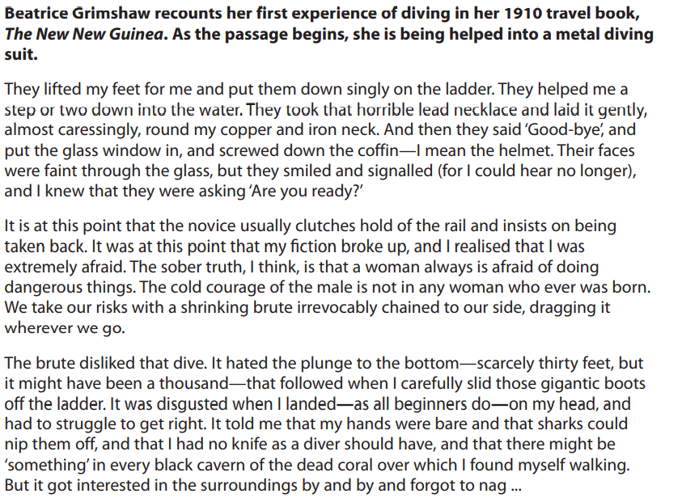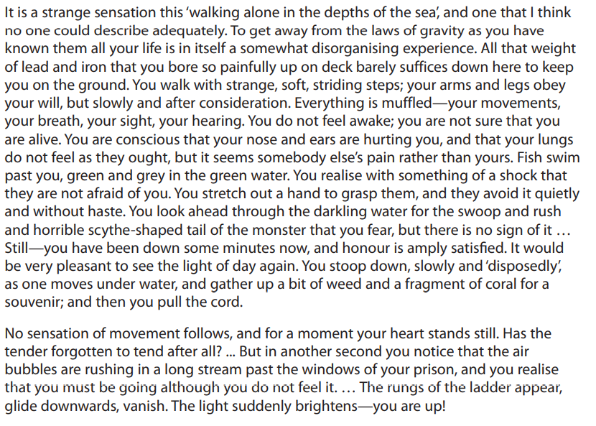

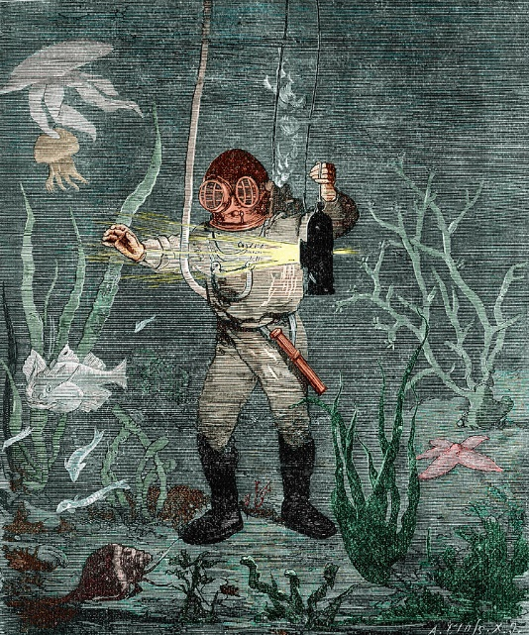

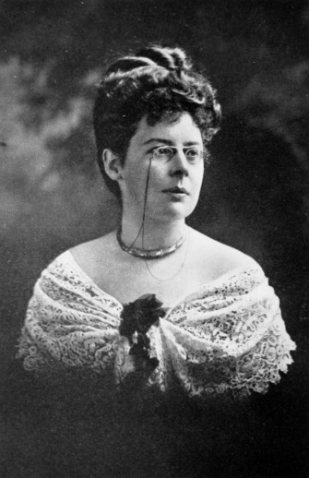
Beatrice Grimshaw

