Accounting Transition Activity

Well done for making a good choice of considering A Level Accounting. It is one of the demanding subjects and has a great career opportunities across Business, Finance, Investment and Banking sectors.

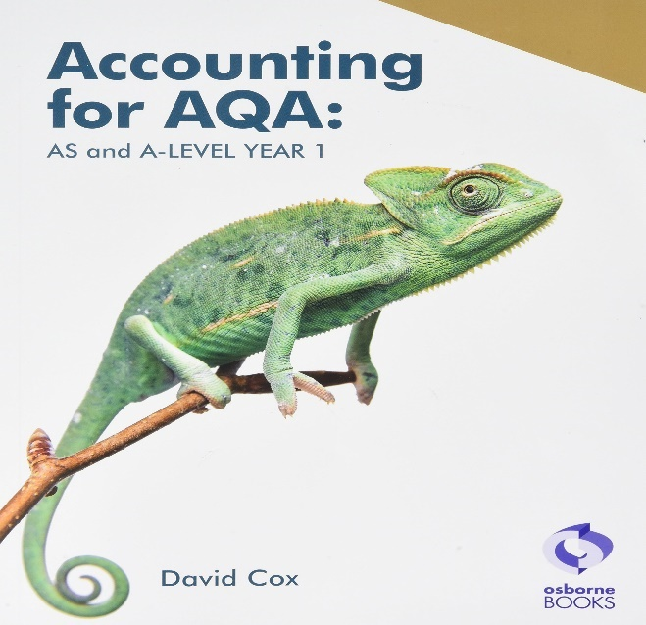

Q. 1. What are the top three reasons for choosing/considering Accounting?

Qn 2. How important it is to be healthy? Very important. Right? If we are not healthy then, we cannot carry on our daily activities properly.

Every business wants to be financially healthy.
Q 2. List out few factors that will indicate the financial health of a business?
One is done for you.
1.Positive cash flow
2.
3.
4.
5.

Q 3. An accountant maintains an organisation's accounts and provides financial information to different stakeholders who are interested in a business.
Define a stakeholder.

Cash flow statement
Cash flow statement records inflows and outflows and helps a business to understand how much cash do they have in hand to carry on their daily activities. Cash flow helps to calculate net flow in a set period of time. A business tries to avoid negative cash flow and tries to maintain a positive cash slow.
Following are some examples of inflows and outflows.
Can you identify inflows and out flows and write them accordingly in the given space?
Cash sales, bank loan amount received from the bank, bank interest paid, cash purchases, Rent paid, salaries paid, commission received.
Cash inflows | Cash outflows

Following are the definitions of Assests and Liabilities.
Assets: Assets are properties owned by a business
Liabilities: Liabilities are debts owed by a business.
Can you identify and put the following assets and liabilities in the respective columns?
Bank loan, Share capital, furniture, buildings, cash and bank balance, bank overdraft, trade payables and trade receivables.
Assets | Liabilities

