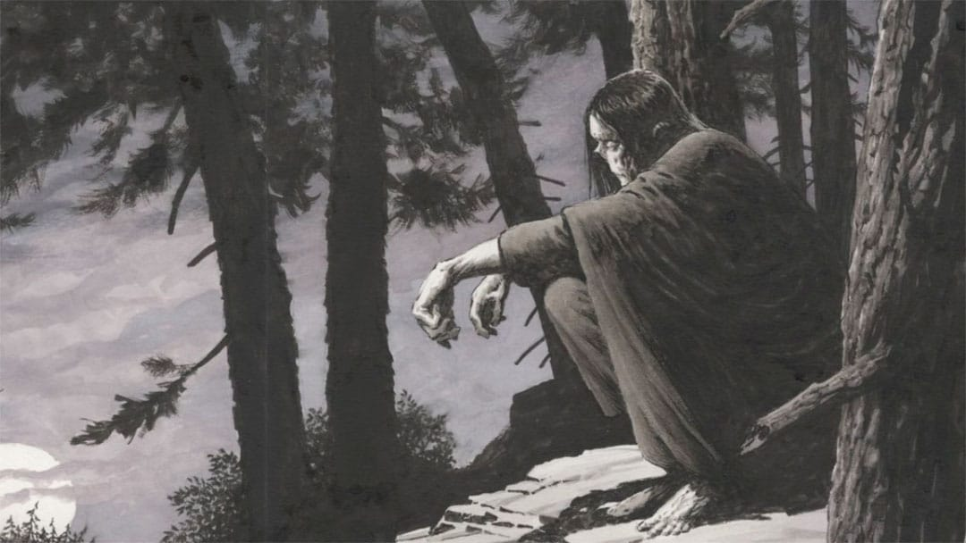

“It was about seven in the morning, and I longed to obtain food and shelter; at length I perceived a small hut, on a rising ground, which had doubtless been built for the convenience of some shepherd. This was a new sight to me, and I examined the structure with great curiosity. Finding the door open, I entered. An old man sat in it, near a fire, over which he was preparing his breakfast. He turned on hearing a noise, and perceiving me, shrieked loudly, and quitting the hut, ran across the fields with a speed of which his debilitated form hardly appeared capable. His appearance, different from any I had ever before seen, and his flight somewhat surprised me. But I was enchanted by the appearance of the hut; here the snow and rain could not penetrate; the ground was dry; and it presented to me then as exquisite and divine a retreat as Pandæmonium appeared to the dæmons of hell after their sufferings in the lake of fire. I greedily devoured the remnants of the shepherd’s breakfast, which consisted of bread, cheese, milk, and wine; the latter, however, I did not like. Then, overcome by fatigue, I lay down among some straw and fell asleep.
“It was noon when I awoke, and allured by the warmth of the sun, which shone brightly on the white ground, I determined to recommence my travels; and, depositing the remains of the peasant’s breakfast in a wallet I found, I proceeded across the fields for several hours, until at sunset I arrived at a village. How miraculous did this appear! The huts, the neater cottages, and stately houses engaged my admiration by turns. The vegetables in the gardens, the milk and cheese that I saw placed at the windows of some of the cottages, allured my appetite. One of the best of these I entered, but I had hardly placed my foot within the door before the children shrieked, and one of the women fainted. The whole village was roused; some fled, some attacked me, until, grievously bruised by stones and many other kinds of missile weapons, I escaped to the open country and fearfully took refuge in a low hovel, quite bare, and making a wretched appearance after the palaces I had beheld in the village. This hovel however, joined a cottage of a neat and pleasant appearance, but after my late dearly bought experience, I dared not enter it. My place of refuge was constructed of wood, but so low that I could with difficulty sit upright in it. No wood, however, was placed on the earth, which formed the floor, but it was dry; and although the wind entered it by innumerable chinks, I found it an agreeable asylum from the snow and rain.
“Here, then, I retreated and lay down happy to have found a shelter, however miserable, from the inclemency of the season, and still more from the barbarity of man.”
Frankenstein
by Mary Shelley.

1. Narrative Voice.
Read the text – Chapter 11 (Volume 2) from Frankenstein – in your responses to any type of prose you should be looking at the ‘narrative voice’ (tenses, the type of narrator, the tone of writing and style of language). What kind of narrative voice is used in this extract?
For assistance with this question you can visit the pages: https://www.bbc.co.uk/bitesize/guides/ztdmtyc/revision/4

2. Characterisation.
The author attempts to establish ‘pathos’ in this text. How does she do this? Give an example of where we might feel sympathetic towards this narrator.
For assistance with this answer see: https://www.litcharts.com/literary-devices-and-terms/pathos

3. Context:
Without knowing something about the time period of the writing, it’s difficult to establish not only what is happening, who is ‘speaking’ to us, but also WHY the text is written in this manner.
This narrator is ‘othered’ by the villages, he is rejected and violently assaulted. This appears to be linked to his appearance. The novel itself is written and published between 1816 and 1818.
Why might the time period in which the novel is written and set affect how this narrator (as he is physically so different) is perceived and responded to?
For assistance in answering this next question you will need to visit:
https://www.sparknotes.com/lit/frankenstein/context/historical/frankenstein-and-the-scientific-revolution/

4. Context continued – author’s perspective.
When we read a text we are not reading only a reflection of the time period in which it was created and received, we’re also being presented with an author’s own experiences and ideas.
Read the text again, consider your previous answers.
Do you think the author herself agrees with the villagers’ responses to the narrator?
For assistance with this answer visit this page: https://www.bbc.co.uk/news/magazine-12711091

English Literature

Transition Activity

1. Which texts (novels, plays and poetry) did you enjoy reading and studying at GCSE? Explain what you particularly enjoyed about studying them.

2. Why have you chosen to study English Literature at A level? What was it about your GCSE course that inspires you to take this subject to a higher level?

