Structure of the lungs and their roles
WATCH IT!
https://youtu.be/AJpur6XUiq4

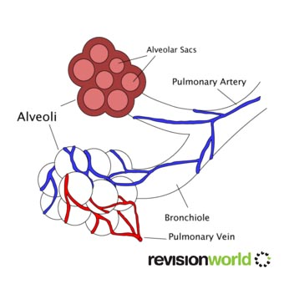
Fill in the labels below.

Use the next page to describe their roles.
Scan the QR code to watch a video clip to help you.
