A-Level Photography – Transition Activity 2
Visual Identification
Photography can be a great tool for capturing an almost identical replica of a scene or object. It can also be used to abstract and obscure the world, confusing the audience and making everyday objects unrecognisable.

- Look at the examples below and see if you can work out what objects have been photographed.

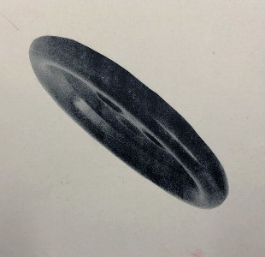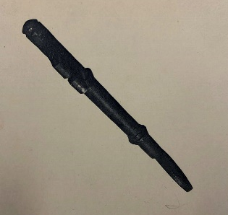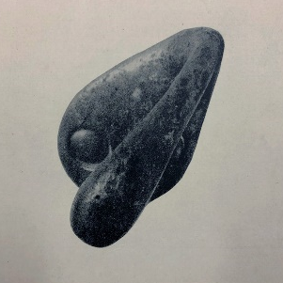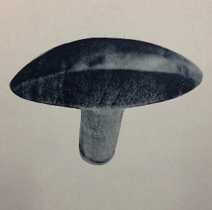
These images come from a card game called ‘Puzzle ‘em’

- Using objects from around your house, create a set of 24 images where it is difficult to work out what object has photographed.
- Do not edit your images using Photoshop.
- Use different angles and perspective to obscure the object you are photographing.

- Show the images you have created to your friends and family.
See if they can guess what the objects are and record the results.

Example of recording results
Name | What person thought object was… | What object really was…
Joe Bloggs | Chair leg | Wooden spoon

- Bring your photographs and results to college when you start in September.

