Creative Media Production Transition Activity

Part 1:

As part of the course you are required to create a portfolio website that will hold all your work for the next two years.

This website, along with your ‘work’ social media sites will be where you promote yourselves during the course but also after when you go for university interviews or Job interviews.

So, for your transition activity we would like you to set yourself up on all platforms ready to start promoting your work in a professional setting

- Website
- Twitter account
- Instagram account
- Linked in account
- YouTube account

Website: Your website needs to be through Weebly.com and you need to call it cmpfirstnamesecondname.weebly.com - for example cmpsarahwilson.weebly.com

We will design it with you throughout the two years, so each tab represents the work you are doing but for now we ask you to populate the ‘About’ page. You can either write a statement about yourself with a picture OR you can produce a short 1-minute video together and upload that.

Twitter and Instagram: A lot of you will already have your own personal accounts, but we would like you to create a new WORK one. These will have images and links to your productions, behind the scenes footage and any other material you feel could promote yourself.
You will also need to start following people in industry such as BBC, FilmFour, or any directors or journalists you like.
Add these links to your new website

LinkedIn: Everyone in industry is signed up to linkedIn so please do start an account and start linking with people you feel could help you in future

YouTube: Many of you will have YouTube accounts already so start a new channel which can hold all your college work. If you haven’t got a YouTube account, please do create one as you will need it throughout your time at college.

Once set up please start to follow us at:

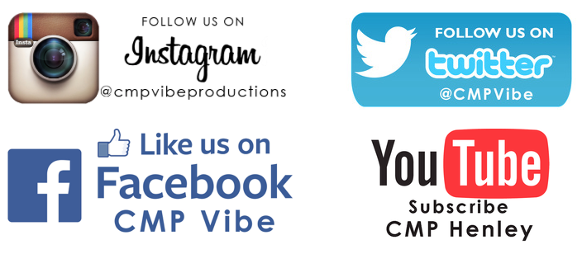

Please also have a look at our website at https://henleycreativemedia.weebly.com

Part 2: Write a ‘critical’ review

This can be on a programme of your choice, but it must be from the book / watch list below. Discuss the technical aspect (lighting, sound, editing) along with the delivery of the content. Does your production stir emotion, tell facts or simply entertain? Sometimes it is easier to review something you don’t like but I’ll leave that up to you.

Add this to your website under a new tab. Call that new tab: Transition activity.

Please do email your website address to sarw@henleycol.ac.uk or just come with it on your first day

From the CMP team
Sarah, Adam and James

Reading and watching list

Academic books

- Get Started in Film Making: The Definitive Film Maker's Handbook

Making Short Films, Third Edition: The Complete Guide from Script to Screen
- The 21st Century Journalism Handbook: Essential Skills for the Modern Journalist

Cinematography for Directors: A Guide for Creative Collaboration

The Filmmaker's Handbook: A Comprehensive Guide for the Digital Age: Fifth Edition

10 Books every aspiring filmmaker should read https://www.bustle.com/articles/118334-10-books-every-aspiring-filmmaker-should-read

However – watching ‘how to guides’, videos or reading articles is a better way to learn the skills

10 mistakes every beginner filmmaker makes

https://www.youtube.com/watch?v=JNXmjTmuGNM

Hollywood Lighting Formula with Scene Recreations

https://www.youtube.com/watch?v=_6fS_mIQBpQ

How to Light a Night Scene

https://www.youtube.com/watch?v=hosNTseoBk4

The Guardian – visit here regularly

https://www.theguardian.com/books/journalism

https://www.theguardian.com/uk/media

How to shoot a documentary

https://www.premiumbeat.com/blog/a-complete-guide-to-documentary-filmmaking/

BBC Shorts (films – this is a must)

https://www.bbc.co.uk/programmes/p07fvnmq

Other ways to learn are to watch the masters themselves. Watch a variety of films, factual programmes and music videos and analyse what they do.

*Some of these films are 18 and contain violent imagery so please ask guardian before you watch

Editing at its best

- The Godfather (edited by William Reynolds and Peter Zinner)
- City of God ((edited by Daniel Rezende)
- Raging bull (edited by Thelma Schoonmaker)
- Baby Driver (edited by Paul Machliss)

Cinematography

- Apocalypse Now (Director of Photography Vittorio Storaro)
- 2001: A Space Odyssey (Director of Photography Geoffrey Unsworth)

Classics such as Hitchcock’s Rear Window or Vertigo are a masterclass in storytelling, montage and cinematography.
Taxi Driver, The Shawshank Redemption and A clockwork Orange
will help you understand how to tell a story

Documentary (factual reporting)

- Louis Theroux’s Altered States (BBC iPlayer)
- The Central Park Five (Amazon Prime)
- Fire in the Blood (Netflix)
- Blackfish (Netflix)
- Blue planet

Knowing about the world (as depressing as it is right now) is also an important part of the course. Watching investigative shows and news productions will help you understand how to question people, deliver content as well as broaden your knowledge and give you ideas for stories.

- Watchdog
- Panorama
- Vice Documentaries
- News Round
- Question time
- BBC news
- ITV News
- Radio 5 Live (sports shows)
- The Today programme on BBC Radio 4

Podcasts are leading the way at the moment and have become part of many people’s daily routine (especially during lockdown)

- Serial Podcast season one: https://serialpodcast.org/season-one
- This American Life: https://www.thisamericanlife.org/
- The Archers – someone in your family may already listen to this so maybe sit through one or two episodes with them
- Teds Talks daily https://www.ted.com/about/programs-initiatives/ted-talks/ted-talks-daily

Find a podcast on a subject that interests you and start listening. Think about how they are put together and why they are popular.

You should also listen to and watch what you are passionate about. If it’s British Youth of today – look into films / podcasts / TV shows that focus on this topic, the same if it is music, sports or gaming. If you are passionate about it – research, it. Find films, documentaries and podcasts that cover your interests. If Film is your passion – watch as many as you can. Make sure to broaden your horizons though and watch a genre / actor that you may not like.

Practice makes perfect

Download the Adobe software package (students get a discount)
There are many tutorials on YouTube as well as Adobes own tutorials for editing, adding effects and sound.

This is by no means compulsory as we will teach you all you need to know when you start, and you do not need the software for the course.

If you have managed to buy your camera – have a play with it. Set it to manual and learn how to use it properly. If it doesn’t come with a guide you will be able to find YouTube clips to help you learn.

