A level Sociology
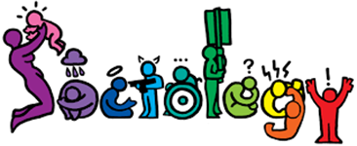  Teachers | Marco Azevedo | Exam Board | AQA | https://www.aqa.org.uk/subjects/sociology/as-and-a-level/sociology-7191-7192
 | Deb Carter | Click on link above then here to see examples of the papers you will sit (A level not AS level)  Click on link above then here for a brief look at what you will study (the specification)
At the Heart of Sociology are three questions:
What is happening in society? (Social Research – overlaps with Psychology and Criminology)
Why is it happening? (Social Theory – overlaps with Politics, History and Philosophy)
What can be done about it? (Social Policy – overlaps with Politics)
Each of the three exam papers are sat at the end of year 13. Each of the papers are 2 hour written exams. Each paper is worth 80 marks in total.  Paper 2  Two topics. Each with 2x 10-mark and 1x 20-mark questions = 40 marks in total.  - Families and Households  - The Media  Paper 3  - Crime: 4, 6, 10 and 30-mark questions = 50 marks in total.  - Theory and Methods: 10 and 20-mark questions.  Paper 1  - Education: 4, 6, 10 and 30-mark questions = 50 marks in total.  - Research methods applied to education: 20-mark question.  - Theory and Methods: 10-mark question.  Assessment |  |  |  | Useful web links:
www.revisesociology.com
www.senecalearning.com (see Edmodo for Sociology class code)
www.tutor2u.net/sociology
www.thesociologyguy.com/a-level-sociology
www.youtube.com/channel/UC6VpoZj33Df_rNb8KymCczw
www.bbc.co.uk/news (you should be constantly keeping up with the news. You need to be applying and relating what we earn in class to what is going on in society) www.simplepolitics.co.uk will help make sense of the politics!
www.youtube.com/watch?v=WtW9IyE04OQ&feature=youtu.be You are about to study a vast area of academia – there is SO much information out there relating to Sociology and it can feel overwhelming. Have a look at this video which goes through the Cornell Notes Technique. It will help with note taking in general.

You have chosen a subject that will ‘keep you on your toes’ and make you think in ways you couldn’t imagine. You will certainly have a very different outlook on society by the end of your course. | Course Expectations | It is expected that at least 4 hours a week on Sociology in addition to the lessons. This time will be spent completing homework tasks, reading ahead, revising your notes using the repeated retrieval method, preparing for assessments and completing exam answers. You are expected to be pro-active and use your study time productively.
 |  | Your progress will be reviewed on a regular basis. The review process will provide feedback explaining how to improve upon your work and you ACTIVELY engaging by responding to feedback and reflecting on what needs to be amended.
 |  | You will need to have a folder for each ‘paper’ you sit. Your folders will be checked on a regular basis to help you keep organised and up to date with your work.
Suggested Reading List  - Brave New World – Aldous Huxley  - Animal Farm – George Orwell  - 1984 – George Orwell  - Chavs: The Demonisation of the Working Class – Owen Jones  - The Establishment and How They Get Away With It – Owen Jones  - The Handmaid’s Tale – Margaret Atwood (also a series)  - Vox – Christina Dalcher  - The God Delusion – Richard Dawkins  - Outsiders: Studies in Sociology of Deviance – Howard S Becker  - Folk Devils and Moral Panics – Stanley Cohen  - A Glasgow Gang Observed – Patrick James  - Gang Leader For A Day – Sudhir Venkatesh  - Sociology Review Magazine  (In addition to the above, ensure you read a wide range of newspapers including The Guardian and Independent) |  |  | Suggested Watch List  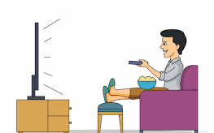  - Documentaries, including Panorama, Louis Theroux, Stacey Dooley, Mind of a Murderer etc  - I, Daniel Blake (Amazon Prime)  - Years and Years (BBC I-player)  - The ‘Up’ series (eg. 56 Up, 63 Up - on Netflix or YouTube)  - The Secret Life of 5 year olds (Channel 4 series)  - McMafia (Netflix)  - Freedom Writer’s Diary (Amazon Prime)  - When They See Us (Netflix)  - The Society (Netflix)  - Love, Simon (Amazon Prime)  - Pixar’s ‘A Bug’s Life or Antz’ (for Marxism)  - Ted Talks/Sociology (online)  - Made in Dagenham (BBC I-player)  - Wonder (Netflix)  - The Wife (Netflix) | You will be expected to know and understand (AO1) the information about the topics, to be able to apply (AO2) that knowledge and understanding and to be able to analyse and evaluate (AO3) that knowledge and understanding.

 | Before September you MUST: | You COULD | Tick when completed.
Week 1 | Society does not remain static over time, it constantly changes – through decades, centuries, and across countries and societies. Answer the following questions:  • Give 3 different ways society has changed over the last 100yrs – think about different areas of social life and work.  • In your opinion, why has society changed? Why are societies different?  • If you were in power, what would your first four items on your agenda be? What would you hope to do? | Research the 3 main political parties – Conservative, Labour and Liberal Democrat: What are their main ideas? How are they different?  www.parliament.uk/about/mps-and-lords/members/parties/  www.simplepolitics.co.uk/questions-and-answers/who-are-the-parties-and-what-do-they-stand-for
Week 2 | Look at the statements below and then write them out in a list which ranks them in order of the one you MOST agree with, to the one you LEAST agree with.  - Society works for the benefit of all.  - Women are systematically disadvantaged.  - We live in a democracy.  - Life is unfair.  - The world is run for the benefit of a very small group of people.  - Most people cannot see that they spend their entire lives being exploited.  - Structures in society exist to help people and the smooth operation of society.  - Men dominate.  - Gender inequalities exist.  - People are judged only in terms of their merit / skills / intelligence.  Take the one from the top and bottom and for each, write a developed paragraph explaining why you placed it where you did. Please follow this writing frame: I most agree/disagree with the statement________. This is because …. Evidence to support this includes… Furthermore….. Therefore, it is clear that (insert statement) is…. (Valid? Irrelevant? Misguided? Outdated?) | Go to www.senecalearning.com and go through some of the Sociological Theory tasks.  Which of these theories do you feel best explains how society works? Why?
Week 3 | 1. Watch this video https://www.youtube.com/watch?v=YnCJU6PaCio and note down 5 things that tell you what Sociology is. It is a US based video, but the subject of Sociology is global and what it looks at/investigates is the same around the world.  2. Find the definitions for the following key sociological terms:  - Socialisation (primary socialisation and secondary socialisation)  - Norms  - Values  - Beliefs  - Culture  - Social Class  - Gender  - Ethnicity  - Society | Look at this photograph; not everything is as it seems!  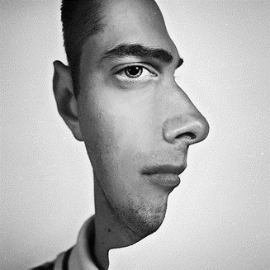  There is usually another way of looking at things – and that is what we do as sociologists. We take normal, taken-for-granted life and turn it upside down, looking for meanings. And very often we end up seeing things very differently. Create your own piece of art work that explains what Sociology is.
Week 4 | 1. What makes up your identity? What makes you who you are? Create a mind map showing all the influences on your identity.  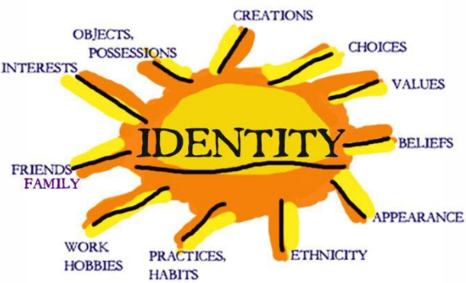  Identity is about how we see and define ourselves –our personalities – and how other people see and define us. Many aspects of our individual identity are influenced by agencies of socialisation. These are structures or groups of people.  2. Suggest between 5 and 10 examples of social structures or groups of people that impact upon you (e.g. family, education, peers, media etc.)  3. Which of these social structures or groups influence you most? Does it depend on your age as to when they are more influential? Does it depend on other factors such as your gender or social class? Explain your answers. | 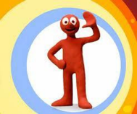  Individuals are like moulded putty, squished and squashed by society and its structures, but there are decisions we make that are driven by internal motivations. Behaviour that comes from within us – decisions we make in order to do things - is called agency. Agency behaviour is meaningful and a reflection of self-will. Sometimes we can challenge and oppose structures, and in this way we help construct a part of our identity.  BIG question – Does society create us as individuals, or do we create society? Write up your response, analysing points that go for and against the idea that we are created by society. Offer evidence where you can and come to a clear conclusion.
Week 5 | Nature Vs Nurture Debate: Biologists think that people behave as they do because they are controlled by nature. Humans are compared to animals and seen to act on instinct. Sociologists believe that people behave as they do because they are taught how to behave. Nurture means the way you are brought up. It is also a reference to socialisation, the lifelong process by which we learn our culture, values, norms and how to behave. 1. Write out what is meant by the Nature Vs Nurture Debate. 2. Create a table that has evidence and arguments ‘for’ the nature side and a second column ‘for’ the nurture side. | A Feral child is one that has spent time in their formative years away from social interaction with human beings, or very limited interaction. https://youtu.be/cymZq1VblU0 Have a look at this documentary. What does is suggest about the Nature Vs Nurture debate?
Week 6 | What makes us Human? Think about your answers to the questions below:  • Are we meant to live alone?  • What would a person be like if they grew up without human contact?  • What would a person be like if they were then introduced into a society?  • Do we need a society in which to survive?  • Can someone be truly human if they grew up without human contact?  • Are we ruled by our instincts? (An instinct can be defined as a complex, unlearned pattern of behaviour that is universal in a species).  Discuss these with friends and family. Sociology recognises that as members of society we have to learn ‘human’ behaviour, and this is done through a variety of social institutions and social groups right throughout our lives. Sociologists challenge the focus on the ‘nature’ side of the debate for two particular reasons. Firstly, people acted differently in the past from the way that they do today. They had different ideas and different beliefs. If it were ‘natural’, we would see little change in human behaviour throughout history. Furthermore, anthropology is the study of different human societies. Wherever you go in the world, people act differently from the way they do in Britain. This suggests again, that human behaviour cannot simply be ‘natural’ as it would be the same the world over. Task: In ONE sentence, answer the question – What makes us human? | 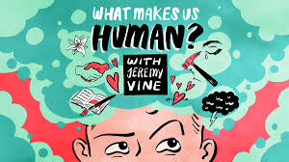  Enjoy this series of Podcast on the topic of ‘What makes us human?’ www.bbc.co.uk/programmes/p02nrw9m/episodes/downloads Do any of them change the view you had on your answer to ‘What makes us human?’
Week 7 | 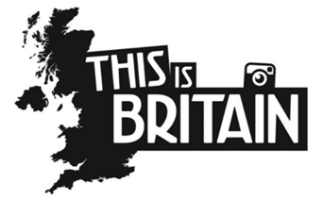  Have a look at this guide offered to advise people on British ‘norms’ to help them adjust to British life, if coming here to study. https://www.studying-in-uk.org/british-culture-and-social-norms/ Your task is to create your own ‘Guide to British Culture’. This can take any form that suits you; booklet, poster, video etc. Consider the expected and accepted behaviour (norms) and ideas (values) that you’d see from the people of Britain, if visiting for the first time. | Have a look at this article:  https://www.theguardian.com/commentisfree/2018/jul/24/national-identity-fake-toxic-intolerance-italy-fascism  Do you agree that national identity can lead to negative ideas? What are the benefits of maintaining or creating a ‘national identity’ for a nation such as Great Britain? These are difficult questions – reflect on them and discuss with friends and family.
Week 8 | Go to the AQA website and read the specification carefully. Write out a brief description of each of these topics:  - Theory and Methods  - Education  - Methods in Context  - Crime  - Families and Households  - The Media | Use all available online links to write a brief explanations of key terms, thinkers, facts related to each of the topics mentioned. Ensure your explanation is no longer than one side of A4 if hand written, and half a side if typed up.
Week 9 | 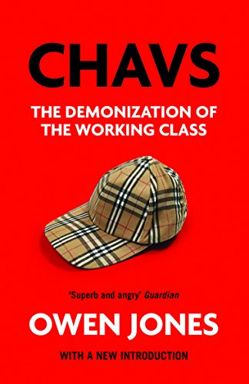  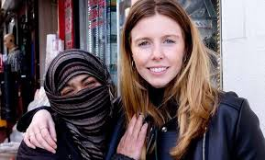  Select something from the suggested watch or read list. In your first Sociology lesson you will be expected to feed back to the rest of the class what you learnt from it and how it applies to the study of sociology. You will need to draw out 5 key lessons from the book/film/article and then show how it links to sociology as a whole, and which particular topic/areas.  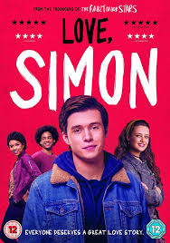  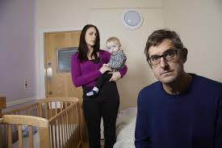  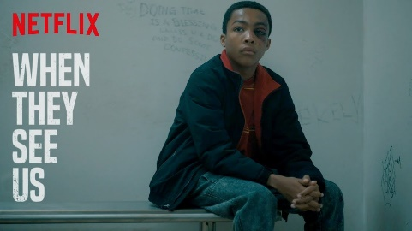 | On the back of all the tasks you have completed, create your own video entitled ‘This is Sociology’. You may want to sign up to www.loom.com to use a screen sharing software tool, but you may create the video however you wish. The target audience will be future A level students who may be thinking about signing up to study sociology at college.  Enjoy!

