A Level Psychology Additional Transition Task
Task One – Approaches in Psychology
►There are some core approaches to Psychology that you need to know for your A level – they are different ways of explaining human behaviours.
►Some of these are listed below: your job is to do some research on them using the internet (Wikipedia, while sometimes untrustworthy, is very good for this! There are also plenty of great videos on YouTube you can watch).
►You should find out: How might this Approach explain human behaviour? Identify one key researcher from this area – and why are they famous?
The Behaviourist Approach
The Social Learning Theory Approach
The Cognitive Approach
The Biological Approach
Optional extension: The Psychodynamic Approach & Humanistic Approach

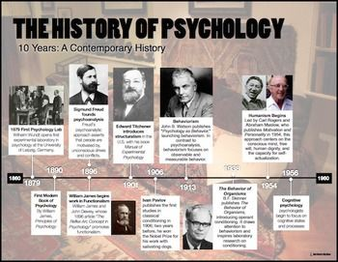
Task Two – Psychological History
►You need to create an A4 Psychological History timeline.
►On your timeline you should include a number of features such as the ones below. To make a high quality timeline, you will need to do some additional research into what each of the events actually refers to – and why it might have been important to the development of Psychology.
►The Curious Case of Phineas Gage, Wilhelm Wundt’s Psychology Lab, foundation of the American Psychological Association, Sigmund Freud publishes “The Interpretation of Dreams”, Pavlov’s Dog Studies are published, Carl Rogers publishes “Counselling and Psychotherapy”, the first use of a brain scan in Psychological research.
►A great link for this task is https://allpsych.com/timeline/.

Here are details of the set textbook we use in the first year:
