Heart rate values
Task 1
Complete the table below:
Value | Abbreviation and definition | Approximate Resting Value (units) | Approximate Exercise Value (units)
Heart rate

Stroke volume

Cardiac output

Task 2
Measuring heart rate response to varying intensities of workload.

- Note your heart rate while you are resting for a 10 second count.

- Record your heart rate immediately before the exercise commences for a 10 second count.

- Commence your choice of exercise for a period of 3 minutes.

- Take heart rate values for a 10 second pulse count:

  - At the end of the 3 minutes of exercise

  - Every minute during the recovery phase until your heart rate has returned to its resting value prior to exercise.

- Once your heart rate has returned to its resting value, repeat the same investigation but increase the workload to medium intensity.

- Repeat this investigation one more time but at high intensity.

- Collate your results in the following table and produce a graph with the data.

Intensity of workload | Resting heart rate | Heart rate prior to exercise | Heart rate at end of exercise | Heart rate during recovery  1 2 3 4 5 6
Low

Medium

High

Task 3
Heart rate range in response to exercise

Heart rate increases with exercise but how much it increases is dependent on the intensity of the exercise. Heart rate will increase in direct proportion to exercise intensity. The higher the intensity the higher the heart rate. Heart rate does eventually reach a maximum. Maximum heart rate can be calculated by subtracting your age from 220.
Write the calculation for your age below:

The graphs below illustrate what happens to heart rate during maximal exercise such as sprinting and sub-maximal exercise such as jogging.

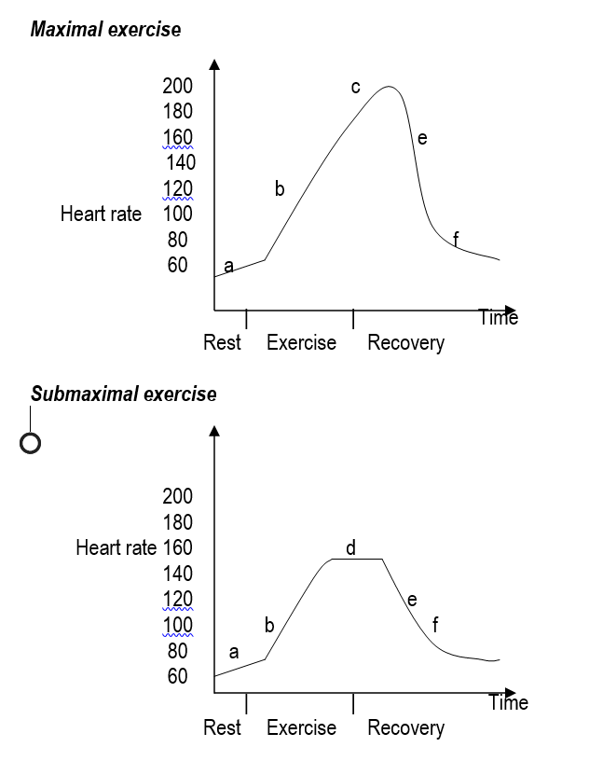

a = Anticipatory rise due to hormonal action of adrenalin which causes he SA node to increase heart rate

b = Sharp rise in heart rate due mainly to anaerobic work

c = Heart rate continues to rise due to maximal workloads stressing the anaerobic systems.

d = Steady state as the athlete is able to meet the oxygen demand with the oxygen supply

e = Rapid decline in heart rate as soon as the exercise stops

f = Slower recovery as body systems return to resting levels. Heart rate needs to remain elevated to rid the body if waste products, for example, lactic acid.

Task 4
How does Stroke Volume respond to exercise?

Task – Draw a graph to explain the response to low, medium and high intensity exercise. Try to explain the graph.

Task 5
How does Cardiac Output respond to exercise?

Task – Use a table to show how Cardiac Output responds at rest and during maximal exercise in a trained and an untrained person.

