**Forensic Fire Investigation**

**(More BTEC Applied Science Transition Work)**

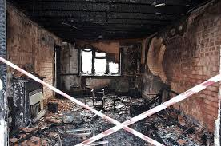 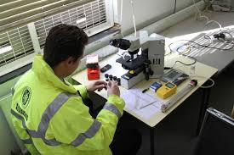 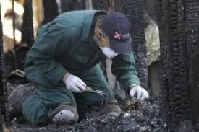

.

Well done on completing the first set of transition work! Here is some more to help prepare you for your course next term. Please bring the completed work with you on the first day of college.

This work is all about Forensic Fire Investigation.

Fire investigation is a specialist branch of forensic science. The analysis of a fire scene requires the investigator to determine the origin of the fire, the cause and how the fire developed. It is one of the more challenging areas of forensic science due to the destruction that occurs and the health and safety implications that are involved.

The multi-disciplinary nature of the investigator’s job requires them to understand the science behind the behaviour of fire and the chemistry of combustion and extinction. An investigator will study how materials can ignite, burn and be extinguished, as well as the behaviour of fire itself. They will examine the remains of a fire and trace back, through the damage, to the point of origin, uncovering the evidence of what caused the incident and reconstructing the events. Fire investigators do not work alone. They work with different agencies and build an understanding of how they work together to extinguish a fire, treat casualties, make the site safe, and preserve and examine the evidence. The investigator’s role doesn’t end with the successful determination of the cause of a fire, as they can also be called to court as an expert witness.

**Below are your tasks on UK Forensic Fire Investigation. Do some research and reading then answer the questions in your own words, don’t just cut and paste from the Internet. Pictures would be useful too.**

1. **Find out all you can about COMBUSTION.**

You could include:

* Sources of ignition
* The fire tetrahedron – heat, fuel, oxygen, chain reaction
* The colour of flames depending on the materials involved in the combustion
* Fuel and pyrolysis – solid, liquid, gas, conversion of fuel into the gaseous state by pyrolysis
* Heat of combustion – energy released as heat when a compound undergoes complete
* Flash point and fire point
* Flammability
* Products of combustion – heat, light and gaseous by products, water and carbon dioxide, toxic products, e.g. phenols, carbon monoxide, nitrogen oxides.

1. **Describe and explain methods used for extinguishing a fire**

You could include:

* Smothering – fire blanket, chip-pan fire safety and boil over.
* Starving – cutting off the fuel supply.
* Cooling – applying water to reduce the temperature.
* Extinguishers – water, carbon dioxide, foam and dry chemical.
* A3 Heat transfer

1. **Describe and explain the 3 methods of heat transfer.**

* **Conduction** – heat may be conducted from one body to another by direct contact of the two bodies (or by an intervening heat-conducting medium), different materials conduct better than others and this determines the rate at which heat is transferred.
* **Convection** – transfer of heat by the movement of air or liquid, fire spread by convection is mostly in an upward direction.
* **Radiation** – radiated heat will travel through space until it reaches an opaque object; radiated heat is one of the major sources of fire spread.

1. **Describe and explain the causes of fire.**

You could include:

* Natural, e.g. ‘acts of God’, such as lightning strikes
* Accidental, e.g. malfunction of an electrical appliance
* Deliberate – intentionally, arson, fire trail, fire-setting device, accelerants, multiple points of origin.
* Undetermined – if the fire investigator cannot determine the cause of the fire it is documented as undetermined.

1. **Describe and explain the phases of fire.**

You could include:

* Incipient phase.
* Growth phase.
* Free-burning phase (fully developed stage).
* Smouldering phase (decay stage).
* Heat release rate (HRR).

1. **Describe and explain fire behaviour.**

You could include:

* Flame propagation and the surroundings – depends upon the rate at which flammable pyrolysis products can be released from materials:
* Why different fires spread at different rates
* Hot gas layer.
* Flame over.
* Flashover.
* Suppression.

1. **Describe and explain some of the methods involved in processing a fire scene.**
   * What does a fire scene investigator do?
   * What are the possible hazards at a fire scene?
   * How should a fire scene be preserved so evidence can be collected?
   * What evidence is a fire investigator looking for?
   * What evidence might witnesses be able to provide?