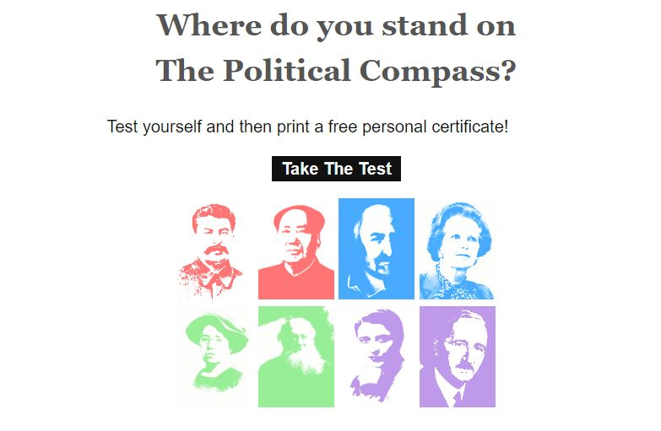
A-Level Media Studies challenge: The Political Compass

Newspapers in the United Kingdom are independent and free to adopt a political viewpoint that suits their owners and readers.
These are not fixed but change over time to reflect changing moods and values in wider society.
We tend to define political views in terms of right-wing (Conservative) or left-wing (Labour) but many people sit somewhere between the two.
We can also think of viewpoints as being liberal or authoritarian. Liberals believe people should be able to do whatever they want as long as it doesn’t harm others. Authoritarians believe everyone should obey the law regardless of their individual views.
Of course, not everyone holds the same views and opinions. It would be a dull world if we all though the same things.
The political compass is a fun test you can take to find out where you sit on the ideological spectrum and you can compare yourself to famous world-leaders. Are you a left-wing liberal or a right-wing authoritarian?
Make sure you download the certificate at the end of your test and save it so that you can bring it to The Henley College when you start in September.
Click here to take the test: https://www.politicalcompass.org/test

