FAQ APPLIED CRIMINOLOGY (EXTENDED CERTIFICATE)
What are the grade requirements to be accepted to this course?
4 in English, 4 in Maths, 4 in Science

What kind of qualification do I get?
If you study two years of criminology, you will get Level 3 Applied Diploma in Criminology, which is equivalent to one A level in points for the university.
If you study one year of criminology, you will obtain Level 3 Applied Certificate in Criminology, which is equivalent to half an A level in points for the university.

What will I study?

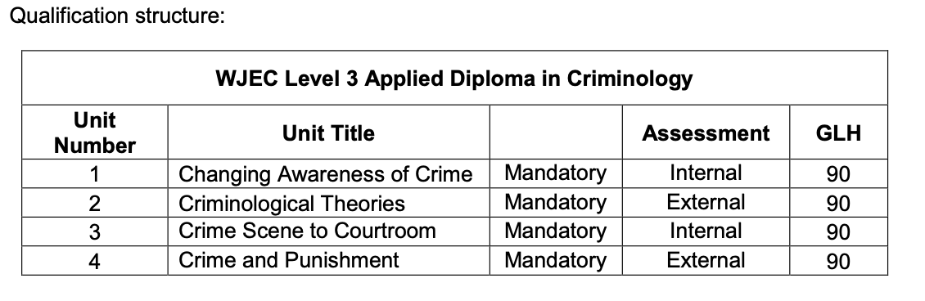
Learners must complete ALL units above.
The first mandatory unit will enable the learner to demonstrate understanding of different types of crime, influences on perceptions of crime and why some crimes are unreported. The second mandatory unit will allow learners to gain an understanding of why people commit crime, drawing on what they have learned in Unit 1. The third mandatory unit will provide an understanding of the criminal justice system from the moment a crime has been identified to the verdict. Learners will develop the understanding and skills needed to examine information in order to review the justice of verdicts in criminal cases. In the final mandatory unit, learners will apply their understanding of the awareness of criminality, criminological theories and the process of bringing an accused to court in order to evaluate the effectiveness of social control to deliver criminal justice policy.
Each unit within the qualification has an applied purpose which acts as a focus for the learning in the unit. The applied purpose demands learning related to authentic case studies. It also requires learners to consider how the use and application of their learning impacts on themselves, other individuals, employers, society and the environment. The applied purpose will also allow learners to learn in such a way that they develop:
- skills required for independent learning and development
- a range of generic and transferable skills
- the ability to solve problems
- the skills of project based research, development and presentation
- the fundamental ability to work alongside other professionals, in a professional environment
- the ability to apply learning in vocational contexts
What if I don’t like it and want to change?
You have a month to change your mind and choose another subject within The College.

How many students in one class?
15-25

How many teaching hours a week and homework?
4 hours direct contact (2hours twice a week) and 2-3 hours a week at home.

How will I be assessed?
You will have two Internal Assessments in December of each academic year (for UNIT 1 and 3) which will be done in controlled environment and you will be able to use all your notes and have internet access for some sections. You will be given 8 hours over 3 days to complete the tasks. They are worth 100 marks each. These will be marked by your teacher and then samples verified by WJEC.
Units 2 and 4 will be assessed by two External Assessments in May of each academic year. These exams are 1.5 hr long, similar to A level but not as heavy in content. They will be worth 75 marks, each.

Which textbooks will I need?

You can have a look inside: https://criminology.uk.net/book-samples/

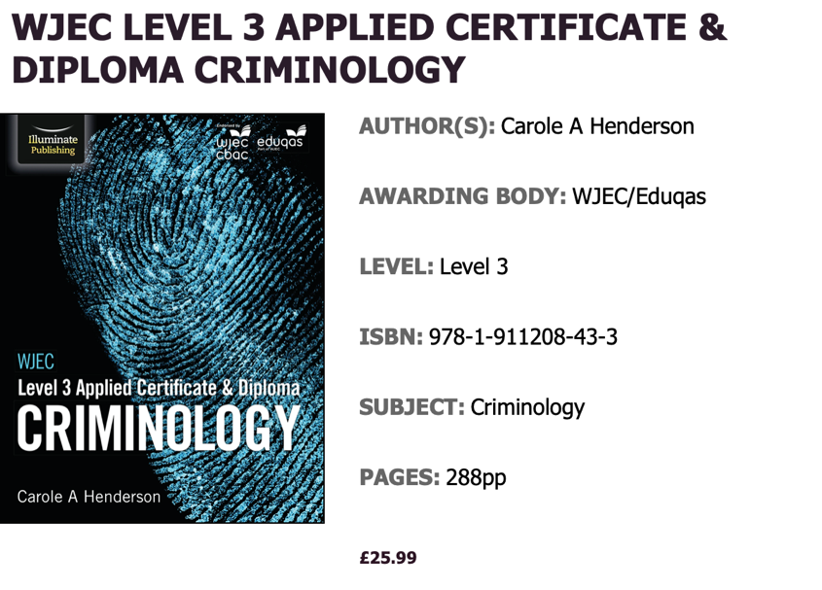
Take a look inside: https://www.illuminatepublishing.com/samples/WJEC_Criminology_Level_3_Applied_Certificate_%26_Diploma_sample/

How is this course taught?
Two 2 textbooks and online resources, videos and student activities are used ( https://criminology.uk.net/book-one-activities/ ). Students are asked to read the chapter pages in advance. Some worksheets are completed in lessons, others at home. Teaching goes in 10 min segments where teacher may present a part of material and then discussion will follow. After discussion, time is given where teacher can recap what was being said, students take notes and/or creating mind maps or condensed version of the material are created. The information is then applied to various criminal cases. At the end of each assessment criteria (AC ) potential questions for that AC are analysed. Answers are constructed together, checklists created of the content. Students are then given time to write their own answer. Several answers are read out loud (usually students volunteer them) and verbal feedback given for improvement. While writing their answers some students presents parts or completed answer to the teacher and are given personal verbal feedback to improve their answer on the spot while their mind is still fully engaging with the material. For the units 2 and 4 at the end of each learning objectives (LO) a combination of past paper questions is given in timed condition, to assess the learning progress and their answering skills and timing.

Do teachers use technology? How so?
Yes. You are encouraged to use your laptop, tablet or phone. If you need our laptop, we have it available. We use Online worksheets and videos (https://criminology.uk.net), Microsoft Teams where teacher shares resources and information, Snapchat (teacher encourages classes to form their own group to keep in touch, exchange information and resources, socialise, bond, discuss…etc. teacher isn’t part of the group on Snapchat).

What can I do with this qualification?
Progress to University
WJEC Level 3 Applied Diploma in Criminology is a qualification with elements of psychology, law and sociology that complements studies in humanities. This is an Applied General qualification. This means it is designed primarily to support learners progressing to university. Usual courses for progression:
- BSc Criminology
- BA Criminology
- BA Criminology and Criminal Justice
- BSc (Hons) Criminology and Psychology
- LLB (Hons) Law with Criminology
- BA (Hons) Criminology and Sociology
- BA (Hons) Criminology
- BSc (Hons) Psychology and Sociology
- BSc Criminology with Law
Employment
An understanding of criminology is relevant to many job roles within the criminal justice sector, social and probation work and sociology and psychology. Employment may be obtained within some aspects of the criminal justice system, e.g. the National Probation Service, the Courts and Tribunals Service or the National Offender Management Service.

