Task 1 - SI Prefixes

Sometimes in engineering measurements are too big or too small to be measured using the base unit, so we use multiples and submultiples of 10 (10 being the number base of SI). These are known as prefixes, which are shown in front of the base unit, and are given special names. Some examples are given below. Please complete the missing terms and add new prefixes and symbols to this table as you encounter them.

Prefix Symbol Factor Multiplication

Terra

Giga

Mega

Kilo K 10³ 1,000

Hecto

milli m 10⁻³ 0.001

micro

nano

In engineering we use SI units, for instance length is measured in metres. Complete the table below using the appropriate SI units (i.e. give the number of metres in a mile in the first row).

Name | Unit symbol | Value in appropriate SI Units
mile | m
inch | ins
foot | ft
yard | yd
minute | min
hour | h
degree | °
tonne | t
degree Celcius | °C
degree Fahrenheit | °F
standard atmosphere | atm
bar | bar

Please complete the third column in the table below, giving the SI unit for each of the terms (i.e. time is measured in seconds).

TERM | SYMBOL | SI UNITS
Time | t
Mass | m
Temperature | T
Linear Displacement | s, L, d, h, x, y
Linear Velocity | u, v,
Linear Acceleration (Gravitational) | a (g)
Angular Displacement | θ
Angular Velocity | ω
Angular Acceleration | α
Pi | π
Diameter | D,d, Ø
Radius | R, r
Area | A
Volume | V
Density | ρ
Coefficient of Friction | μ
Force | F
Work Done | W
Energy | E/Q
Power | P
Momentum | M
Impulse | I
Moments | M
Torque | T
Moment of Inertia | I
Pressure | P
Stress (T/C) | σ
Shear Stress | τ
Strain (T/C) | ε
Shear Strain | Ø
Young’s Modulus | E
Shear Modulus | G
Specific Heat Capacity | c
Change in | δ, Δ
Sum of | Σ

Please complete the table below, giving the symbol for each of the terms. Add new terms, units, symbols & formulae to this table as you encounter them.

Term | Symbol
force
mass
acceleration
weight
mass
gravitational acceleration

Task 2 - Circuit Symbols

In electronics we use circuit symbols to represent different components. Write the correct term/name for each of the symbols below.

Please complete the tables below and on the next page using the Internet for research. You will need to obtain images of the circuit symbols and then provide the functions of the components.

Resistors
Component | Component Picture | Function of Component
Resistor |  | A resistor restricts the flow of current, for example to limit the current passing through an LED.
Variable Resistor
(Rheostat)
Variable Resistor
(Potentiometer)
Variable Resistor
(Preset)

Capacitors
Component | Component Picture | Function of Component
Capacitor
Capacitor
polarised
Variable Capacitor
Trimmer Capacitor

Add new components to these tables as you encounter them.

Now identify each symbol for the electric circuit shown below, annotating the names on the diagram.

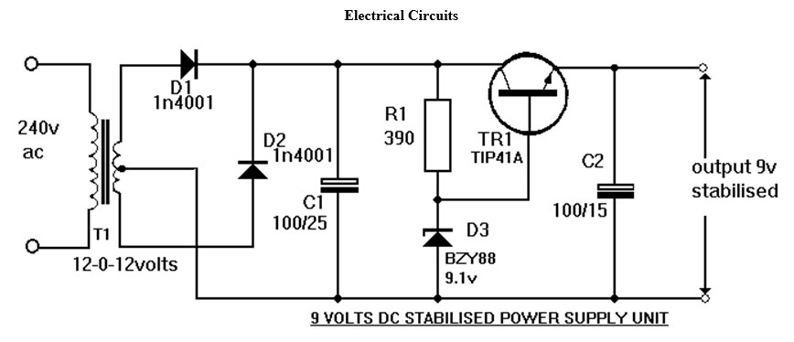

Task 3

Identify the major parts of the lathe machine by annotating it e.g. chuck, tail stoke etc.
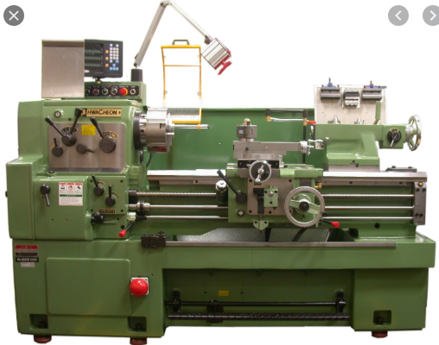

Task 4

Identify the major parts of the milling machine shown below by annotating it e.g. milling machine head etc.

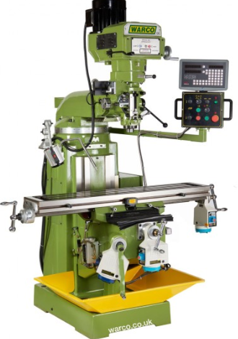

Task 5

Identify the major parts of the drilling machine shown below by annotating it e.g. drilling machine head etc.

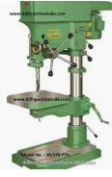

Task 6

Make a list of fasteners, with images and descriptions of each of them, generally used for engineering products and structures. See the example shown below. These fasteners are used for designing engineering components.

Hex Head Bolts

Machine Screws

Socket Cap Screws

Hex Nuts

Square Nuts

POP Rivets

Dowel Pins

Stud

Plain Washer
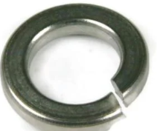
Spring Washer - Spring washers are used to prevent nuts, bolts and screws from vibrating loose. These washers are rings, which are split at one point and bent into a helical shape.

Task 7

Working effectively and safely in an engineering workshop.

Health and Safety is a vital part of an engineering course. Complying with legislation is a requirement for all students and staff. Please complete the table below. You will need to identify the potential hazards to each part of the body listed and give examples of the PPE used for protection.

Part of the body | Hazard | PPE
Head
Eyes
Hearing
Lungs
Hands
Feet
Skin
Trunk and body

Whole body

Please complete this document and make sure you bring it with you on your first day at college.

