BTEC Applied Science Transition Work
.
The BTEC Applied Science Level 3 course is a mixture of different assignment modules and examined science theory and practice. It is a rigorous, academic course that is highly valued by higher education and employers. So to help you succeed we would like you to complete these tasks before you start the course. Please bring the completed work with you on the first day of college.

PHYSICS
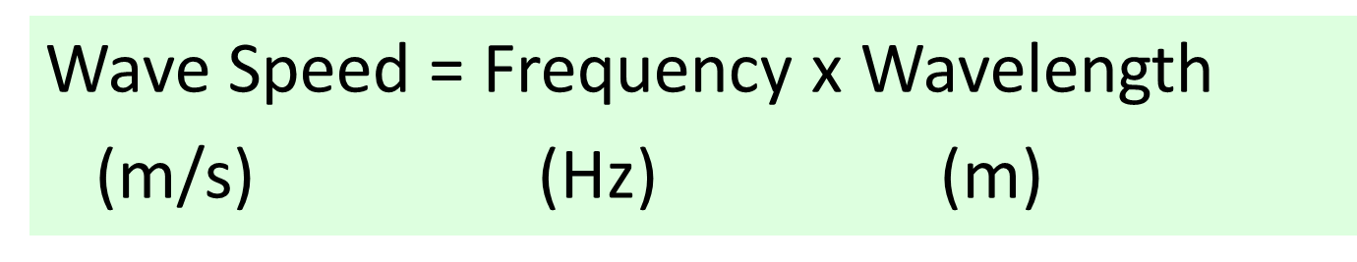
- What is the speed of a wave that has a frequency of 20Hz and a wavelength of 5m?

2. What is the frequency of a wave that has a wavelength of 6m and a speed of 18m/s?

3. What is the speed of a wave that has f = 2kHz and wavelength = 200cm?

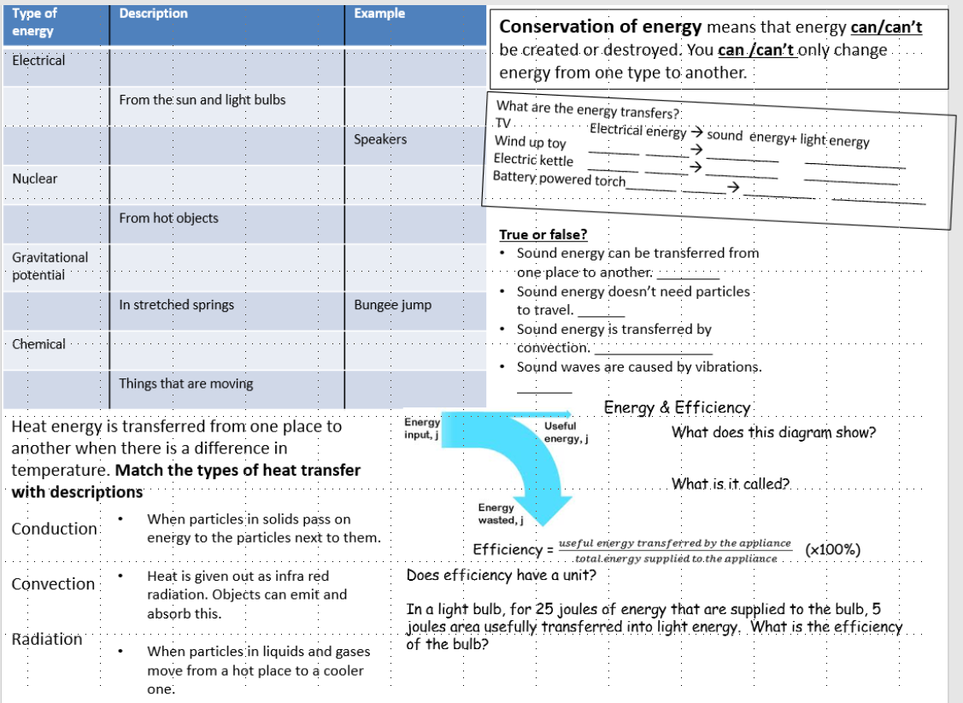
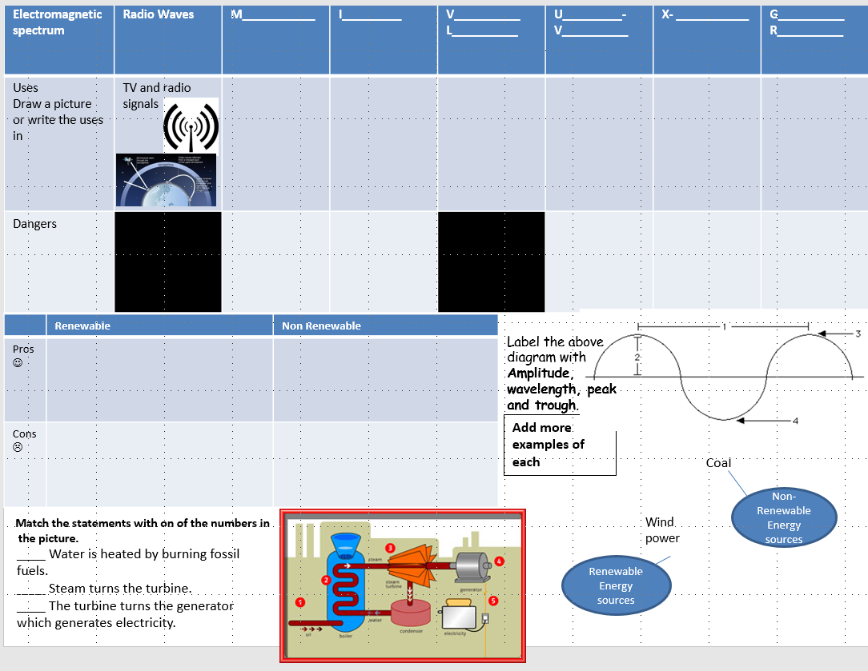

CHEMISTRY

Atomic Structure
1) Which part of the atom contains the protons? ________________________________
2) What is the charge on an electron? ________________________________
3) What does the atomic number measure? ___________________________________________________________
4) Write the chemical symbol and number of protons, neutrons and electrons in an atom of the following elements
Element | Symbol | Protons | Neutrons | Electrons
Nitrogen
Argon
Copper

Trends and Patterns
- What are horizontal rows on the Periodic Table called? _________________________
- What are the vertical columns on the Periodic Table called? _________________________
- Circle the most reactive element in each of the following lists
  - Lithium, Sodium, Potassium
  - Fluorine, Chlorine Bromine

- Describe and explain the trend in reactivity as you go down group 1.
__________________________________________________________________________________________________________
__________________________________________________________________________________________________________
__________________________________________________________________________________________________________

Chemical Bonding and Properties of Ionic and Covalent Compounds
- Define the following types of bonding
Ionic Bonding _____________________________________________________________________________________________________
_____________________________________________________________________________________________________
Covalent Bonding _____________________________________________________________________________________________________
_____________________________________________________________________________________________________
- Draw a dot and cross diagram for the following molecules:-
  - Magnesium Chloride, MgCl₂

  - Methane, CH₄

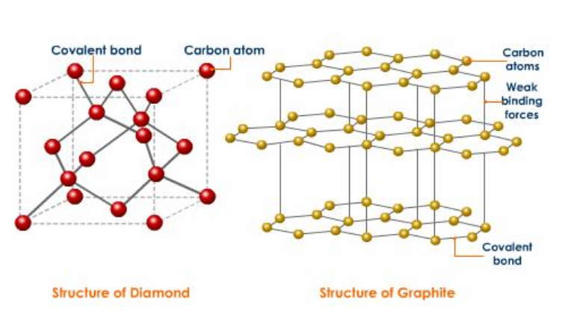
- Circle the correct answer and provide an explanation below
  - Diamond has a very high/very low melting point because ________________________________________________________________________________________________
________________________________________________________________________________________________
  - Diamond can/cannot conduct electricity because ________________________________________________________________________________________________
______________________________________________________________________________________________

- Complete the table:
Material | Use | Explanation for why they are suitable for this use
Diamond
Graphite

BIOLOGY
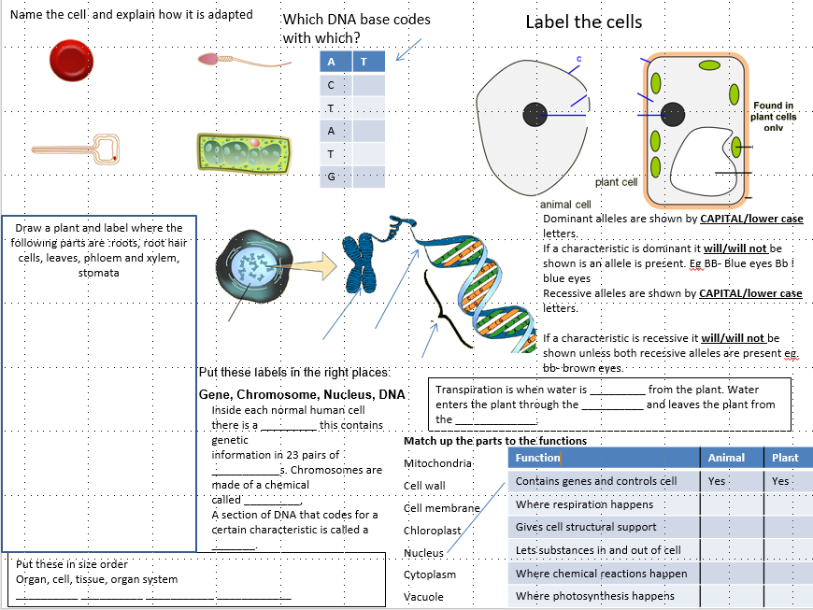
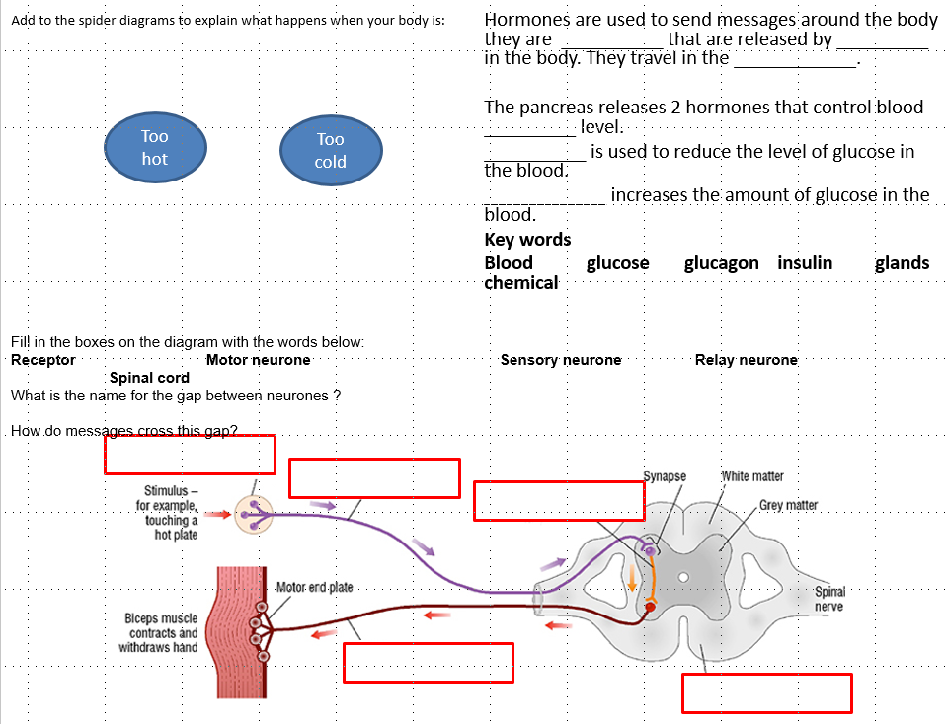

Complete the word search and find definitions for the words:

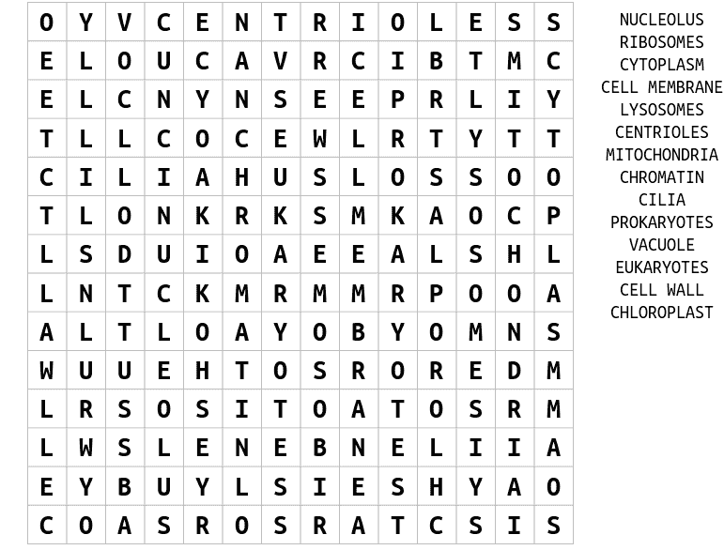

FORENSIC EVIDENCE COLLECTION

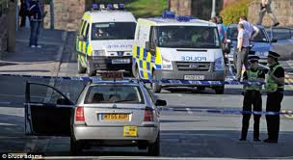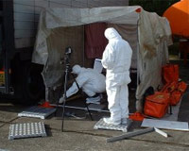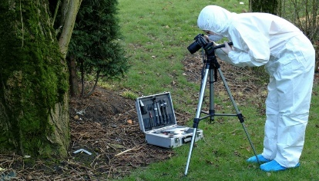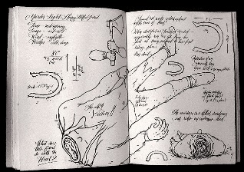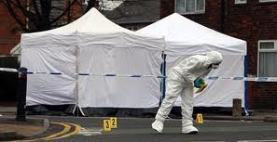

- How is a crime scene preserved so that any evidence collected can be used in court?

- What is documented at the crime scene and how?

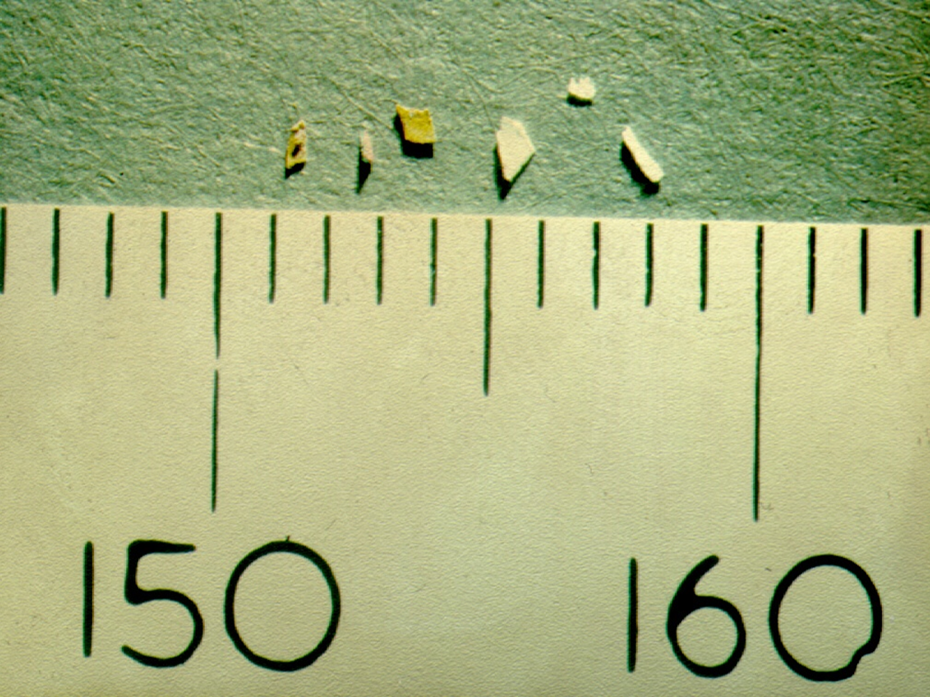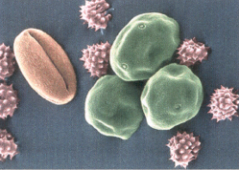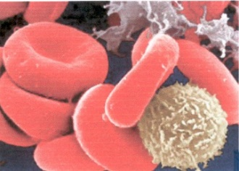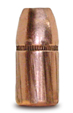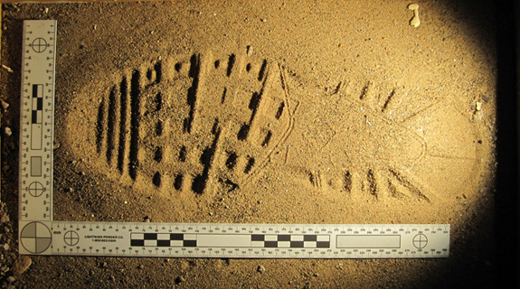

- What evidence could be collected at a crime scene?

- Who might be at a crime scene and what are their roles?

FORENSIC TRAFFIC INVESTIGATIONS

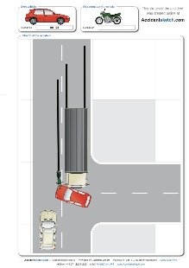
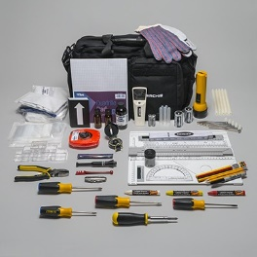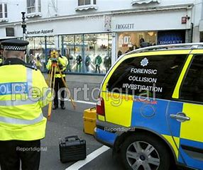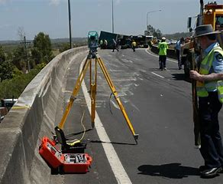

- What evidence might be collected at the scene of an RTA (Road Traffic Accident)?

- How could this information can be used to estimate the speed the vehicles were travelling immediately before the accident?

- What factors affect the stopping distance of a vehicle?

- Evaluate why motorways are less dangerous than rural roads.

