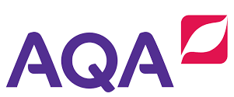
Bridging activities GCSE to A level Geography

Planning to study Geography at A level?

Or interested in just furthering your knowledge of Geography post the GCSEs?

There are many things you can do:
- Developing as a geographer – through general reading around/ watching videos/listening to podcasts etc the geography subject to develop your geography knowledge and understanding.
- Become a News Buff- Watch the news- BBC news between 6am-9am or at 6pm. Or get on the BBC news app? Other websites such as The Guardian, The Independent. Create a Geography in the News Diary of all things that are relevant to what you are studying?
- Preparing for the A Level Course- Starting to explore the topics and their foundations in which they will be studied in the A Level Course.
To be a great geographer, you will need to develop the ability to think synoptically, being able to see the greater overview and how everything we study in Geography links together. Geography is not just about the studying people and landscapes; it is also the relationships that exists between people and their environment.

How can I develop as a Geographer before September?

Below are some links to podcasts, websites, books and even films which provide a great way of staying inspired and engaging with Geography:

PODCASTS:
- Costing the Earth- There are some great podcasts here to pick from on a wide variety of geographical issues. https://www.bbc.co.uk/programmes/b006r4wn/episodes/player (many topics including climate change, carbon, urban greening, deforestation, alternative powers, plastics (etc)
- Royal Geographical Society – ‘Ask the Geographer podcasts’
- https://www.rgs.org/schools/teaching-resources/ask-the-expert-podcasts/ = a fantastic set of podcasts to keep A Level studies up to date with the latest geographical research = pick out some that interest you.
- Links to general podcasts
- https://eternalexploration.wordpress.com/2016/01/04/top-10-podcasts-for-geography-students/ - this has a number of different links to geography podcast, specifically targeted to Geography students. Definitely recommend TED talks like - https://www.ted.com/search?q=Geography https://www.youtube.com/watch?v=gadT3BO4GJc&feature=youtu.be

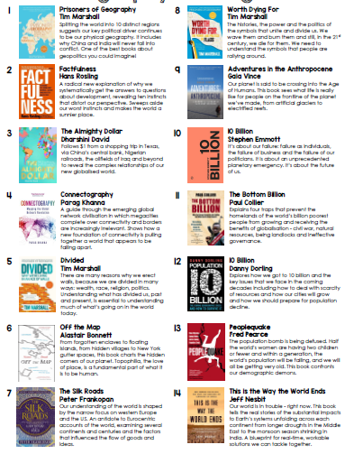
Books:
If you are into reading both fiction and non- fiction, why not try some Geographically themed books/magazines:
- Prisoners of Geography by Tim Marshall – an insightful book which helps understanding how the physical geography impacts on political reality and really helps to understand how decisions of world leaders have been shaped by geography- a good introduction to Geopolitics
- Geography Review Magazines: Subscribe for £40 and you will get 4 up to date magazines with articles that will be relevant to the topics that you are studying.
- Six Degrees by Mark Lynas – a scary walkthrough of the impacts of Climate Change as world temperatures increase by 1 degree through to 6 degrees.
- Divided by Tim Marshall – his follow-up to Prisoners of Geography – a great book which explains how & why the world is becoming more divided and how countries are putting up barriers. Very relevant to events in Europe (Brexit), the US (Trump) and the Coronavirus situation.

Geographical Documentaries:
There are some great geographical documentaries which will help develop your general geographical knowledge and understanding and help you see what an amazing world we live in.
The following are all available online:
- David Attenborough Box Sets- there are 9 amazing boxsets available on iPlayer from David Attenborough exploring our amazing world. https://www.bbc.co.uk/iplayer/group/p06m42d9
- The Americas with Simon Reeve https://www.bbc.co.uk/iplayer/episodes/m00095p0/the-americas-with-simon-reeve
- Simon Reeve around the World https://www.bbc.co.uk/iplayer/group/p06rrnkm The Russia series is really interesting.
- Race across the world
https://www.bbc.co.uk/iplayer/episodes/m0002tvs/race-across-the-world
- Andrew Marrs Megacities https://www.bbc.co.uk/programmes/b011qmcl/episodes/guide
- Trumps War on the Border https://www.channel4.com/programmes/trumps-war-on-the-border
- Dispatches https://www.channel4.com/programmes/dispatches/on-demand/67256-001
- Earth from Space – episode 4 The Changing Planet (BBC iPlayer) https://www.bbc.co.uk/iplayer/episode/p072n8m0/earth-from-space-series-1-4-changing-planet
- The Beauty of maps
https://www.bbc.co.uk/iplayer/episodes/b00s2w83/the-beauty-of-maps

Geography on NETFLIX, DVD or YOUTUBE:
- Before the Flood- A film presented by Leonardo DiCaprio- exploring climate change and looking at what needs to be done today to prevent catastrophic disruption
- Our Planet Netflix Series- Explores how climate change impacts all living creatures
- Blood Diamond – looks at the diamond trade in Sierra Leone
- An Inconvenient Truth – follows Al Gore on the lecture circuit as he seeks to raise awareness about Climate Change.
- + An Inconvenient Sequel

What should I do with the News that I am Watching?
You should be regularly watching the news to keep you up to date with what is happening in relations to the inter-relationship between people and the environment. You will be really surprised how many of the news bulletins relate to what you are studying.
- BBC news: https://www.bbc.co.uk/news- an excellent source of up to date articles- explore the headings such as Science, UK, WORLD and other stores
- The Guardian: https://www.theguardian.com/uk - Again many useful articles and logically ordered – keep an eye on the Environment, Science, Society, Global Development Stories in particular.
- The Conversation: https://theconversation.com/uk - Really useful to support many of you’re a Levels. Up to date articles from academics and specialists in the field written in a way that is accessible to all, summarising the key points in short but insightful articles.
- Google earth https://beyondthemap.withgoogle.com/en-us/?fbclid=IwAR14xhoVLHHumTfjKvMIwEKGe_AJkO5BLrwRmhtkL2X29gmHR9u-RlRV398
You could create a digital scrapbook and either cut out the headline from a newspaper/print it off/create a Pinterest collection/ file as Geography as a word document and summarise the following:
- What are the key things that the article is telling you about- can you summarise in 10 bullet points?
- What part of Geography/what we study does this link to?
- Are there any keywords that you need to look in to or you feel would be useful for your studies?

You could bring this with you for your first lesson in the September.
