A Level Biology Transition Work
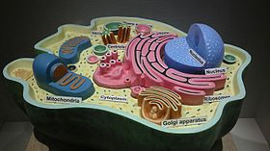
To be a successful student of A level Biology takes an independent, proactive and thinking approach to your study. This transition work will help you to connect what you have learned at GCSE to the extended ideas at A level and start to develop your study methods and thinking skills. Your A level Biology study will start with some fundamental ideas which you need to understand really well as they form the foundations that all other biological concepts depend on.
- Cells
https://www.youtube.com/watch?v=gFuEo2ccTPA
Review – use the revision mat to review what you already know about cells 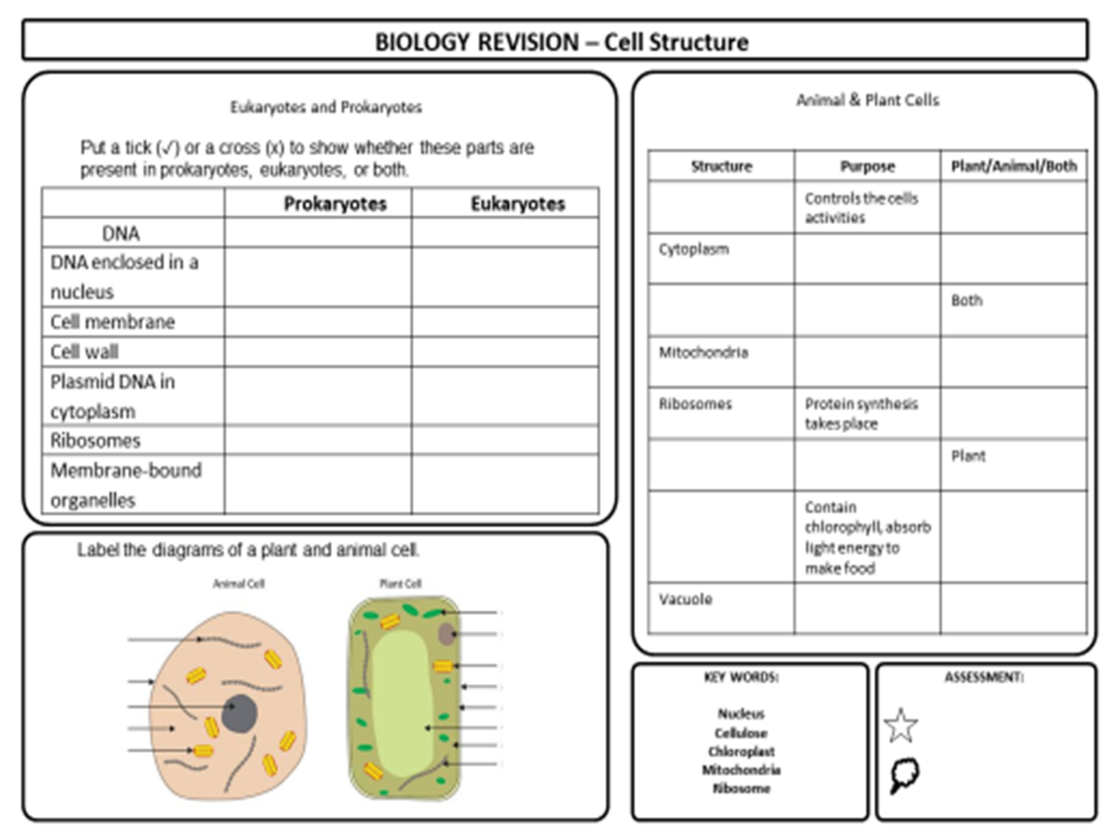

Label this Prokaryote and describe what is meant by a prokaryote:

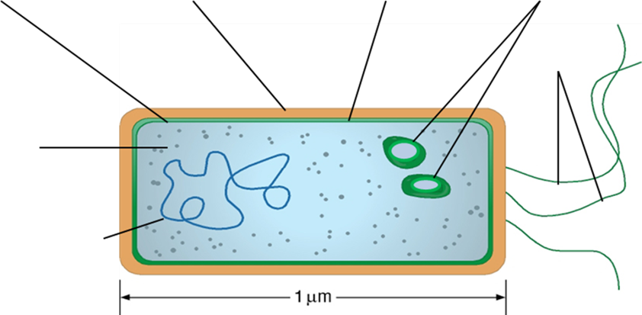

- Research – view the animation below. Note any processes and reactions that must happen to allow a cell to stay alive:

https://www.youtube.com/watch?v=Aa0cvmsD_2Q

Ideas

What are the meanings of the following terms used in the clip:
Pseudopods
Food vacuole
Membrane-bound
Cilia
Cytoplasm
DNA and mRNA
Mitosis
Mitochondria

View the following animation and fill in the table (3) with the functions of the organelles:

https://www.youtube.com/watch?v=URUJD5NEXC8

Organelle | Description | Function
Nucleus

Mitochondria

Chloroplast

Golgi Apparatus

Ribosome

Cytoskeleton

Complete the word search and find definitions for the words:

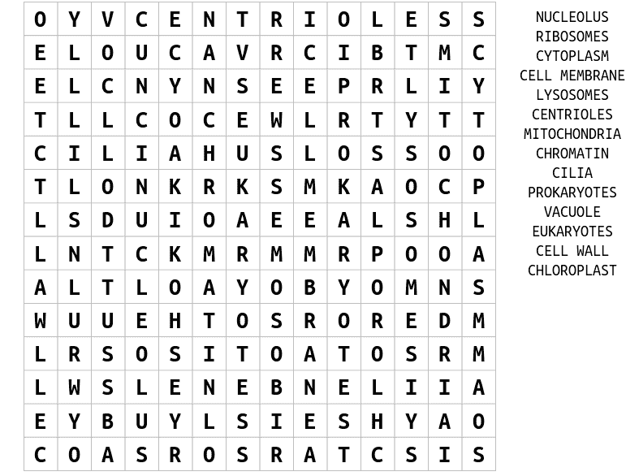
View the animations on microscopy:
https://www.youtube.com/watch?v=znSQ9A7OPVc

https://www.youtube.com/watch?v=ZqgKrd4Lp24

Create a mind map for your ideas

Microscopes

Calculating Magnification
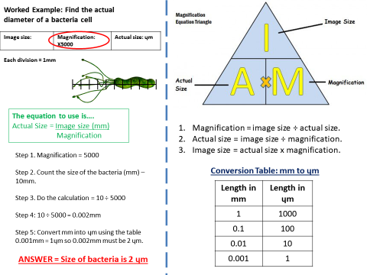

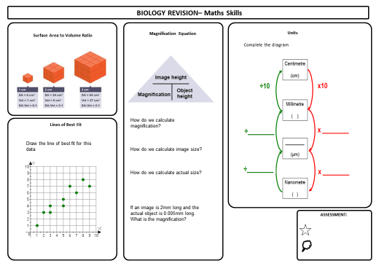

- Practice

1. | Fig. 23 shows a microscope image of a cross section taken from the stem of a sunflower, Helianthus annuus.  Fig. 23  Calculate the magnification of this image.  [2]

2. | Fig. 1 shows two blood smears, A and B.  Fig. 1  - Which of the two images, A or B, shows a non-specific immune response?  Explain your answer.  [1]  - The actual width of X in Fig. 1 image B is 15 µm.  Calculate the magnification used to produce image B in Fig. 1.  Give your answer to two significant figures.  Answer = ................................................................... [2]

END OF QUESTION paper

- Think
Can you answer the questions on cell structure? If you can you have become an A level thinker!

1. | Which of the following structures, A to D, are found in prokaryotes and in eukaryotes?  - a cell wall made of peptidoglycan  - circular genomic DNA  - a nucleus surrounded by a nuclear membrane  - ribosomes  Your answer  [1]

2. | State the correct term for of the following definition:  The detailed structure of cells visible only with an electron microscope.  [1]

3. | Cyanobacteria are photoautotrophs and fossil records confirm their existence 3.5 billion years ago.  Which row describes the structure of cyanobacteria?  Feature  Nucleus Circular DNA Mitochondria Ribosomes Chloroplast Cell wall  A ✓ ✓ ✓  B ✓ ✓ ✓  C ✓ ✓ ✓  D ✓ ✓ ✓  Your answer  [1]

4. | Plant and animal cells have different structural features.  - Name two features of plant cells that are not features of animal cells.  1  2  [2]  - Name one structure present in animal cells that is not present in plant cells.  [1]  - The cytoskeleton in cells consists of microtubules and microfilaments.  Describe the roles of the cytoskeleton.  [3]

5. | One theory about the evolution of organelles is the endosymbiotic theory. This theory suggests that the mitochondria and chloroplasts found in eukaryotic cells represent formerly free-living bacteria that were absorbed into a larger cell.  The following list describes a number of features of mitochondria and chloroplasts.  Place a tick (✓) next to the three statements that could be used as evidence for the endosymbiotic theory.  mitochondria contain ribosomes that are smaller than those found in the cell cytoplasm  chloroplasts contain chlorophyll and other photosynthetic pigments  mitochondria are a similar size to bacteria  the inner membrane of a mitochondrion is folded to form cristae  chloroplasts contain many disc-shaped membranes called thylakoids  chloroplasts have their own circular DNA  [3]

6. | A cytoskeleton is present in all eukaryotic cells. One of its functions is to control the movement of organelles.  Epithelial cells in the airways of mammals play an essential role in defences against pathogens.  Explain the function of epithelial cells in the airways of mammals in the defence against pathogens and suggest the importance of the cytoskeleton in carrying out this function.  [4]

7. | Haemoglobin is found in erythrocytes. Unlike other vertebrates, the mature erythrocytes of mammals lack nuclei and other membrane-bound organelles.  - Explain one advantage and one disadvantage of the lack of nuclei and other membranebound organelles to mammalian erythrocytes.  Advantage  Disadvantage  - [2]  - Viruses do not use erythrocytes as host cells, whereas the malarial pathogen Plasmodium spends part of its life cycle inside erythrocytes.  Suggest why.  [2]  - Explain why erythrocytes do not make use of any of the oxygen that they are transporting.  [2]

8. | Fig. 3.1(a) and Fig. 3.1(b) below show root hairs on the surface of roots. The two images were taken using different types of microscope.  Fig. 3.1(a)  Fig. 3.1(b)  One of the images was taken using a scanning electron microscope.  Identify which image, Fig. 3.1(a) or Fig. 3.1(b), was taken using a scanning electron microscope.  Justify your choice.  [2]

END OF QUESTIONS
- Review
- Biomolecules and Enzymes

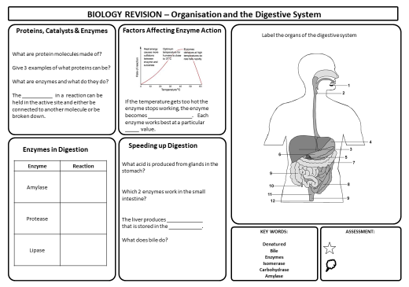

- Research
- Biomolecules
https://www.youtube.com/watch?v=H8WJ2KENlK0

- Carbohydrates
Watch the following animation and answer the questions. Fill in the table if you can

https://www.youtube.com/watch?v=_zm_DyD6FJ0

https://www.youtube.com/watch?v=LeOUIXbFyqk

- Draw a glucose molecule:

- What is meant by a hexose?

- Name 3 monosaccarides:

- What is a disaccharide?

- Name 3 disaccarides and what they are made of:

- Name the bond formed between the hexoses:

Try to complete the table with ticks and crosses:
 | Starch | Glycogen | Cellulose
Found in animals

Found in plants

Made up of alpha glucose

Made up of beta glucose

Polysaccharide

Structural molecule

Storage molecule

Stains deep blue/black with iodine

Found in plant cell walls

Branched chain

Unbranched chain

Tightly coiled

Insoluble

Hydrolysed to form alpha glucose for respiration

Can you spot which polysaccharide is which?

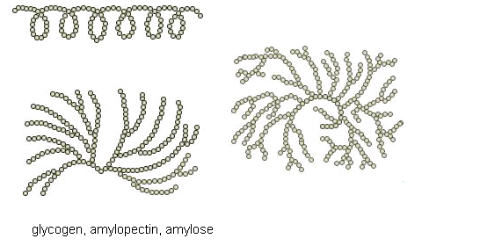
- Research

- Proteins
What is a protein? Your ideas here:

Watch the animations below and try the questions:

https://www.youtube.com/watch?v=Gi9A56nu01E

https://www.youtube.com/watch?v=qBRFIMcxZNM

- Draw an amino acid:

- How many types of amino acids are there?

- How are amino acids different from each other?

- What is the name of the bond between amino acids?

- What is the Primary structure of a protein?

- What then happens to the primary structure of a protein?

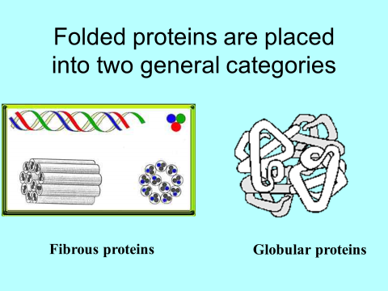

- Can you name any fibrous or globular proteins?

- Can you complete the proteins crossword?

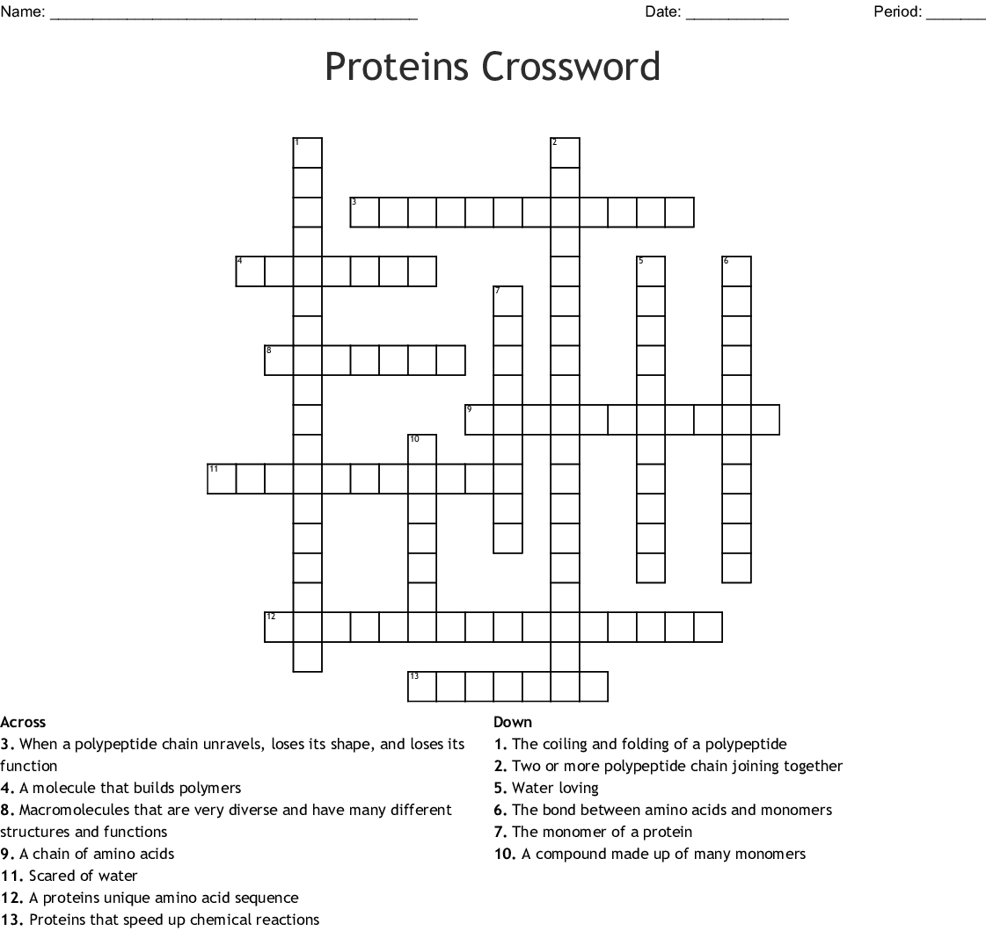

- Research
- Lipids
https://www.youtube.com/watch?v=VGHD9e3yRIU

https://www.youtube.com/watch?v=5BBYBRWzsLA

https://www.youtube.com/watch?v=brs2nMubr84

- Label a triglyceride:

- What components are triglycerides made of?

- What is the difference between a saturated and an unsaturated fat?

- What is a phospholipid?

- Where is this molecule found?

Try the wordsearch and define the terms:

LIPIDS
H | U | E | I | W | N | E | G | J | U | F | I | E | L | A | R | S
F | M | N | E | G | Y | X | O | F | A | T | F | Q | P | H | V | E
O | T | R | I | G | L | Y | C | E | R | I | D | E | Y | L | C | L
W | P | L | N | K | J | C | A | R | B | O | N | G | C | B | O | U
S | D | N | Z | E | F | Y | J | P | M | S | G | O | H | Y | A | C
H | O | T | R | D | Y | Q | L | V | P | R | Y | X | O | H | U | E
N | I | L | D | P | I | P | A | J | O | G | H | C | T | B | V | L
E | L | K | I | T | R | M | J | L | T | M | X | G | U | L | W | O
G | S | S | P | J | N | O | I | T | A | L | U | S | N | I | B | M
O | P | U | I | F | E | A | Q | W | X | T | V | J | O | A | L | O
R | K | N | L | D | Y | W | S | J | M | Y | W | W | W | J | O | I
D | K | P | I | N | U | P | K | H | O | R | M | O | N | E | S | B
Y | L | O | R | K | A | V | Q | L | H | K | H | L | G | D | Z | A
H | S | D | I | O | R | E | T | S | B | S | H | O | A | W | B | X
I | B | E | G | A | R | O | T | S | Q | R | W | F | B | Y | V | I
Q | U | X | T | V | X | R | F | Q | J | Y | L | P | A | V | S | V
K | S | I | I | S | E | X | A | W | E | Z | D | D | Y | Z | K | V
STEROIDS WAXES HORMONES OILS INSULATION TRIGLYCERIDE FAT STORAGE
CARBON OXYGEN HYDROGEN LIPID BIOMOLECULES

- Review
- DNA
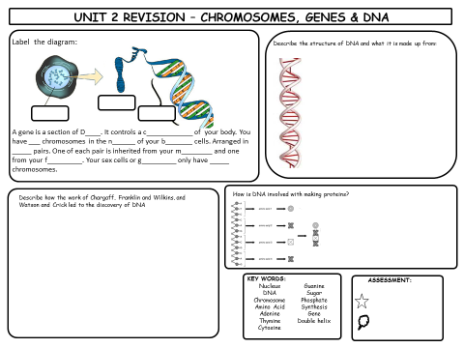
- Research
Use these animations to review and extend your ideas about DNA structure and function:
https://www.youtube.com/watch?v=zwibgNGe4aY
https://www.youtube.com/watch?v=5MQdXjRPHmQ&t=207s

Make a mind map to summarize and link your ideas

DNA

DNA – quick test
- Draw the basic structure of a nucleotide

- Name each 5 carbon sugar below
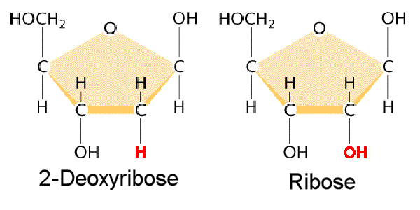

- Name the different nitrogenous bases in DNA

- DNA is often described as a DOUBLE HELIX. What can you remember about the way in which the double helix is formed?

- What is the BASE PAIR RULE in DNA?

- In one sample of DNA , the % of each nitrogenous base is analysed. 22% is found to be thymine. Can you work out what the % of each other base is?

- Think

1. | The following table describes the approximate percentage mass of different chemical elements in organic polymers.  Polymer N (%) C (%) O (%) H (%) P (%)  A nucleic acid 20.0 30.0 20.0 10.0 20.0  B carbohydrate 0.0 33.3 33.3 33.3 33.3  C protein 30.0 10.0 10.0 0.0 50.0  D lipid 0.0 50.0 49.0 1.0 0.0  Which of the rows, A to D, is correct?  Your answer [1]

2. | Energy can be stored in living organisms in the form of carbohydrates or lipids.  Name the carbohydrate molecules used to store energy in plants and animals.  plants ................................................................................................................................................  animals ...............................................................................................................................................  [1]

3. | Which of the processes, A to D, describes the formation of cellulose?  A condensation polymerisation of amino acid molecules  B condensation polymerisation of β-glucose molecules  C hydrolysis polymerisation of α-glucose molecules  D hydrolysis polymerisation of deoxyribose molecules  Your answer  [1]

4. | Cellulose is another polysaccharide that is present in some living organisms.  - Complete the following table to show three other differences in the structures of starch (amylose) and cellulose molecules.  Amylose Cellulose  coiled no coiling  - [3]  - Which properties of cellulose make it suitable for forming cell walls?  [2]

5. | Polymers are important molecules that have structural and functional roles in organisms.  Chitin is a polymer that is found in insects, where it forms a major part of the structure of the exoskeleton.  - Chitin is a macromolecule that is similar to a polysaccharide.  - Chitin is composed of molecules of N-acetylglucosamine, the structure of which is shown in the figure below.  - The monomers of N-acetylglucosamine join by 1–4 glycosidic bonds to form the chitin molecule.  - How does the composition of N-acetylglucosamine differ from the composition of a monosaccharide sugar?  [1]  - Which monosaccharide sugar does N-acetylglucosamine most closely resemble?  [2]  - Using your knowledge of the formation of structural polysaccharides, describe the formation of the chitin molecule from its monomer and predict its structure.  [4]

6. | Biological molecules, such as lipids and carbohydrates, are found in dairy products.  Lipids differ depending on the type of fatty acid they contain.  Stearic acid is a fatty acid commonly found in animal fats. It contains 18 carbon atoms.  The structure of stearic acid is shown in Fig. 1.1.  Fig. 1.1  - State the chemical groups labelled A and B in Fig. 1.1.  A...................................................................................................................................................  B...................................................................................................................................................  [2]  - Fig. 1.2 shows another type of molecule also found in lipids.  Fig. 1.2  Name the molecule shown in Fig. 1.2.  [1]

7. | Pepsin is an enzyme that digests protein foods in the mammalian stomach.  Protein molecules are made from chains of amino acids.  - Name the covalent bond between two adjacent amino acids in a chain of amino acids.  [1]  - Name the type of reaction involved in breaking this bond and describe what happens in this reaction.  [2]

8. | A vet is concerned that a llama is unwell. The vet suspects there may be haemoglobin in the urine of the llama.  Explain how the vet could confirm this suspicion.  [2]

9. | The chromosomes carried by sperm are made of DNA.  The following passage about nucleic acids has four words missing. Choose the correct missing words from the list below and complete the passage by writing them in the gaps.  Nucleic acids are made from ................................... monomers.  Phosphodiester bonds form between the monomers. They consist of a ................................... group between the ................................... molecules, forming the ‘backbone’ of the molecule.  In DNA, hydrogen bonding between the two antiparallel ................................... causes the characteristic double helix shape.  [4]

10. | A DNA molecule contains polynucleotide strands.  - Individual nucleotides are joined together to make a polynucleotide strand.  What type of chemical reaction takes place when two nucleotides in a single polynucleotide strand are joined together?  [1]  - Name the chemical released when the bond is formed between the two nucleotides.  [1]  - A DNA molecule contains two polynucleotide chains.  Describe how these two chains are held together.  [3]

END OF QUESTION paper

- Review
- Enzymes
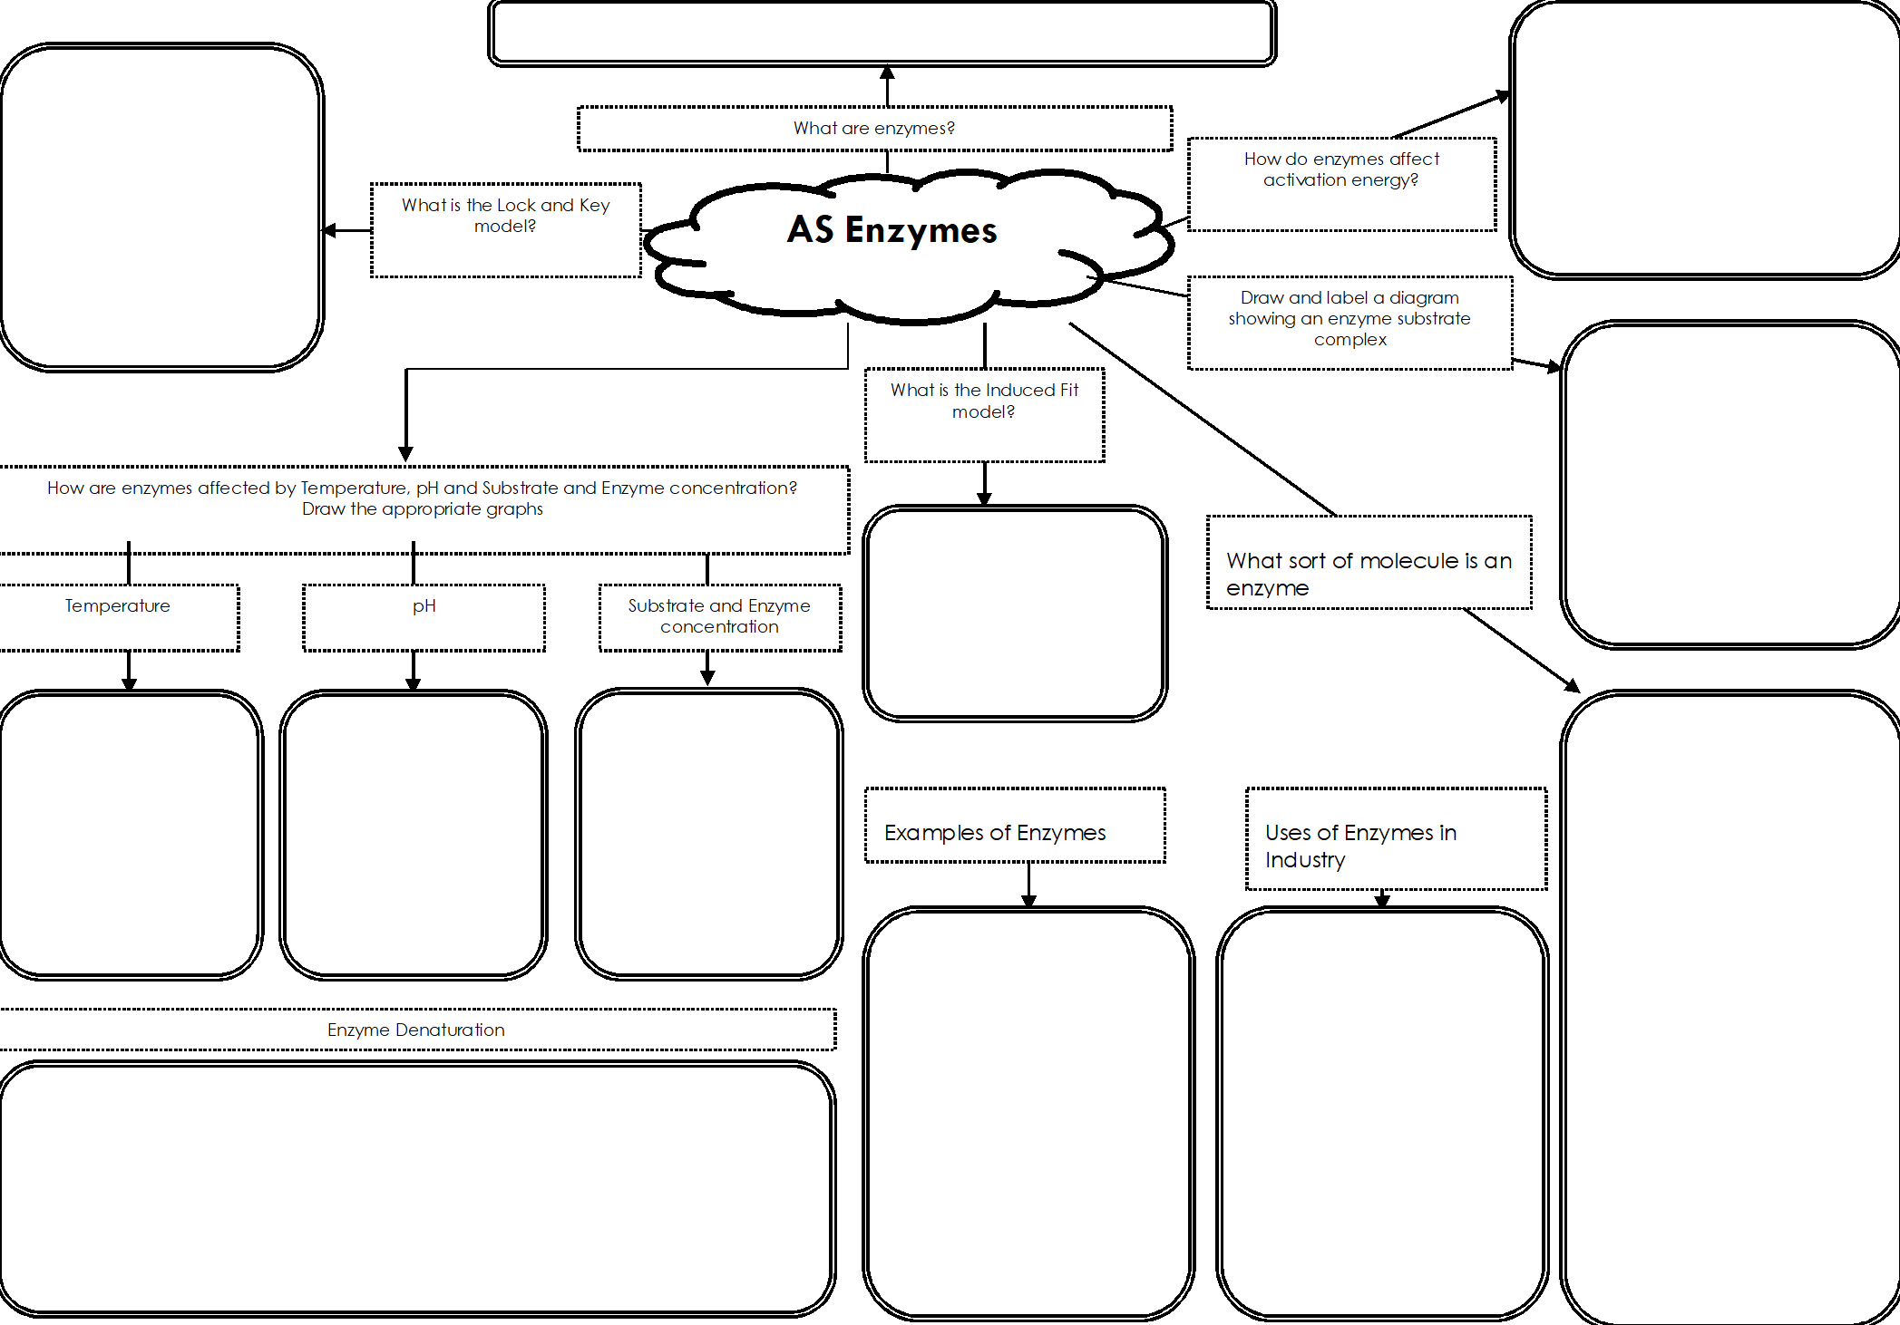

- Research
https://www.youtube.com/watch?v=1BoZfsARSjk

https://www.youtube.com/watch?v=Wm_hW4ATROo

https://www.youtube.com/watch?v=C2gYhT9BrmQ

Match the parts or processes in the list below with the descriptions in the table:
- Active site
- Globular protein
- Lock and key
- Optimum pH
- Optimum temperature
- Substrate
- Biological catalyst
- Product
- Denature
- Enzyme-substrate complex
Description | Part/Process
The tertiary structure of an enzyme
The pH at which an enzyme’s maximum rate of reaction is achieved
An association of enzyme and substrate
Chemical which is made and is present at the end of a reaction
Definition of an enzyme
A theory suggesting that enzyme and substrate fit precisely together
Chemical present at the start of a reaction
The region of the enzyme into which the substrate fits
A change in the structure of the enzyme and its active site
Temperature at which a particular enzyme works best

Enzyme Wordsearch

D O E K S M R R V I S C E L H S A Z U K
P E N R D E A E N Y O T T D Z U C K N O
S X A O U L M H V M U W I B B B T R K C
H T Z T U T I Y P E Q B S Q Q S I Q J W
P K A B H B A E Z R R P E V R T V E J T
A U O T I C T R U N V S V A I R A U H V
X L I T I I A D E X E Q I I V A T D Q U
G K O V T N F P C P R O T B Q T I G V C
Y R B I M C S C M E M S C W L E O P S Q
S X V Q L V G V G U K E A V I E N H R B
Z E P R O D U C T S S Y T P Y Y E G O A
I N D U C E D F I T T H M K E O N W T M
S T S Y L A T A C G Z P R K L L E B C Y
L T V F E I I P V D E R D O J H R R A L
Y T I C I F I C E P S N H W O U G M F A
M Y D X U G Q J S A A C S L B M Y I O S
G R H L W E Y I F K P Y Z I U Z C H C E
F B Y Q N J N T C M T S W B K T A W K T
L S P D M G K O V G P Q L S L Q X Y C V
G R A B S Y L N V A H Q E D W M E V A O

- Enzymes lower the ................... of a reaction.
- The place where the substrate binds to the enzyme.
- An enzyme that breaks down starch.
- Enzymes are biological ................
- Two types of molecule that may be required for an enzyme to catalyse a reaction.
- A type of inhibitor that has a similar shape to the substrate.
- A fungus that may be fatal.
- Enzymes are .............. proteins.
- Two hypotheses that explain how enzymes function.
10) A molecule that prevents an enzyme working.
11) An enzyme that is found in the stomach.
12) The molecules that are produced at the end of a reaction.
13) A term that describes the fact that enzymes are particular to one type of substrate.
14) Drugs that inhibit the production of cholesterol.
15) A factor that affects the rate of enzyme controlled reactions and may cause the enzyme to denature if too high.

- Think

1. | The concept of molecules with complementary shapes can be used to explain many processes in living things.  Complete the following passage about the mechanism of enzyme action.  Enzymes are proteins which speed up the rate of biological reactions. They form an ......................................................................... by binding to their substrate at a site known as the ................................................................... . This site has a specific shape created by the ………..................................................... structure of the protein molecule. This means that each enzyme can bind to only one type of substrate molecule.  This is explained by the lock and key hypothesis. In an alternative hypothesis, the binding site changes shape to fit more closely around the substrate molecule. This is called the ......................................................................... hypothesis. This hypothesis can help to explain how enzymes enable reactions to occur at lower temperatures by reducing the ............................................... required for the reaction to occur.  [5]

2. | Lipase is an enzyme that catalyses the breakdown of lipids.  An investigation was carried out to see the effect of temperature on the activity of a lipase.  - 5 cm³ of an alkaline solution of lipid was poured into a test tube.  - The test tube was placed into a water bath maintained at 20 °C and left to equilibrate.  - A few drops of an indicator were added to the wells of a white spotting tile. The indicator is pink above pH values of 8.3 and turns colourless at pH values below 8.3.  - Once the lipid solution had equilibrated, 1 cm³ of 0.5% lipase solution at the same temperature was then added to the test tube.  - For five minutes, at 30 second intervals, the solution was stirred and a few drops were removed from the test tube and placed in a well on the white spotting tile.  - The time was recorded when the solution and indicator did not remain pink.  - The procedure was repeated four more times at 20 °C and then again at a further six temperatures.  The results are shown in the table below.  Temperature (°C) Time when solution did not remain pink  Replicate 1 Replicate 2 Replicate 3 Replicate 4 Replicate 5  20 210 270 240 300 270  25 90 120 210 180 120  30 60 60 90 90 60  35 60 60 60 90 60  40 210 120 210 180 210  45 240 300 300 – 270  50 – – – – –  - Why is pH not a controlled variable in this investigation?  [1]  - Identify one variable that has been controlled in this procedure.  [1]  - Identify one variable, other than pH, that has not been controlled in this procedure.  [1]  - The procedure required the solution to be stirred and then drops of solution to be placed on a white spotting tile.  Suggest why this procedure was followed rather than simply adding indicator to the test tube, stirring the solution and looking for the colour change in the test tube.  [1]  - What can be concluded from the results in the table about the optimum temperature for lipase activity?  [1]  - Describe two different ways in which the procedure could be modified to obtain a more accurate value for the optimum temperature for lipase activity.  1  2  [4]

3. | A student investigated how changing the pH affected the activity of pepsin.  - He used a blender to make a suspension of egg white (protein) in water.  - At the start of the investigation the suspension was cloudy.  - He prepared fixed concentrations of egg white suspension, acid and pepsin to add to each of six test-tubes.  - He removed 0.1 cm³ of the mixture from each test-tube and used universal indicator to measure the pH of each mixture.  - He incubated each test-tube in a water bath at 35 °C and timed how long it took for the egg white suspension in each tube to clear.  - He prepared a table in which he recorded his results (Table 1.1).  Tube Volume of egg white suspension Volume of acid added (cm³) Amount of pepsin added (cm³) Measured pH Time for suspension to clear (m)  1 5 2.0 3.0 1  2 5 1.5 3.0 2  3 5 1.0 3.0 3  4 5 0.5 3.0 4  5 5 0.0 3.0 5  6 5 2.0 0.0 1  Table 1.1  - Identify three errors the student made in the preparation of his table before he recorded his results.  1  2  3  [3]  - Identify a change the student could make to his procedure that would increase the validity of the investigation.  [1]  - State the term that best describes the purpose of tube 6.  [1]  - Another student suggested that he should repeat the investigation at least twice.  How would this have improved the investigation?  [2]

END OF QUESTION paper

Well done!! Completing this preparation work will really help you to start you’re a level Biology Studies.
You may also want to try this workbook: Or the Text book:
