Applied Science (Forensics)
Transition Activity

To prepare you for your Forensic Science course, please work through the following activities.

1) Access the website below to find out how the Police preserve a crime scene, collect evidence, and use it to solve the crime. http://www.bbc.co.uk/news/magazine-16187225

2) Use the information to produce a poster, or an essay, or a Powerpoint presentation, on either… a) How a crime scene is preserved and evidence is collected. or b) How laboratory techniques are used to investigate evidence from a crime scene. Bring your work to your first Forensic Science lesson at Henley.

3) Just for fun… Access the following website and play the game. Can you identify which of the suspects is guilty? http://www.glasgowsciencecentre.org/glasgowscienceinvestigation .aspx
4) Enjoy your Summer. We look forward to seeing you in September!
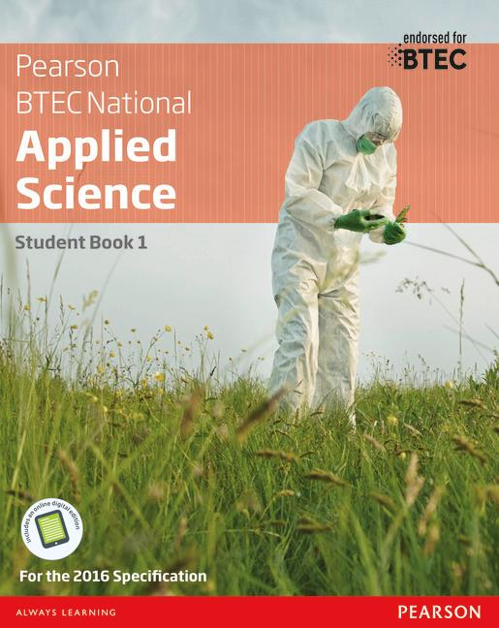
BTEC National in Applied Science
Author: Joanne Hartley,Frances Annets,Chris Meunier,Roy Llewellyn,Sue Hocking,Alison Peers,Catherine Parmar
ISBN: 9781292134093

