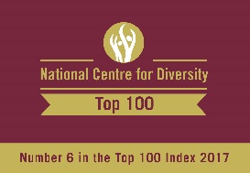
The HENLEY College
EQUALITY, DIVERSITY & INCLUSION
(EDI) INFORMATION LEAFLET

ACADEMIC YEAR 2016-2017
SUMMER TERM ISSUE

D1 CORRIDOR DISPLAYS

In May there was a display questioning what constitutes beauty and does it matter? This was followed by a display in June of books that have been censored or banned including Lady Chatterley’s Lover by D.H. Lawrence, Maurice by E.M. Forster and The Color Purple by Alice Walker.

MENTAL HEALTH AWARENESS WEEK

On May 11th Mental Health Awareness Week was marked by music, a raffle and an information stand in the Deanfield Canteen.

DEAF AWARENESS WEEK

Information was given to staff and students during the week commencing 15 May 2017 on how to best communicate with deaf people.

GENERAL ELECTION 2017

The manifestos of the three main political parties were available in the Library in the run up to the General election on 8 June 2017.

PATHWAYS POSTER
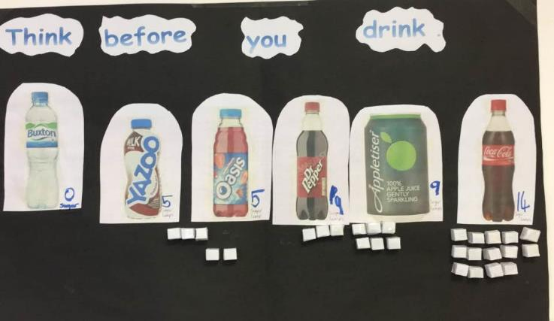
In May Pathways staff and students looked at healthier choices and produced a poster showing how much sugar is in popular drinks.

AMNESTY INTERNATIONAL YOUTH GROUP (AIYG) CAMPAIGN TIME4JUSTICEJA

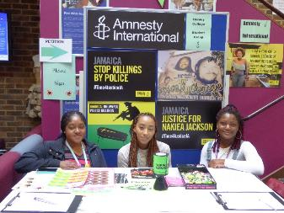
The AIYG organised a petition on June 22 to send to the Jamaican Minister of Justice in support of her fight against the unlawful killing of people in Jamaica by the police. Every week two people, mostly young men from marginalised communities, are unlawfully killed by the police who then often intimidate the families of these young men to silence them.
There were 98 signatures collected and £6.93 in donations to advance police and justice reforms for a safer Jamaica and to accompany relatives of those allegedly unlawfully killed by the police in their quest to see those responsible face the courts.

COLLEGE GROUPS
AMNESTY INTERNATIONAL YOUTH GROUP
The Amnesty International Youth Group (AIYG) met every Thursday lunchtime from 12.00 pm to 1.15 pm in D132 and welcomes everyone.

ANXIETY SUPPORT GROUP

Met every Wednesday from 1.15 pm to 2.15 pm in R144 for any student suffering from generalised anxiety or concerned that anxiety could occur during the exam period. College counsellors run the sessions and they are confidential.
CHRISTIAN UNION GROUP
Every Thursday the Christian Union met in D130 from 11.35 am to 12.45 pm for discussions led by students and staff on topical, ethical issues with a Christian perspective or for bible studies. Sessions have included discussions on the meaning of life, if you only had 24 hours to live what would you do and how to be truly happy.
DEBATE CLUB
The door of Debate Club, D558, opened at 12 on a Tuesday before the debate starts at 12.15 pm for one hour.
Debate Club gives students a chance to express their views on issues of the day, learn how to think on their feet and how to muster well-structured arguments at short notice. They also learn to see through bias and bluster, develop confidence in public speaking and keep on point, all of which take time to master.
INTERNATIONAL RELATIONS DISCUSSION GROUP
The International Relations Discussion Group (IRDG) met Friday from 12.50 pm to 1.20 pm in D131. The aim is to broaden students' knowledge and understanding of international affairs and provide an opportunity to express opinions and listen to the views of others. These sessions are particularly helpful for students applying for Politics, International Relations, Law and History at university. They are also valuable for all students as a form of educational enrichment in a democratic society.

LESBIAN, GAY, BISEXUAL AND TRANSGENDER GROUP
The Lesbian, Gay, Bisexual and Transgender Group (LGBT) met regularly on Monday from 12.45 pm to 1.15 pm in the Deanfield Meetings Room.

Venue, date and timing of the College Groups for the new academic year will be published in September 2017.

EDI ACTION PLAN FOR THE PERIOD
8 APRIL to 14 JULY 2017

ACTION | By Whom | By When | STATUS
EDI Calendar  Publish EDI Calendar on a monthly basis | SHIC | Monthly | Incremental
D1 Corridor Display  Display of books which have been censored or banned | CABO | June 2017 | Completed
LGBT Group  Regular meetings of the LGBT Group | BRIC | Incremental | Incremental
International Relations Discussion Group  Regular weekly meetings of the International Discussion Group | JPAN | Incremental | Incremental
Christian Union  Regular weekly meetings of the Christian Union Group | AREI | Incremental | Incremental
Amnesty International  Regular weekly meetings of the College Amnesty International Group | SBIN | Incremental | Incremental
Debate Club  Regular meetings of the Debate Club | SHNE | Incremental | Incremental
Anxiety Support Group  Regular meetings of the Anxiety Support Group from 22 February 2017 | JDON/TLOW | Incremental | Incremental
EDI Steering Group Meeting  Meeting of EDI Steering Group | EDI Steering Group | 28 June 2017 | Completed
EDI Information Leaflet  Publish termly EDI Information Leaflet | SDEA | Incremental | Incremental

EDI Leaflet: July 2017
Sue Deaville

