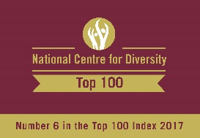
The HENLEY College
EQUALITY, DIVERSITY & INCLUSION
(EDI) INFORMATION LEAFLET

ACADEMIC YEAR 2016-2017
SPRING TERM ISSUE

D1 CORRIDOR DISPLAYS

In January there was a display in the D1 corridor on the water crisis which affects every continent with around 1.2 billion people living in areas of physical scarcity, including information on how to help. In February the display marked LGBT History Month and in March Women’s History Month.

FUND RAISING BY BUSINESS STUDIES STUDENTS

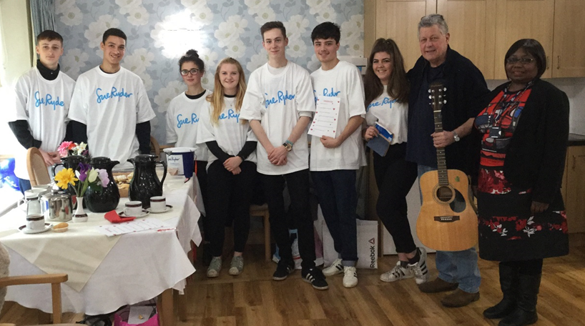
Business Studies students have been fund raising on behalf of Sue Ryder, a hospice which provides palliative care for people with life-limiting conditions. Their fund raising included organising a Pub Quiz at The Little Angel in Henley and a fun filled afternoon for residents of Bury Lodge Care Home.

AMNESTY INTERNATIONAL YOUTH CONFERENCE

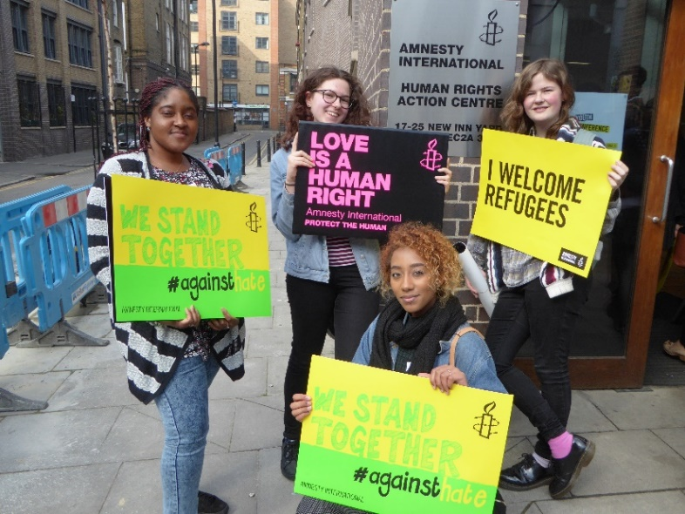
Four students from the college Amnesty International Youth Group really enjoyed attending the Amnesty Youth Conference at The Amnesty Headquarters in Shoreditch, London, on 24th March. A 150 young people heard speakers and attended workshops on the new campaign called “I Welcome Refugees”.
Becca Okyere and Kezia Blake-Payne said “A very beautiful & powerful quote really impacted on us and made us think about the people involved in these tragic and unfair situations – You have to understand nobody puts their children in a boat unless the water is safer than the land.”
Bethan Rees and Steph Batten said: “It made us even more passionate about protecting human rights”.

PATHWAYS POP UP MOTHERING SUNDAY STALL
Pathways staff and students ran a pop up stall for Mother’s Day in the Deanfield Reception foyer. They sold handmade cards, candles, treat boxes and potted plants on Wednesday 22nd and Thursday 23rd March. Over £115 was raised which will be put towards a polytunnel.

LIFE AFTER THE WORLD CHALLENGE LECTURE

Former student, Connor Vinnicombe, gave an inspiring talk in March on the benefits of taking part in the World Challenge, engaging in charity work and the thrills of travelling. Connor has gone on to work for the charity he helped in Mongolia, as part of the World Challenge Expedition organised by the Henley College.
AMNESTY INTERNATIONAL YOUTH GROUP
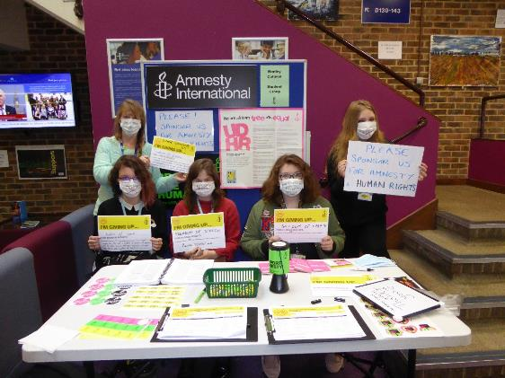
The Amnesty International Youth Group (AIYG) meets every Thursday lunchtime from 12.00 pm to 1.15 pm in D132 and welcomes everyone.
In the Spring Term the AIYG celebrated LGBT history month and studied the case of Roger Jean-Claude Mbede who was arrested, beaten and persecuted in Cameroon for expressing his love for another man in a text.
AIYG students gave up their freedom of speech in March and raised £106.17 in aid of Amnesty’s work on human rights around the world.
ANXIETY SUPPORT GROUP

Meets every Wednesday, commencing 22 February, from 1.15 pm to 2.15 pm in R144 for any student suffering from generalised anxiety or concerned that anxiety could occur during the exam period. College counsellors run the sessions and they are confidential. Students who wish to attend should email Julia Donovan at jdon@henleycol.ac.uk or go to Student Services in D507.

CHRISTIAN UNION GROUP
Every Thursday the Christian Union meets in D130 from 11.35 am to 12.45 pm for discussions led by students and staff on topical, ethical issues with a Christian perspective or for bible studies. Sessions have included discussions on the meaning of life, if you only had 24 hours to live what would you do and how to be truly happy.
DEBATE CLUB
The door of Debate Club, D558, opens at 12 on a Tuesday to give people a chance to settle before the debate starts at 12.15 pm for one hour. Recent debates have included whether or not a university education is still worth having, does God exist, the rise of Islamophobia, Brexit and the American election in the form of "This House Believes..." Students suggest and vote on topics and a decision on who will be on which side is taken the week before. Whilst a member of staff is present throughout, a student chairs the debate and all are welcome to have a go at being the chair. Students are required to stand while speaking, wait for the chairperson to call on them before speaking and remain polite and considerate at all times.
Debate Club gives students a chance to express their views on issues of the day, learn how to think on their feet and how to muster well-structured arguments at short notice. They also learn to see through bias and bluster, develop confidence in public speaking and keep on point, all of which take time to master.
INTERNATIONAL RELATIONS DISCUSSION GROUP
The International Relations Discussion Group (IRDG) meets Friday from 12.50 pm to 1.20 pm in D131. The aim is to broaden students' knowledge and understanding of international affairs and provide an opportunity to express opinions and listen to the views of others. These sessions are particularly helpful for students applying for Politics, International Relations, Law and History at university. They are also valuable for all students as a form of educational enrichment in a democratic society.

In the Spring Term, the discussions have included the impact of President Trump’s temporary ban on entry to the USA of nationals from seven countries, the prospects for the Baltic States, the Dutch and French elections, the success and failures of the United Nations Organisation and the threat posed by the regime of North Korea’s Kim Jung-un. New students are very welcome to attend to broaden their knowledge of international affairs and improve their skills in public speaking. Please bring your lunch.
LESBIAN, GAY, BISEXUAL AND TRANSGENDER GROUP
The Lesbian, Gay, Bisexual and Transgender Group (LGBT) meets regularly on Monday from 12.45 pm to 1.15 pm in the Deanfield Meetings Room.

EDI ACTION PLAN FOR THE PERIOD
1 JANUARY 2017 to 7 APRIL 2017

ACTION | By Whom | By When | STATUS
EDI Calendar  Publish EDI Calendar on a monthly basis | Library | Monthly | Incremental
Faith and Belief Wall Chart  Publish annual Faith and Belief Wall Chart | Library | January 2017 | Completed
D1 Corridor Display  Display on the water crisis which affects every continent with around 1.2 billion people living in areas of physical scarcity including information on how to help. | Library | January 2017 | Completed
Amnesty International  Regular weekly meetings of the College Amnesty International Group | SBIN | Incremental | Incremental
Christian Union  Regular weekly meetings of the Christian Union Group | AREI | Incremental | Incremental
Debate Club  Regular weekly meetings of the Debating Club | SHNE | Incremental | Incremental
International Relations Discussion Group  Regular weekly meetings of the International Discussion Group | JPAN | Incremental | Incremental
LGBT Group  Regular weekly meetings of the LGBT Group | BRIC | Incremental | Incremental
Humanitarian Relief Talk  Talk by Rachel Hastie of Oxfam as a Humanitarian Relief Worker traveling to disaster zones to help protect civilians in places of armed conflict | JLOC | 17 January 2017 | Completed
EDI Steering Group Meeting  Meeting of EDI Steering Group | EDI Steering Group | 22 March 2017 | Completed
EDI Information Leaflet  Publish termly EDI Information Leaflet | SDEA | Incremental | Incremental

EDI Leaflet: March 2017
Sue Deaville

