The HENLEY College
EQUALITY, DIVERSITY & INCLUSION
(EDI) INFORMATION LEAFLET

ACADEMIC YEAR 2016-2017 AUTUMN TERM ISSUE
EDI EVENT WEDNESDAY 5 OCTOBER 2016
The annual EDI Event was held on Wednesday 5 October 2016 to welcome new students to the College, to showcase the different groups and support available to students whilst they are at The Henley College and to raise awareness of equality, diversity and inclusion issues.
In the weeks leading up to the event photographs and accompanying information about a person, or group of people, who played an important role in the development of Human Rights including Anne Frank, Malala Yousafzai, Nelson Mandela and Ai Weiwei were on display around both sites at the College. There was also a wordsearch of Olympians and Paralympians held in Tutor groups.
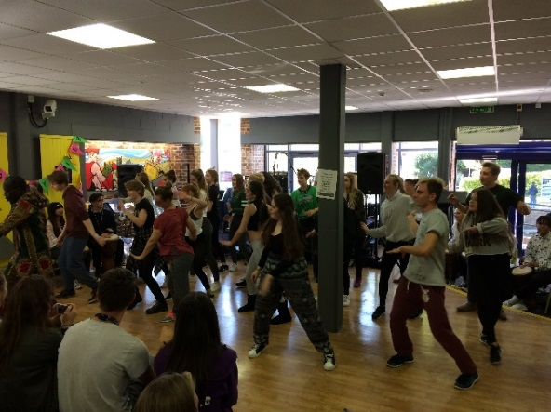
The day of the event started with Kwame and Pape of African Activities holding drumming and dance workshops with Dance, Music and Pathways students.
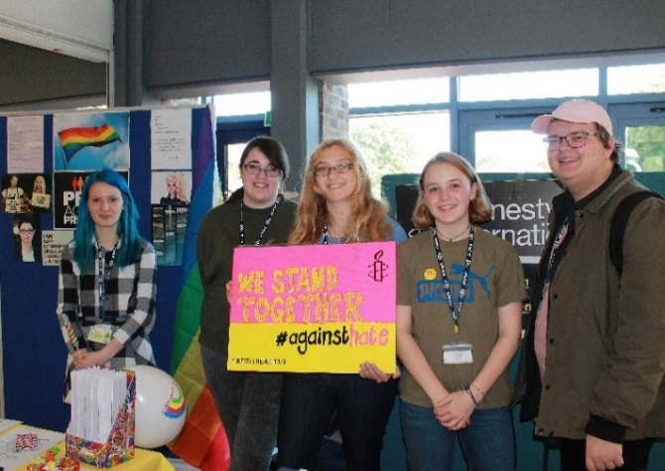
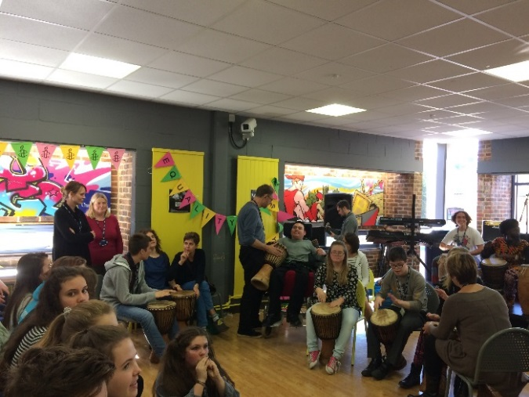
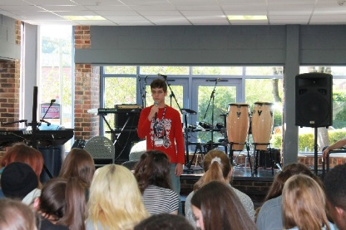
During the event there were fantastic performances by Pathways and Music students on the African drums, the Dance students performing a traditional African dance, thought provoking monologues by the Drama students and singing by the Choir, Rock School, Performing Arts and Steve Morano.

The Amnesty International Youth Group, LGBTQ+ Group, Pathways, Photography and Students’ Union all had stands at the event and there was a display in the Library of books with an EDI theme and information about the International Relations Discussion Group. The human rights photographs were displayed in the Deanfield and Rotherfield canteens on the day of the event. The canteen provided international taster dishes for the many students and staff who attended the event.
A lively debate was held in the Drama Studio with the motion ‘This house believes that the election of Donald Trump would be a disaster for human rights’. The motion was eventually defeated. There was a wonderful atmosphere through-out the event and Mark Turauskis noted that the Pathways ‘students came away feeling proud and exhilarated.’

MACMILLAN COFFEE MORNING

The annual Macmillan coffee morning organised by Sandra Wickens and Karen Broadbent on 30th September raised over £150.

SUNDARA KARMA

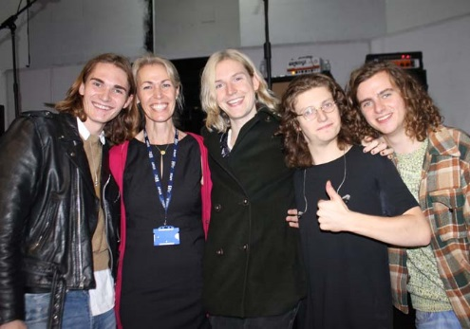
On 20 October 2016 there was a public lecture and performance by Sundara Karma who played at Reading and Leeds this summer. Two members of the band, Dom Cordell (guitar) and Haydn Evans (drums), studied at The Henley College and they played two thirty minute performances followed by a fifteen minute question and answer session. Oscar Lulu, lead singer and guitarist, advised young bands to ‘find out exactly what it is you want. Once you realise this – stick to it. Don’t let others steer you away.’

SUPPORT U

Members of Support U, a Reading based organisation which provides support, advice and guidance with Gay, Lesbian, Bi and Transgender issues, came into College on 31 October to talk to students. Support U have previously worked with students at the College in support of LGBT students and promoting the Support U offices located in Reading. Members of the current LGBT Group have been offered the opportunity to be Support U Ambassadors and there will be further meetings will take place to facilitate this.

BATTLE OF THE SOMME DISPLAY

In November there was a display in the D1 corridor to mark the centenary of the Battle of the Somme, one of the bloodiest battles in History. Staff from the Library and Molly from Pathways assembled photographs, copies of letters written by the soldiers before the battle to their families, information about the first tanks and poppies to create the display.

LIBRARY CHRISTMAS APPEAL

The Library Christmas Appeal is in support of Tree Aid to help lift people out of extreme poverty and hunger in the drylands of Burkina Faso, Ghana, Mali and Niger and the isolated areas of Ethiopia. Tree Aid aims to provide vital food all year round with trees that can survive droughts, to help people earn an income for basic needs like food, education and health, to protect the environment using trees, land and water to protect and improve it and to defend people’s rights to the trees and land on which they rely for survival.

AMNESTY INTERNATIONAL YOUTH GROUP
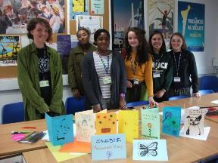
The Amnesty International Youth Group (AIYG) meets every Thursday lunchtime from 12.00 pm to 1.15 pm in D132 and welcomes everyone.
The AIYG have signed a pledge to Stand with Refugees to be used on the big march in London, made cards to show support for Matsumoto Kenji, a prisoner with severe mental health issues on death row in Japan, and wrote to the authorities on his behalf.

They also ran a stand at the EDI Event with a petition to give to the local council showing that We Stand Together Against Hate following the increase in hate crimes after the Brexit vote.
CHRISTIAN UNION GROUP
Every Thursday the Christian Union meets in D130 from 11.35 am to 12.45 pm for discussions led by students and staff on topical, ethical issues with a Christian perspective or for bible studies. Sessions have included discussions on the meaning of life, if you only had 24 hours to live what would you do and how to be truly happy.
INTERNATIONAL RELATIONS DISCUSSION GROUP
The International Relations Discussion Group (IRDG) meets Friday from 12.50 pm to 1.20 pm in the D131. The aim is to broaden students' knowledge and understanding of international affairs and provide an opportunity to express opinions and listen to the views of others. These sessions are particularly helpful for students applying for Politics, International Relations, Law and History at university. They are also valuable for all students as a form of educational enrichment in a democratic society.

So far this academic year the discussions have included the future of the European Union after Brexit, the Syrian crisis, Clinton verses Trump, Aleppo and Mosul. New students are very welcome to attend to broaden their knowledge of international affairs and improve their skills in public speaking. Please bring your lunch.
LESBIAN, GAY, BISEXUAL AND TRANSGENDER GROUP
The Lesbian, Gay, Bisexual and Transgender Group (LGBT) meets regularly on Monday from 12.45 pm to 1.15 pm in the Deanfield Meetings Room.
Support U, a charitable organisation in Reading, providing a support service which specifically focuses on the inclusion of LGBT people, have been into College to talk to the LGBT Group. Support U is based in Castle Street and is currently dealing with over 2,000 enquiries per annum. Several members of the LGBT Group are now attending the offices of Support U on a weekly basis to prepare the youth accommodation, The Loft, and to act as volunteers.

EDI ACTION PLAN FOR THE PERIOD
12 SEPTEMBER 2016 to 31 DECEMBER 2016

ACTION | By Whom | By When | STATUS
EDI Calendar  Publish EDI Calendar on a monthly basis | Library | Monthly | Incremental
College EDI Poster  To be redesigned and displayed in all classrooms | FIBO | November 2016 | Ongoing
D1 Corridor Display  Display for Black History month featuring quotes from Nelson Mandela, Martin Luther King, Tinie Tempah and many others | Library | October 2016 | Completed
LGBTQ+ Group  Regular meetings of the LGBT Group | BRIC | Incremental | Incremental
International Relations Discussion Group  Regular weekly meetings of the International Discussion Group | JPAN | Incremental | Incremental
Christian Union  Regular weekly meetings of the Christian Union Group | AREI | Incremental | Incremental
Amnesty International  Regular weekly meetings of the College Amnesty International Group | SBIN | Incremental | Incremental
EDI Event to Welcome New Students  Annual EDI Event to welcome new students | October Event Group | 5 October 2016 | Completed
Sundara Kurma  Performance and question and answer session | JPAR | 20 October 2016 | Completed
EDI Steering Group Meeting  Meeting of EDI Steering Group | EDI Steering Group | 9 November 2016
EDI Champions  Identify three EDI Champions | BRIC/SDEA | 30 November 2016
EDI Information Leaflet  Publish termly EDI Information Leaflet | SDEA | Incremental | Incremental
Support U  Support U to come into College | LGBTQ+ Group | 31 December 2016

EDI Leaflet: November 2016
Sue Deaville

