The HENLEY College
EQUALITY, DIVERSITY & INCLUSION (EDI) INFORMATION LEAFLET
ACADEMIC YEAR 2014-2015 SPRING TERM ISSUE

JACO VAN GASS LECTURE
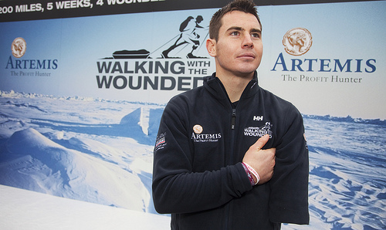
On March 11 2015 Jaco van Gass gave an inspirational lecture which he began by recalling the events of August 20th 2009. As a member of the British Armed Forces Parachute Regiment in Afghanistan he was directly hit by a Rocket Propelled Grenade and severely wounded. He spoke movingly of returning to consciousness in a ditch and trying to lift his rifle to the firing position two times before realising he had lost his left arm below the elbow. He applied an emergency tourniquet and awoke from a medically induced coma to find himself in hospital with a collapsed left lung, shrapnel wounds to his left side, punctured internal organs, blast wounds to the upper thigh, a broken tibia and a fractured knee.
Jaco spoke of the world being a very grey place at this time as he struggled to come to terms with his injuries and began to think about what he would do with his life. He set himself small goals and by succeeding at these he gradually set himself larger challenges. In 2011 he took part in Walking with the Wounded North Pole Challenge as part of a team of eight which included three other wounded servicemen. They successfully trekked unsupported to the North Pole and in the process they broke several world records. Jaco explained how the team had to rely on each other as the range of disabilities meant they all had areas in which they needed assistance.
In 2012 Jaco attempted to climb Mount Everest as part of a team of nine wounded servicemen including Martin Hewitt from the North Pole Challenge. Despite trying to reach the summit the attempt was eventually halted by the high threat of avalanche caused by the warmest ever temperatures being recorded on Mount Everest.
Jaco has gone on to be selected for the British Cycling Paralympic Academy and won double gold in the Time Trial and Circuit Race at the Invictus Games.

EDI SURVEY

The annual EDI survey of students was held from Monday, 2 February to Friday, 13 February 2015. The data collected in the survey will be analysed and provide information on how well the College performs in achieving a culture where all students are treated equally, diversity is celebrated and everybody is included.
WOMEN’S HISTORY MONTH
There is currently a display in the D1 corridor celebrating women artists. The artists range from Lavinia Fontana (1552-1614), the first woman to paint numerous large altarpieces and nudes with over one hundred surviving works to Adrian Piper, a contemporary American conceptual artist and philosopher professor, whose work addresses ostracism, otherness and racist thought.
MALALA YOUSAFZAI DISPLAY
Malala Yousafzai became the youngest Nobel Peace Prize winner in 2014 at 17 years old. There is a display in the D5 foyer celebrating her life and achievements as a global advocate for millions of girls denied a formal education due to social, economic, legal or political factors. Malala’s advocacy has grown into an international movement and the Malala Fund has helped girls under threat of the Taliban in Pakistan, Syrian refugees in Lebanon and Jordan, girls affected by the Ebola crisis in Sierra Leone, girls kidnapped or under threat of Boko Haram in Nigeria and girls from rural areas and the slums in Kenya.
AMNESTY INTERNATIONAL YOUTH GROUP
The Henley College Amnesty International Youth Group meets every Thursday lunchtime from 11.55 am to 12.55 pm in D132 and welcomes everyone.
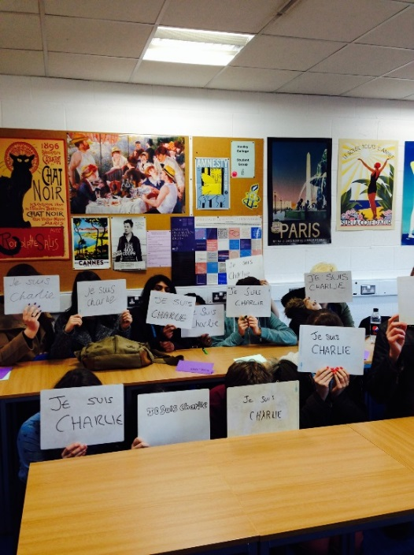
During the Spring Term the group has written letters about human rights issues to the governments of Cuba and China, devised a Twitter photo action following the Charlie Hebdo attack in Paris and raised money in the Give It Up for Amnesty campaign.
Alice Horncastle has been shortlisted in the Amnesty Youth Reporter Awards section for her article on Female Genital Mutilation.
The group has also run a creative action for the campaign to urge the USA to ratify the Convention on the Rights of the Child. The campaign included running a stall with a petition, creating a giant fairy tale book about the Convention to be submitted to the US Embassy in London and making a video of the book which was sent to Amnesty International UK head office.
CHRISTIAN UNION GROUP
Every Thursday the Christian Union meets in D130 from 12.05 pm to 12.40 pm for discussions led by students and staff on topical, ethical issues with a Christian perspective or for bible studies. Students of all faith, or none, are always welcome to attend.
The group have invited all students to participate in a number of discussions such as ethical consumerism, whether there is common ground between world religions and if religion and politics mix. In other meetings the group has focused on a variety of Bible passages and discussed their relevance to life in 2015.
INTERNATIONAL RELATIONS DISCUSSION GROUP
The International Relations discussion Group (IRDG) has continued to meet regularly on Friday from 12.15 pm to 12.45 pm in the Deanfield Meetings Room.
In the Spring Term the group have reviewed the impact of the Charlie Hebdo killings in Paris, the economic and political positions in Greece and Spain and the on-going problems relating to Ukraine and Russia. They have also studied the key issues in one of Africa's largest and richest countries, Nigeria and continued to review events in the Middle East, with discussions on Saudi Arabia, Assad's views on Syria, the threat of ISIL and the recent election in Israel.

Further topics include the political and social developments of Nicaragua and other trends in Latin America and there was an interesting session on the meaning and evaluation of multiculturalism.
These meetings are open to everyone and feel welcome to take your lunch.
LESBIAN, GAY, BISEXUAL AND TRANSGENDER GROUP
The Lesbian, Gay, Bisexual and Transgender Group (LGBT) meets regularly on Tuesday from 12.10pm to 12.45 pm in D106. The group has been working on Tutorial materials which will be piloted in the summer term. The resource comprises a number of statements in order to generate debate and to challenge misconceptions and prejudices.
The group has also been discussing the positive and negative impact of the portrayal of sexual identity in the media (Film and Television). In the summer term there will be a focus on Newspaper coverage of LGBT related articles and events.

EDI ACTION PLAN FOR THE PERIOD
1st JANUARY 2015 to 10th APRIL 2015

ACTION | By Whom | By When | STATUS
EDI Calendar  Publish EDI Calendar on a monthly basis | Library | Monthly | Incremental
D1 Corridor Display  Display marking LGBT History Month of the place of LGBT artists within the music industry from the 1980’s to the present day. | Library | February 2015 | Completed
LGBT Group  Regular meetings of the LGBT Group | BRIC | Incremental | Incremental
International Relations Discussion Group  Regular weekly meetings of the International Discussion Group | JPAN | Incremental | Incremental
Christian Union  Regular weekly meetings of the Christian Union Group | AREI | Incremental | Incremental
Amnesty International  Regular weekly meetings of the College Amnesty International Group | SBIN | Incremental | Incremental
EDI Student Survey  The annual EDI survey of students from 2 to 13 February 2015 | BRIC/SDEA | February 2015 | Completed
EDI Steering Group Meeting  Meeting of EDI Steering Group. | EDI Steering Group | 4 March 2015 | Completed
Student Ambassadors  Identify representative groups for action in the summer term. | EDI Steering Group | Summer Term | Ongoing

EDI Leaflet: March 2015
Beryl Richardson/Sue Deaville

