**The HENLEY College**

**EQUALITY, DIVERSITY & INCLUSION (EDI) INFORMATION LEAFLET**

**ACADEMIC YEAR 2015-2016 AUTUMN TERM ISSUE**

**PROTECTED CHARACTERISTICS**

The Henley College is committed to providing an environment in which people feel comfortable, supported and positive about themselves. We celebrate diversity and are passionate about embedding a culture where all students and staff are treated equally, diversity is celebrated and everybody is included.

The Equality Act became law in 2010 and replaced previous legislation (such as the Race Relations Act 1976 and the Disability Discrimination Act 1995). Under the Act, it is unlawful to discriminate against people because of nine areas termed in the legislation as protected characteristics:

**AGE**

Where this is referred to, it refers to a person belonging to a particular age (e.g. 45 year olds) or range of ages (e.g. 18 - 30 year olds).

**DISABILITY**

A person has a disability if s/he has a physical or mental impairment which has a substantial and long-term adverse effect on that person's ability to carry out normal day-to-day activities.

**GENDER REASSIGNMENT**

The process of transitioning from one gender to another.

**MARRIAGE AND CIVIL PARTNERSHIP**

Marriage is defined as a 'union between a man and a woman'. Same-sex couples can have their relationships legally recognised as 'civil partnerships'. Civil partners must be treated the same as married couples on a wide range of legal matters.

**PREGNANCY AND MATERNITY**

Pregnancy is the condition of being pregnant or expecting a baby. Maternity refers to the period after the birth, and is linked to maternity leave in the employment context. In the non-work context, protection against maternity discrimination is for 26 weeks after giving birth, and this includes treating a woman less favourably because she is breastfeeding.

**RACE**

Refers to the protected characteristic of Race. It refers to a group of people defined by their race, colour, and nationality (including citizenship) ethnic or national origins.

**RELIGION AND BELIEF**

Religion has the meaning usually given to it but belief includes religious and philosophical beliefs including lack of belief (e.g. Atheism). Generally, a belief should affect your life choices or the way you live for it to be included in the definition.

**SEX**

A man or a woman.

**SEXUAL ORIENTATION**

Whether a person's sexual attraction is towards their own sex, the opposite sex or to both sexes.

**EUROPEAN DAY OF LANGUAGES**

On 24 September the College celebrated the European Day of Languages with games, quizzes and nibbles. The Modern Foreign Languages team organised the lunch time gathering to bring together bilingual staff and students and those with a home language other than English.

**EDI OCTOBER EVENT TO WELCOME STUDENTS**

The annual Equality, Diversity and Inclusion (EDI) Event was held on 14 October 2015 with a theme of Africa as October is Black History Month.

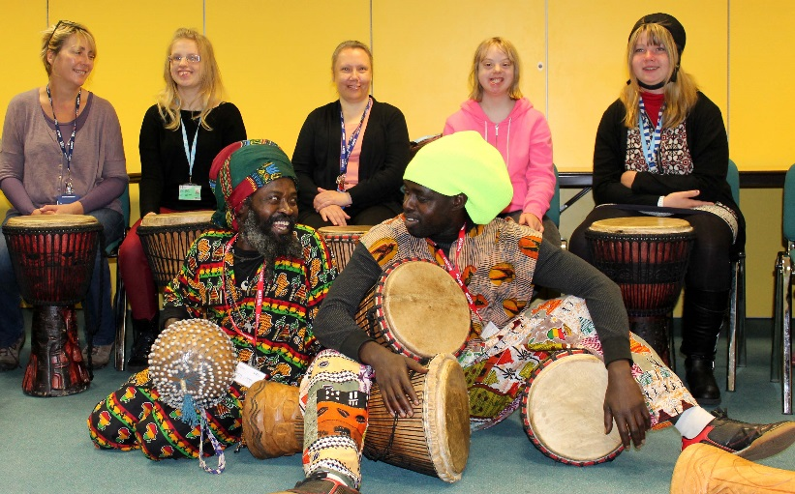The day started with students from Pathways having a drumming workshop led by Kwame Bakoji-Hume and a dancing workshop led by Palie Seck of African Activities. This was great fun and Mark Turauskis, Music Teacher, said that ‘smiles filled the room’. One of the students said ‘It was quite fun doing the dancing and I quite enjoyed the drumming.’

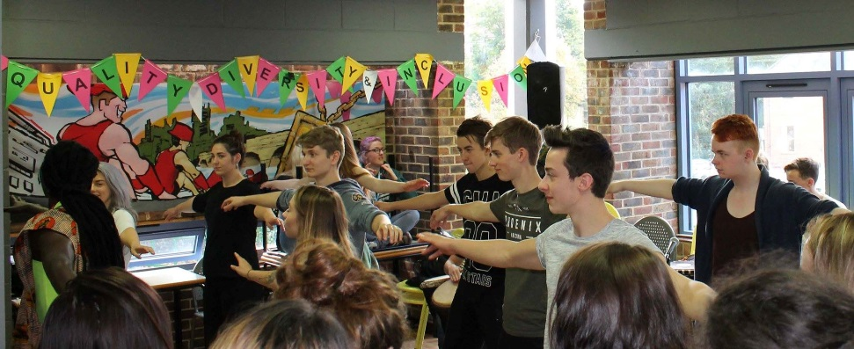Drumming and Dance workshops followed with music and dance students. The Performing Arts students, together with the African Activities practitioners, produced fantastic drumming and dancing displays. Students Liv Foster-Browne and Caleb Obediah performed thought provoking poems and the choir gave rousing renditions of ‘Azikatale’, a traditional South African song, and Wimmoweh.

The stands included Pathways selling cakes the students had made, autumn flowers in terracotta pots, Henley College Training showcasing the apprenticeships on offer at the College and students from Bridge hosting a raffle which was won by Pauline Winfield.

The College catering team, Chartwells, provided complimentary Moroccan couscous and South African spiced biscuits. There were also African dishes of Bobotie and spicy sweet potato and squash stew served with yellow rice on the main menu.

The ‘Find the Word Competition’ was won by Lalina Shallow for correctly finding the letters to spell ‘EDUCATION’.

The Students’ Union ran a photo booth with African themed props and Shannon Kelly hosted a stall to raise awareness of Mind by asking students to sign pledges in support of those suffering from mental illness.

Two representatives from Promoting Equality in African Schools (PEAS) attended the event and staff and students were asked to ‘Guess the Weight of the Peas’. The closest guess was from Mayah Bentley-Holder.

The Henley College Amnesty International Youth Group students persuaded staff and students to sign letters to the President of Burkina Faso, urging him to improve women's and girls' access to sexual and reproductive health services and information. In Burkina Faso women and girls are discriminated against and often prevented from making decisions about their bodies.

**BLACK HISTORY MONTH**

In October there was display in the D1 corridor put together by library staff celebrating the life and work of Maya Angelou as an author, singer, poet, civil rights activist, journalist and professor.

**WELLBEING WEEK**

Wellbeing Week 2015 in October was marked in College ‘Risky Behaviour Workshops’ for all students and a taster meditation session with Buddhist nun Gen Kelsang Wangmo.

**SARA ALMEIDA LECTURE**

In November Sara Almeida gave a lecture about life as a volunteer in the Moria Refugee Camp on the Greek island of Lesbos. Sara spoke movingly about the practicalities of dealing with up to 7,000 refugees a day.

**AMNESTY INTERNATIONAL YOUTH GROUP**

The Amnesty International Youth Group (AIYG) meets every Thursday lunchtime from 11.55 am to 12.55 pm in D132 and welcomes everyone.

In September 2015 the AIYG made solidarity keys in support of Amnesty El Salvador where there is a total ban on abortion which also means that women who miscarry or have stillbirths can be charged with murder if accused of abortion, and end up imprisoned for decades. Amnesty is creating a sculpture with solidarity messages written on keys and will share pictures of the sculpture decked with the solidarity keys with the women in prison so that they know they are not alone.

The sculpture will be delivered to the Minister of Justice and Public Service in El Salvador to urge him to free all women who have been imprisoned after suffering complications with their pregnancies.

The AIYG have also supported action for women in Burkina Faso at the EDI Event, organised an urgent action petition for a Cuban graffiti artist prisoner of conscience, Danilo Maldonado, and made greetings cards for prisoner Albert Woodfox who has been in solitary confinement for over 40 years in the US. One female member of the AIYG has received event and conference experience to enable her to lead campaigns and talk to students and staff about Amnesty initiatives.

**CHRISTIAN UNION GROUP**

Every Thursday the Christian Union meets in D130 from 12.00 pm to 12.45 pm for discussions led by students and staff on topical, ethical issues with a Christian perspective or for bible studies.

**INTERNATIONAL RELATIONS DISCUSSION GROUP**

The International Relations Discussion Group (IRDG) has continued to meet regularly on Friday from 12.10 pm to 12.45 pm in the Deanfield Meetings Room. The discussions have been led by staff and students and have sought to extend and deepen knowledge and understanding of recent and current developments in different parts of the world and engage in discussions on key issues associated with these events.

The topics discussed include the future of Ukraine, elections in Burma, economic crises in Greece, terrorism in Nigeria, attitudes towards Saudi Arabia, threats from Daesh in the Middle East and Europe and future prospects in Argentina. On two occasions, students have led these sessions, with Hannah Meakes discussing her experience in China and Adrian Rodriguez-Sobstel providing a presentation on the recent elections in Poland.

The session will resume next term and new students are very welcome to attend in order to broaden their knowledge of international affairs and improve their skills in public speaking. Please feel welcome to bring your lunch.

**LESBIAN, GAY, BISEXUAL AND TRANSGENDER GROUP**

The Lesbian, Gay, Bisexual and Transgender Group (LGBT) meets regularly on Tuesday from 12.10pm to 12.45 pm in D108. The group has focused on transgender this term and the preparation of materials for the EDI Event held in October and tutorials. One male student has been trained as a Student Ambassadors through Stonewall and three more students are going to be trained. The College group is also making contact with ‘Support U’ which is a charitable organisation that provides a support service that specifically focuses on the inclusion of LGBT people.

**COLLEGE PHILOSOPHY DISCUSSION GROUP**

The College Philosophy Discussion Group meets Tuesdays at 12 pm in the Deanfield Meetings Room. This group is chaired by students and discusses a wide range of topical issues. Please contact Shaz Ney for further information. All students are welcome.

**EDI ACTION PLAN FOR THE PERIOD**

**10 SEPTEMBER to 31 DECEMBER 2015**

|  |  |  |  |
| --- | --- | --- | --- |
| **ACTION** | **By Whom** | **By When** | **STATUS** |
| **EDI Calendar**  Publish EDI Calendar on a monthly basis | Library | Monthly | Incremental |
| **Faith and Belief Wall Chart**  Publish Faith and Belief Wall Chart on an annual basis | Library | Annual | Incremental |
| **College EDI Poster**  To be redesigned and displayed in all classrooms | RVIT/FIBO  /KBOW | December 2015 | Ongoing |
| **D1 Corridor Display**  Display marking Black History Month celebrating the work of Maya Angelou. | Library | October 2015 | Completed |
| **D5 Foyer Display**  Display celebrating the life and achievements of Malala Yousafzai, the youngest Nobel Peace Prize winner at 17 year old. | Library | March 2015 | Completed |
| **LGBT Group**  Regular meetings of the LGBT Group | BRIC | Incremental | Incremental |
| **International Relations Discussion Group**  Regular weekly meetings of the International Discussion Group | JPAN | Incremental | Incremental |
| **Christian Union**  Regular weekly meetings of the Christian Union Group | AREI | Incremental | Incremental |
| **Amnesty International**  Regular weekly meetings of the College Amnesty International Group | SBIN | Incremental | Incremental |
| **EDI Steering Group Meeting**  Meeting of EDI Steering Group | EDI Steering Group | 11 November 2015 | Completed |
| **Student Ambassadors**  One male LGBT Group member completed training through Stonewall. Three more students waiting to complete the training.  One female student has received event and conference experience with Amnesty International | EDI Steering Group/ BRIC/SBIN | Incremental | Ongoing |
| **Faith and Belief Ambassadors**  AREI has contacted Colin Whitehead at Redbridge regarding Faith and Belief Ambassadors | AREI | Incremental | Ongoing |
| **EDI October Event**  Annual EDI Event to be held | October Event Focus Group | 14 October 2015 | Completed |

EDI Leaflet: December 2015

Sue Deaville