The HENLEY College
EQUALITY, DIVERSITY & INCLUSION (EDI) INFORMATION LEAFLET
ACADEMIC YEAR 2014-2015 AUTUMN TERM ISSUE

EDI OCTOBER EVENT TO WELCOME STUDENTS

The first EDI event of the new academic year was held on 1 October to showcase the various groups and activities available at the College. Over £100 was raised and this was split between Breast Cancer Care and Pathways.

Students studying Drama at the College impressed performing thought provoking monologues with EDI related themes throughout the event and Steve Morano provided fantastic live music.
There were numerous stalls with displays and information including the Amnesty International Youth Group, Enrichment, the International Relations Discussion Group, Henley College Training, the Lesbian, Gay, Bisexual and Transgender Group, Pathways, the Library and Sport. There was also a display about breast cancer with information leaflets, cards, balloons and badges as October is National Breast Cancer Awareness month.
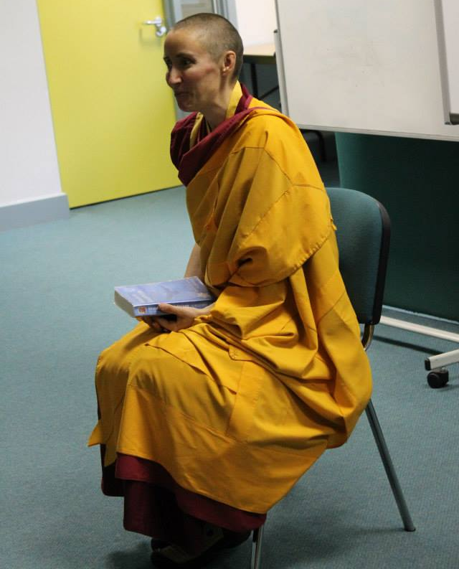
Gen Kelsang Wangmo, the resident teacher nun from Shantideva Kadampa Buddhist Centre in Reading, gave a well-attended, informative talk followed by an introductory meditation session which students and staff found calming and relaxing.
Students from Pathways held a raffle, sold chocolates and cakes they had made and hanging baskets and potted plants they had planted prior to the event. Chartwells provided samples of world food including Danish pastries, houmous, onion bhajis, olives and pitta bread.
The Amnesty International Youth Group took the opportunity to take photographs in support of women’s rights in Afghanistan.
Beryl Richardson, the Manager responsible for Equality and Diversity, said: 'The event today is an opportunity for the students and staff to celebrate difference and to embrace the diverse culture of the College. At Henley we offer a wide range of activities in support of an inclusive community and students are actively encouraged to get involved and participate.'
BLACK HISTORY MONTH
In October there was display in the D1 corridor put together by library staff and a student from Pathways. The display commemorated the role of black/mixed race personnel in the First World War including William Robinson Clarke, the first black pilot to fly for Britain, Walter Tull, the first black/mixed race combat officer in the British Army and Ben Aissa, a Moroccan, who was a non-commissioned officer in the German First Guard Foot Regiment.
AMNESTY INTERNATIONAL YOUTH GROUP
The Amnesty International Youth Group meets every Thursday lunchtime from 11.55 am to 12.55 pm in D132 and welcomes everyone.
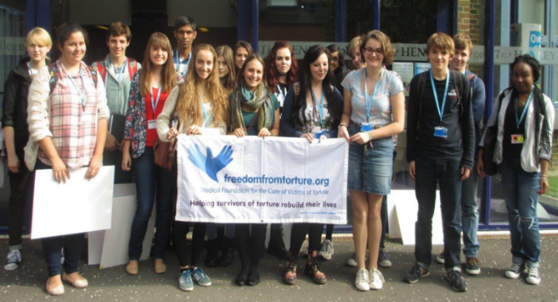
At the start of the academic year Amy Porter, an ex-student, gave a fascinating and moving talk about her work as a Regional Fundraiser with Freedom from Torture.
This talk was an excellent introduction to the current Amnesty ‘Stop Torture’ campaign.
On December 11th a Write for Rights Stall was held in the Deanfield Reception to give students and staff the opportunity to sign cards for 6 people around the world suffering human rights abuses in order to let the individuals know they are not alone.
CHRISTIAN UNION GROUP
Every Thursday the Christian Union meets in D130 from 12.05 pm to 12.40 pm for discussions led by students and staff on topical, ethical issues with a Christian perspective or for bible studies.
On December 11th a discussion was hosted by the Christian Union to debate if Christmas is still a religious festival.
INTERNATIONAL RELATIONS DISCUSSION GROUP
The International Relations discussion Group (IRDG) has continued to meet regularly on Friday from 12.15 pm to 12.45 pm in the Deanfield Meetings Room. Mo Corcoran has been publicising the weekly meeting and there is a regular body of students who attend. The discussions have been led by staff and students and the topics include the future of the European Union, the problems in Southern Europe, the threat posed by the Islamic State in Iraq and the Levant (ISIL) in the Middle East, the Ebola epidemic in West Africa, the challenges facing Japan and the race conflicts in the United States of America.
These meetings are open to everyone and feel welcome to take your lunch.
LESBIAN, GAY, BISEXUAL AND TRANSGENDER GROUP
The Lesbian, Gay, Bisexual and Transgender Group (LGBT) meets regularly on Tuesday from 12.10pm to 12.45 pm in D108. The group has been working on Tutorial materials which will be piloted in the spring term. The resource comprises a number of statements in order to generate debate and to challenge misconceptions and prejudices.

MINDFULNESS LECTURE
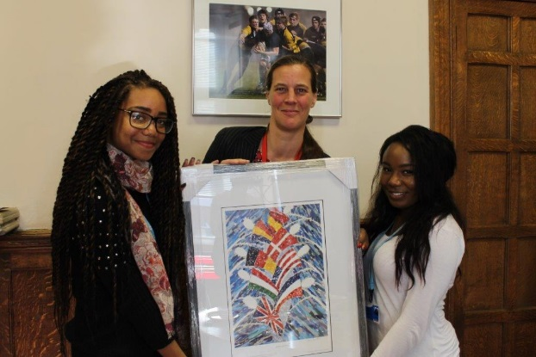
Dr Tamara Russell, the Director of the Mindfulness Centre of Excellence, London and Visiting Lecturer at King’s College London, gave a really interesting lecture titled ‘Mental Wealth through Mindfulness’ on 19 November in the Rotherfield Hall.

The lecture was an informative and thought provoking look at modern society and the challenges we face as members of a fast paced, rapidly evolving world.
PATHWAYS ANNUAL CHRISTMAS FAIR
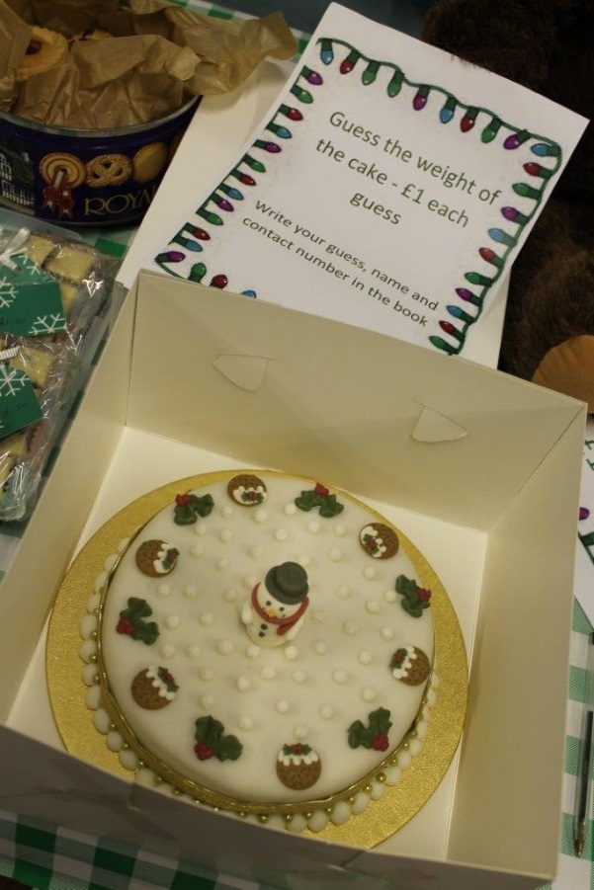
Pathways held their very successful annual Christmas Fair on 4th December in the Henley Youth Centre. Students were busy in the lead up to this event making lemon curd, pickled onions, gingerbread mix and mincemeat for the preserves stall together with muffins, mince pies and festive cakes including Rudolph the Reindeer cupcakes for the cake stall. They also made Christmas cards and potted up bulbs for sale.
A magnificent Christmas cake was made by Sue Wiseman which was won by Joy Stallwood who guessed the weight.
There were some wonderful raffle prizes including a cake from Pattiserie Valerie, various toiletries and a box of fruit.
Over £370 was raised by the event for equipment needed in Pathways.

EDI ACTION PLAN FOR THE PERIOD
8th SEPTEMBER 2014 to 31st DECEMBER 2014

ACTION | By Whom | By When | STATUS
EDI Calendar  Publish EDI Calendar on a monthly basis | Library | Monthly | Incremental
Black History Month  October: A display in the glass cabinet in D1 marking the role of black and black/mixed heritage personnel in World War 1 | Library | October 2014 | Completed
EDI October Event  Held at Deanfield in aid of Breast Cancer Care and Pathways | October Event Focus Group | 1 October 2014 | Completed
Leaders in Diversity Survey  Survey for Leaders in Diversity | BRIC | 6 October to 20 October 2014 | Completed
LGBT Group  Regular meetings of the LGBT Group | BRIC | Incremental | Incremental
International Relations Discussion Group  Regular weekly meetings of the International Discussion Group | JPAN | Incremental | Incremental
Christian Union  Regular weekly meetings of the Christian Union Group | AREI | Incremental | Incremental
Amnesty International  Regular weekly meetings of the College Amnesty International Group | SBIN | Incremental | Incremental
Leaders in Diversity Assessment  Joyce Dargie in College for Leaders in Diversity assessment | BRIC | 12 November 2014 | Completed
EDI Steering Group Meeting  Meeting of EDI Steering Group. Joyce Dargie in attendance. | EDI Steering Group | 12 November 2014 | Completed
Interfaith Community Links  Initial Meeting with Revd Martin Gorick, Archdeacon of Oxford held. Waiting information on Faith Ambassadors from Revd Martin Gorick | BRIC/JLOV /SDEA | 31 December 2014 | Ongoing

EDI Leaflet: December 2014
Beryl Richardson/Sue Deaville

