The HENLEY College
EQUALITY, DIVERSITY & INCLUSION (EDI) INFORMATION LEAFLET
ACADEMIC YEAR 2013-2014 SUMMER TERM ISSUE

EDI SUMMER EVENT

On Wednesday 21 May, World Day for Cultural Diversity, the College held an EDI Summer Event in the Deanfield canteen. May is Mental Health Awareness Month and the £50 proceeds from the event were split between Mind and Pathways.

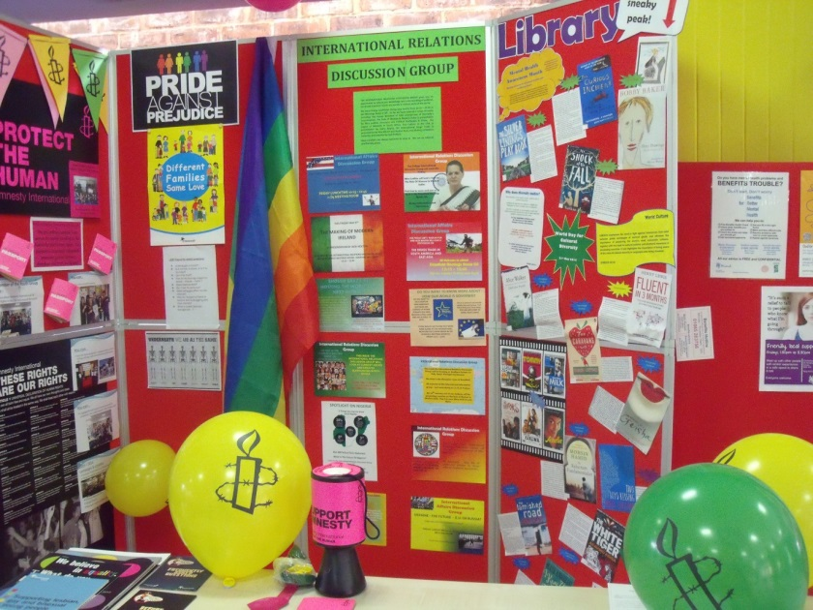
There were displays from Amnesty International, the International Relations Discussion Group, the Lesbian, Gay, Bisexual and Transgender Group and the Library.

There were also information leaflets including a recipe for stress free exams and a guide to improve listening comprehension for people with English as a second language.

The Pathways students baked cakes, made lollipops, multi coloured chocolates and held a raffle. The activities the students have undertaken in the last year were shown via displays and a screen based presentation.

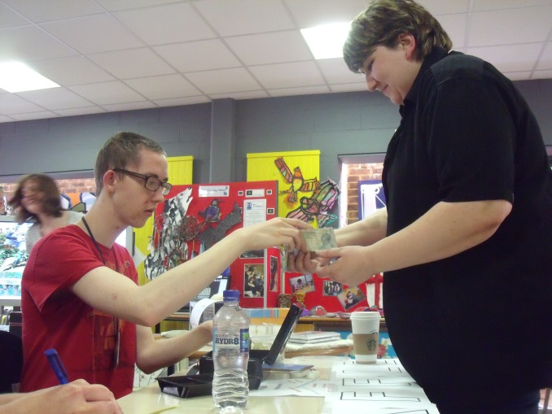
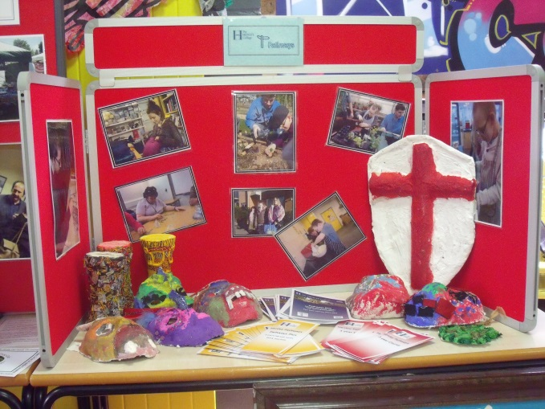

A representative from Mind attended the event and held a Well Being session which was most informative and very well received.

The Headway and Henley Concert took place during the afternoon and there was a drop in dance session. World food was available through-out the event.

Steve Morano provided highly enjoyable live music for the event.

Beryl Richardson the College’s EDI Manager stated that ‘The event clearly demonstrates the diverse culture of the College and celebrates difference. This was the first EDI Event of its kind and has proven to be a really good platform for the future.’

A member of the College’s EDI Steering Group said that ‘The EDI Summer Event is a wonderful opportunity for the wide-ranging groups with the College to come together and celebrate. It is a reinforcement of the inclusive and caring philosophy which is at the heart of the College.’

EDI STUDENT SURVEY

In February 2014 there was an anonymous survey of the understanding, experience and views of students regarding Equality, Diversity and Inclusion at the Henley College. The results of this survey have been analysed and a report presented to the Governors. Any recommendations arising from the survey will be discussed with the College EDI Steering Group and implemented as appropriate.

BUDDHISM DISPLAY

In May and June there is a display in the D1 corridor marking the birth of Buddha (enlightened one). The display gives an overview of Buddhist beliefs and the path to enlightenment.

AMNESTY GLOBAL STOP TORTURE CAMPAIGN

On Thursday June 26th, International Day in Support of Victims of Torture, there will be a stall in the Deanfield Reception on behalf of the global Stop Torture campaign from 12 noon until 1 pm.

EDI ACTION PLAN FOR THE PERIOD
22nd APRIL to 11th JULY 2014

ACTION | By Whom | By When | STATUS
Buddhism Display  May: A display in the glass cabinet in D1 to mark Buddha’s birthday in May about 2600 years ago | Library | May 2014 | Completed
Student EDI Survey Analysis.  Analyse the data from the Student EDI Survey carried out in February 2014 | BRIC/SDEA | 12 May 2014 | Completed
EDI Summer Event  To be held at Deanfield in aid of MIND and Pathways | Summer Event Focus Group | 21 May 2014 | Completed
LGBT Group  Regular meetings of the LGBT Group | BRIC | Incremental | Incremental
International Relations Discussion Group  Regular weekly meetings of the International Discussion Group | JPAN | Incremental | Incremental
EDI Steering Group Meeting  To meet with the EDI Steering Group to review the EDI Summer Event and make plans for 2014-15 | BRIC/SDEA | 18 June 2014
Amnesty Stall  A stall in the Deanfield Reception on behalf of the global Stop Torture campaign | SBIN/Students | 26 June 2014  12 – 1 pm
Interfaith Community Links  Establish links with local faith groups. Meet with Revd Martin Gorrick, Archdeacon of Oxford | BRIC/JLOV /SDEA | 7 July 2014

EDI Leaflet: June 2014
Beryl Richardson

