The HENLEY College
EQUALITY, DIVERSITY & INCLUSION (EDI)
For the Academic Year 2012-2013

INFORMATION LEAFLET for Students, Staff, Governors & Visitors
from Beryl Richardson the College EDI Manager.

Explanation of the key terms:
EQUALITY: Where every individual has equal rights and a fair chance. There is recognition that different people have different starting points.
DIVERSITY: Diverse means different. It means understanding that each individual is unique, and recognising our individual differences.
INCLUSION: Where everyone feels respected and valued and included in the College culture.
EQUALITY ACT 2010: A relatively new act that covers issues around equality and diversity. The law established 9 characteristics that receive legal protection from discrimination. These are: age, disability, gender reassignment, marriage and civil partnership, pregnancy and maternity, race, religion and belief, sex and sexual orientation.

INVESTORS IN DIVERSITY (IiD): is a standard endorsed by the National Centre for Diversity (NCFD) which helps organisations to create, develop and embed a culture of equality, diversity and inclusion. Working towards these standards demonstrates the College’s commitment to the continued development of effective behaviours and practices to ensure an inclusive and accessible college for all students and staff. The College was awarded the Investors in Diversity standard at Stage One in April 2011.

Love Music Hate Racism Mural
On 24 February 2012 the Henley College Student Union held a successful ‘Love Music, Hate Racism’ event. A mural made up logos, posters and slogans was made by students prior to the event and is now held by the Student Union executive in readiness for the next event.

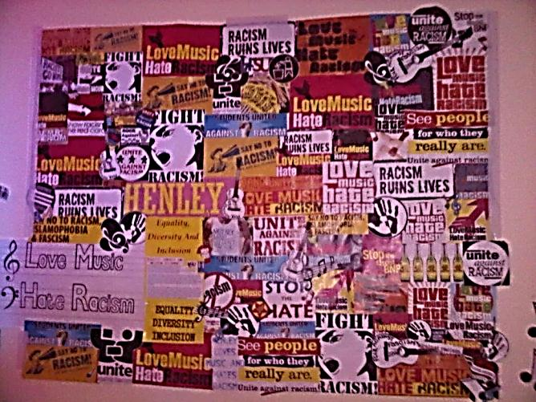

EDI Events 2012-2013
New Equality, Diversity and Inclusion Manager from September 2012:
Beryl Richardson the Director of HR & Professional Development.
Opening of the new Sports Hall: Paralympian and former student, Scott Moorhouse, opened the new facility on 27 September 2012
Students and EDI events: B Richardson to meet with the Student Union & Student EDI Focus Group to build on the successful ‘Love Music Hate Racism’ event which took place last academic year.
Student EDI Focus Group: B Richardson to meet with the Focus Group on 22 November 2012: To discuss positive experiences and any issues or concerns
To explore strategies to challenge prejudice, assumptions and pre-conceived ideas. To discuss the feasibility of future sub-group representation
Black History Month (October): Display in D1 that highlighted significant black history examples.
EDI Staff Group: Met on 3 October 2012 to discuss and agree the EDI Events for 2012-2013 including themed meals on sale at the Canteen created and promoted by Caterlink throughout the year.
What you can find on the Henley College EDI Website:
√ The College Single Equality Scheme √ EDI Statement √ EDI Report & Action Plan √ Multi Faith Calendar √ Forthcoming events and more
‘Enable’ magazine and ‘Right 2 Work’ publication: A College advertisement has been placed in these publications. These Magazines promote a positive message about all aspects of disability. Please click to view the November/December 2012 issue of Enable with our advertisement (page 56).
EDI Report for Governors Strategy, Students and Curriculum Committee meeting 22 November 2012: The Report is published on the College Website after the Governors meeting.
Access: The College has been making adjustments to promote greater access to the buildings and facilities. Note the improved access due to the installation of automatic doors during the summer break.
Spring Term KEY EDI Event: An event will be held for 3 consecutive days in the Spring Term. This event will include a keynote lecture from an inspirational Paralympian, alongside College competitions, sports, and photographs.

EDI Leaflet 1: November 2012

