A-Level Physics Transition Activities
Congratulations for choosing one of the most challenging and rewarding courses of study at A-Level! In September, you will be working towards a qualification in science that is both worthwhile in itself and highly respected by employers and universities.
The secret to learning physics is to spend lots of time solving problems and answering questions. While you might have been able to get by in your GCSE’s by reading though your notes and revision guides and just letting the information soak into your brain, for A-Level you’ll have to adopt a much more active learning style. Real learning happens when you spend time reasoning through questions and working stuff out for yourself. There really is a big difference between the strategy that probably got you by in school and the work you will need to do for your A-Levels
The tasks below give you the opportunity practice some of the basic skills that you’ll need to be successful on the course. You’ll need to have worked though these tasks before September. At the end of these tasks there’s a list of (optional) books and websites that you might find useful for developing your general appreciation of physics. If you’re already thinking about studying physics or maths at university then these will equip you with lots of ammunition for your UCAS personal statement and university interviews. In both of these you’ll want to talk about some of the big ideas in physics that have captured your imagination.

Best wishes
Kevin Jones
Physics Teacher
The Henley College
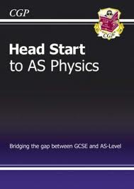
Task 1 – Head Start to AS Physics
Work through ‘Head Start to AS Physics’. ISBN: 978 1 84762 115 3

Available from Amazon quite cheaply.

Task 2 – The Following summary questions are taken from the course text book
They cover Standard Form, trigonometry, rearrangements and converting units. These are key skills in physics, and being proficient in them will mean that you can focus on understanding the other topics
Multiple | Prefix | Symbol
10¹² | tera- | T
10⁹ | giga- | G
10⁶ | mega- | M
10³ | kilo- | k
10⁻³ | milli- | m
10⁻⁶ | micro- | µ
10⁻⁹ | nano- | n

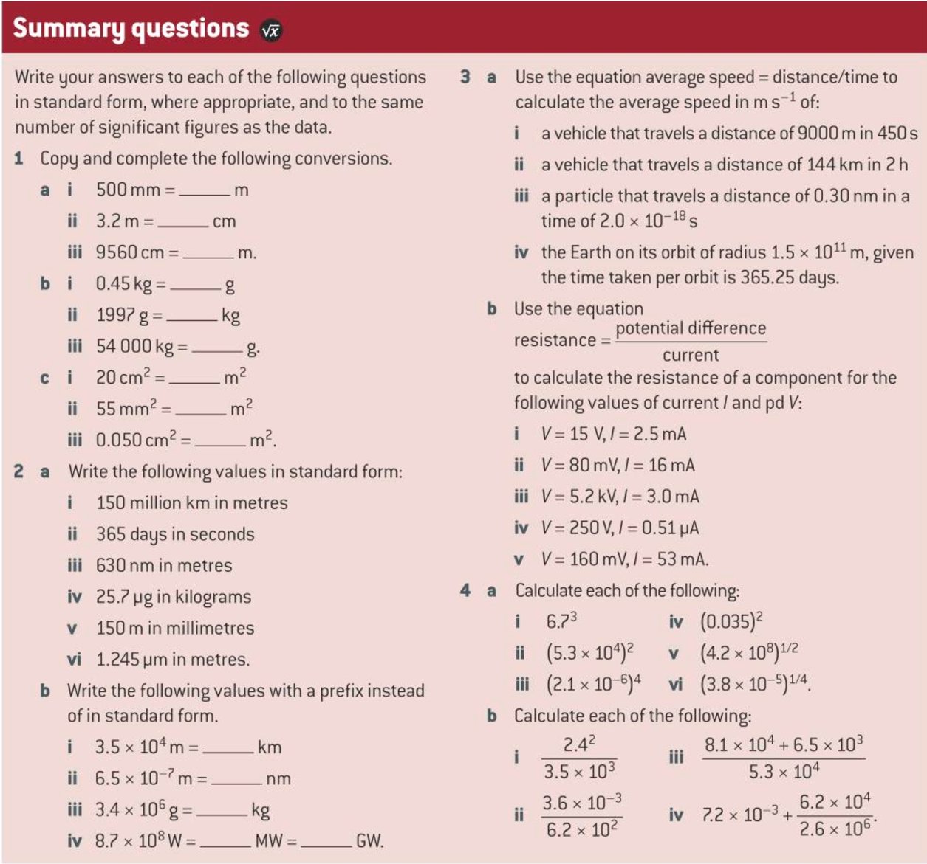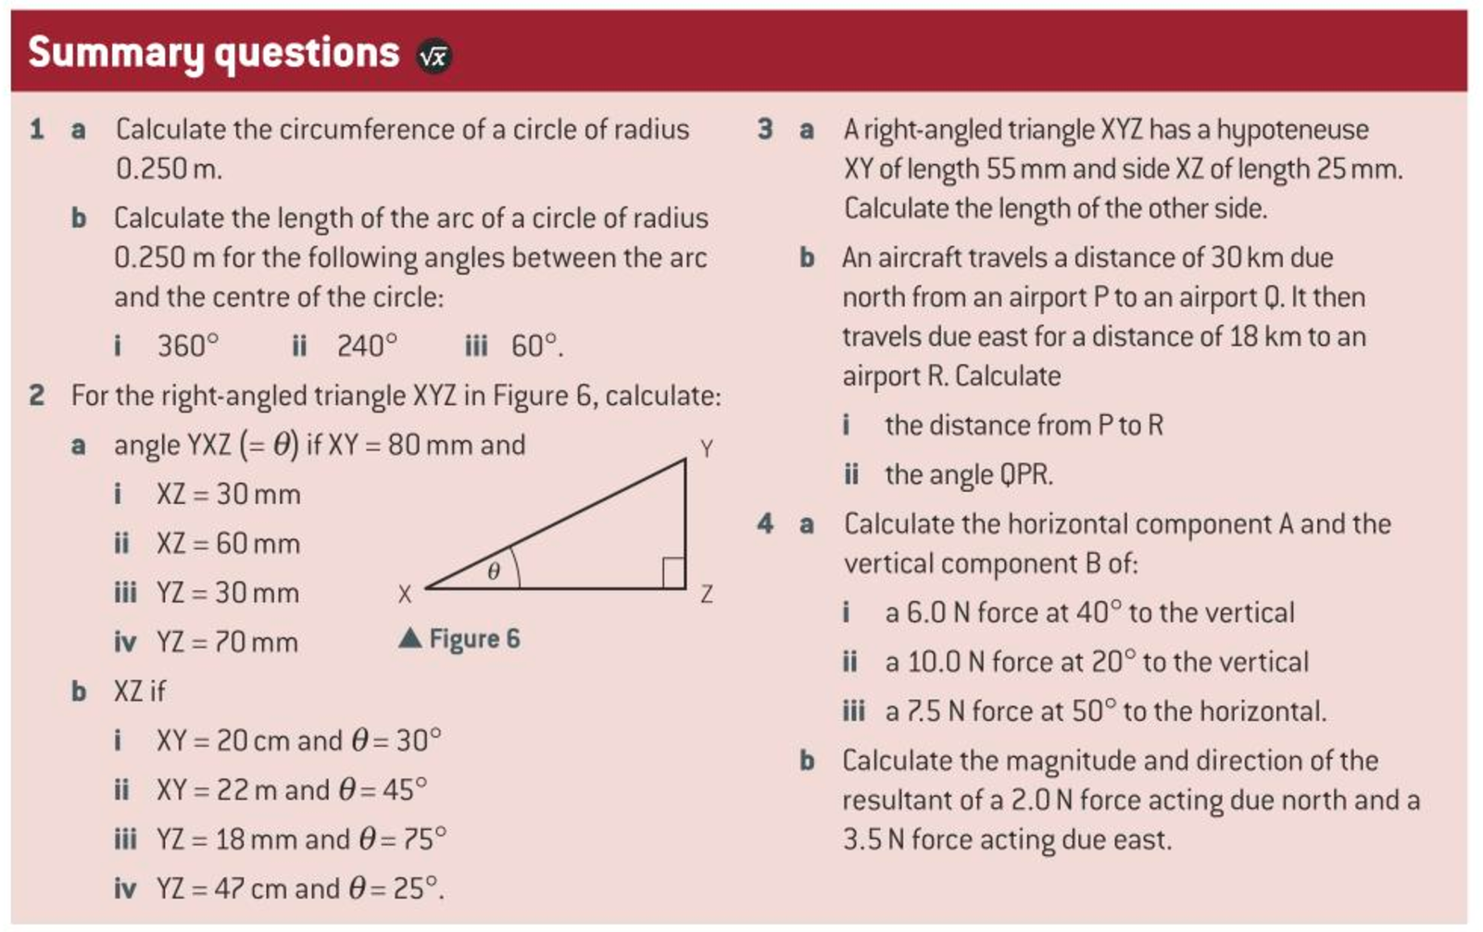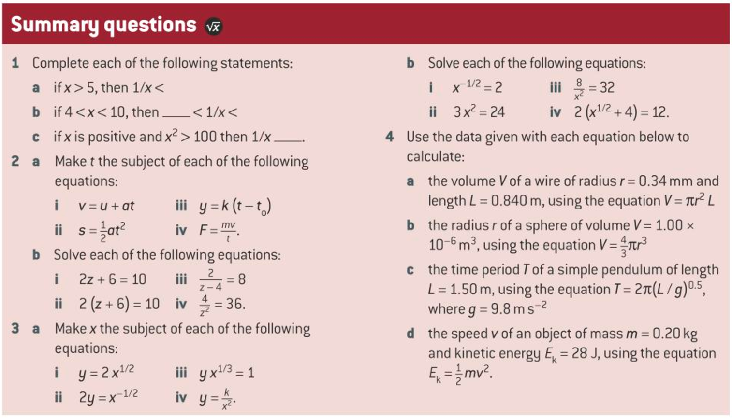

Task 3 – Reading up on some A-Level work
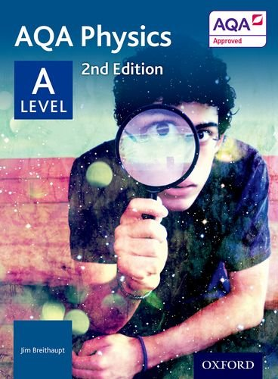
The textbook for the physics course is available on Amazon for about £35. You might be able to find it cheaper second hand somewhere. Other books are available, but this is the one that we’ll be using in class.
In September we’ll be starting with particle physics. You’ll find things much easier if you have gained some familiarity with some of the important new words before we get started. Particle physics will require us to use many words that are not familiar, so the more practice we get the better! You can use the text book, the internet or whatever source of information you choose to answer the following questions.
- Write a sentence describing what is meant by the term fundamental particle…

- Complete the following table(s)
Sub atomic particle | Mass in kg | Charge in Coulombs | Location

- There are two families of fundamental particle. Write down their names…

- Particles such as protons and neutrons are made up of even smaller particles. Write down the names of each of the three particles that are inside a proton.

- Write down the names of the three particles that make up a neutron.

Task 4 – Specific Charge
Background
The specific charge of a charged object is its charge divided by its mass. As the unit of charge is the coulomb (C) and the unit of mass is the kilogram (kg), the unit of specific charge is the coulomb per kilogram (C kg–1).
Every atom contains a positively charged nucleus surrounded by electrons, which are negatively charged. Every nucleus contains protons and neutrons, except the hydrogen-1 nucleus, which is a single proton. Neutrons and protons in a nucleus are called nucleons.

Questions
- Calculate the specific charge of the 3 subatomic particles
- Complete the following table (note ignore the electrons as we are concerned with the nucleus)
Nucleus | No of nucleons (mass number) | Overall mass in kg (mass number x 1.67 x 10⁻²⁷ kg) | Number of Protons (proton number) | Overall Charge (no of protons x 1.60 x 10⁻¹⁹ C) | Specific Charge = (charge / mass)
$${}_{24}^{52}{Cr}$$
$${}_{6}^{12}C$$
$${}_{26}^{56}{Fe}$$
$${}_{3}^{7}{Li}$$

Further Reading
Read any, all or none of these. It’s up to you! You won’t be disadvantaged by not reading these, but if you think you might want to go on to study physics or maths at university then picking up at least one of these at some point would be a good idea. Hawking’s book is probably the most accessible one on the list so you might want to start there. Most of these can be picked up quite cheaply second hand.
Hawking, S. (1998) A Brief History of Time, ISBN: 0553380168 - This is a very good general physics book. The early chapters provide a neat account of our how our understanding of the universe has evolved over history.

Allday, J. (2001) Quarks, Leptons and the Big Bang, ISBN: 0750308060 – This book contains lots of modern physics and should provide you with plenty to think about.

Feynman, R. (1994) The Character of Physical Law, ISBN 0679601279 – The opening chapters provide a good account of why physics is mathematical. Interesting stuff.

Joining the Institute of Physics as a 16-19 student is free. You’ll get a free electronic copy of Physics World magazine each month. You can join by going to:
http://members.iop.org/16-19.asp

