BTEC Level 3 National Extended Certificate Applied Psychology
Transition Activity

Your task is to choose and research one of the following studies:
Asch (1951)- Conformity Line experiment, Effects of group pressure upon the modification and distortion of judgments

Bandura (1961)- Bobo doll study, Transmission of aggression through imitation of aggressive models
Bartlett (1932)- War of ghosts
Loftus and Palmer (1974)- Car crash videos study- Reconstruction of automobile destruction: An example of the interaction between language and memory
Zimbardo (1973)- The Stanford prison experiment (see Netflix)
You can do this through reading the study online or watching a video of the study. 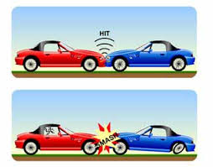

Task details:
Produce a written report 250-300 words (1- 1½ pages) that addresses the following questions:
- What was the aim, hypothesis and the key procedure and findings of the study?
- Look up and define the following key terms: Laboratory experiment, Field experiment, Ethics, Validity and Reliability.
- Can you link any of these terms to your chosen study in your report?
- What positives and negatives can you think of regarding the study and its method?

Some Links
https://www.youtube.com/watch?v=NyDDyT1lDhA - Asch clip
https://www.youtube.com/watch?v=zerCK0lRjp8 - Bandura clip
https://www.youtube.com/watch?v=uJByRr49fqA - War of ghosts clip
https://www.youtube.com/watch?v=-hha1bAtV5c – Loftus and Palmer clip
Stanford prison experiment- see Netflix

