COURSE TITLE PSYCHOLOGY

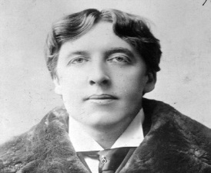
PSYCHOLOGY TRANSITION TASK
How have nonconformists contributed to society?
THINK ABOUT IT!
What makes a person a nonconformist? People considered nonconformists have also been labelled mavericks, rebels, originals, and eccentrics – they are known for going against the grain and being themselves without apology.
Your task is to research one individual who has fought for their beliefs, attempted to change the rules of society, or has simply lived in a way that was considered strange or unique.
You may choose from the list below or choose a different person.
NOTE: Some nonconformists that students have proposed, as an alternative to the list provided, have been Eminem, Jesus, and Bob Marley, among others.
Suggested Nonconformists:
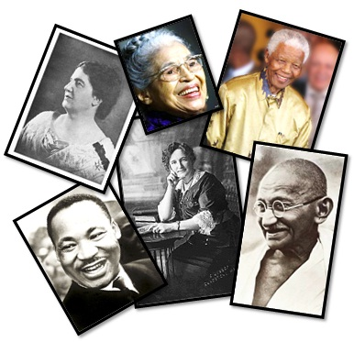
Martin Luther King Jr.
Emily Pankhurst
Rosa Parks
Mahatma Ghandi
Nelson Mandela
Rachel Carson

Produce a hand-written research report (format of your choice) which must address the following questions:

- What brief background information will help describe their context?
- Why did he/she decide to rebel against mainstream society?
- Look up and define these terms snowball effect, zeitgeist and social
Crypto-amnesia
- Can you identify any of the above processes in your chosen area of
research.

The report should be between 250-300 words (approx. 1-1/2 sides of A4 margined paper).

