COURSE TITLE(S) BTEC Extended Certificate in Engineering

Transition Activity

Using the internet, books and other suitable sources research materials for their properties, using this information complete the following tasks:

Suggest a suitable material for the application, giving 3 reasons for your choice based on the physical and mechanical properties of your suggested material.

Suggest a suitable manufacturing process and give a description of the process.

Use diagrams if that makes you explanation clearer

Car Body Panel 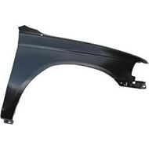

Material:

Reason 1:

Reason 2:

Reason 3:

Manufacturing Process:

