A Level Chemistry

Transition Work

- To prepare you for the first year of A’ level chemistry, ideally you should work through ‘Head Start to AS Chemistry’ by David Mason
ISBN: 978 1 78294 2801
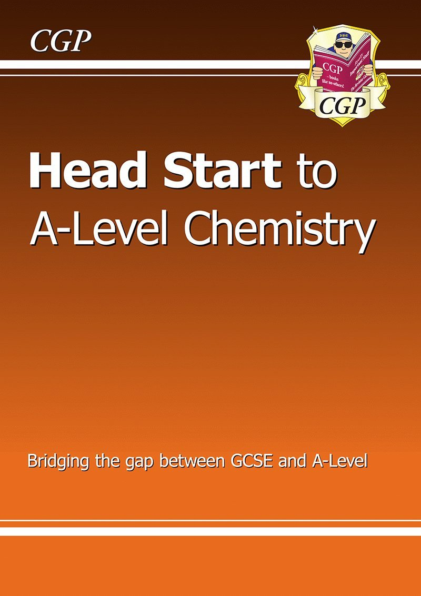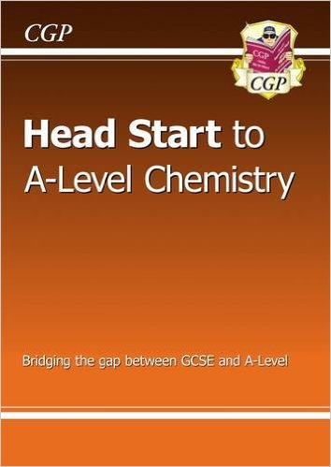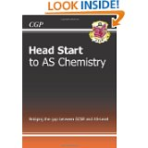

Available from Amazon and other booksellers
for approximately £5.

Read each section then answer questions.
Check and correct answers before moving onto the next section.

- As a minimum (for your first homework) you should answer the following exam style questions. The questions are higher tier GCSE chemistry questions and are relevant to the topics covered at A’ level during the first term. You must bring your answers along to your first chemistry lesson in September.

- The Text book for the course can be ordered through the College when you start in September, If you wish to purchase it before then the details are given below:

Edexcel A’ Level Chemistry 1  By Graham Curtis, Andrew Hunt and Graham Hill  ISBN 978-1-4718-0746-6 | 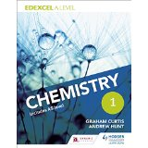

Homework Questions
The following questions would take about 1 hour under test conditions.
However, this is not a test, it is revision!
- Please use your GCSE notes, ‘Head start’ or a GCSE revision guide to help.
- Take however long you need to remind yourself how to tackle these types of question!
- It may therefore take 2-3 hours to do properly.
- Please complete the table below and attempt all questions.

Name | GCSE Grades:
 | Maths | Chemistry OR Science | Physics OR  Additional Science | Biology OR  N/A

Q1.
Chlorine is an element in group 7 of the periodic table.
Chlorine, Cl₂, is a simple molecular, covalent substance.
The atoms in a molecule of chlorine are held together by a covalent bond.
(i) Explain what is meant by the term covalent bond.
(2)
.............................................................................................................................................
.............................................................................................................................................
(ii) Phosphorus reacts with chlorine to form phosphorus trichloride, PCl₃.
A phosphorus atom has five electrons in its outer shell.
A chlorine atom has seven electrons in its outer shell.
Draw the dot and cross diagram to show the bonding in a molecule of phosphorus trichloride, PCl₃.
Show outer electrons only.
(2)
(iii) Aluminium reacts with chlorine to form aluminium chloride, AlCl₃.
Write the balanced equation for this reaction.
(2)
.............................................................................................................................................

(Total for question = 6 marks)

Q2.
An atom of copper has an atomic number of 29 and a mass number of 63.
(i) Complete the table to show the numbers of protons, neutrons and electrons in this atom of copper.
(2)
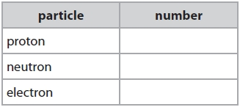
(ii) Copper is in period 4 of the periodic table.
State what information this gives about the number of shells that contain electrons, in a copper atom.
(1)
.............................................................................................................................................
(iii) Copper exists as isotopes.
Explain what is meant by the term isotopes.
(2)
.............................................................................................................................................
.............................................................................................................................................
.............................................................................................................................................
.............................................................................................................................................
(iv) A sample of copper contains
70% of copper-63 atoms and
30% of copper-65 atoms.
Use this information to calculate the relative atomic mass of copper in this sample.
(3)
.............................................................................................................................................
.............................................................................................................................................
.............................................................................................................................................
.............................................................................................................................................
.............................................................................................................................................
.............................................................................................................................................
.............................................................................................................................................
.............................................................................................................................................
relative atomic mass of copper = ...........................................................

Q3.
(a) The table shows the number of electrons, neutrons and protons in particles P, Q, R, S, T and V.
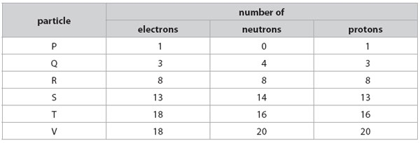
(i) Which particle is a negatively charged ion?
Put a cross ( ) in the box next to your answer.
(1)
A P
B S
C T
D V
(ii) Which particles are atoms of metals?
Put a cross ( ) in the box next to your answer.
(1)
A P and R
B Q and R
C Q and S
D Q, S and V
(b) Each element has an atomic number.
(i) State what is meant by atomic number.
(1)
..............................................................................................................................................
..............................................................................................................................................
(ii) The atomic number of boron is 5.
Boron exists as two isotopes boron-10 and boron-11.
Use this information to explain why boron-10 and boron-11 are isotopes.
(2)
..............................................................................................................................................
..............................................................................................................................................
..............................................................................................................................................
..............................................................................................................................................
(c) (i) Explain what is meant by the term relative atomic mass.
(2)
..............................................................................................................................................
..............................................................................................................................................
..............................................................................................................................................
.............................................................................................................................................

(ii) A sample of boron contains
19.7% of boron-10.
80.3% of boron-11.
Use this information to calculate the relative atomic mass of boron.
(3)
..............................................................................................................................................
..............................................................................................................................................
..............................................................................................................................................
..............................................................................................................................................
..............................................................................................................................................
..............................................................................................................................................
(Total for Question = 10 marks)

Q4.
The atomic number of carbon is 6.
The atomic number of hydrogen is 1.
Draw a dot and cross diagram of a molecule of methane, CH₄.
Show the outer shell electrons only.
(2)
Q5.
Marble chips react with dilute hydrochloric acid.
Marble is a form of calcium carbonate.
(i) Complete the balanced equation for this reaction.
(2)

(ii) Explain how using smaller sized marble chips affects the rate of this reaction, when all the other conditions remain the same.
(2)
.............................................................................................................................................
.............................................................................................................................................
.............................................................................................................................................
.............................................................................................................................................
.............................................................................................................................................
.............................................................................................................................................
(iii) Explain, in terms of collisions between particles, how increasing the concentration of the hydrochloric acid affects the rate of this reaction, when all the other conditions remain the same.
(2)
.............................................................................................................................................
.............................................................................................................................................
.............................................................................................................................................
.............................................................................................................................................
.............................................................................................................................................
.............................................................................................................................................

(Total for question = 6 marks)

Q6.
(i) When calcium carbonate is heated, it breaks down to form calcium oxide and carbon dioxide.
What type of reaction is this?
Put a cross () in the box next to your answer.
(1)
A combustion
B decomposition
C oxidation
D precipitation
(ii) Calcium oxide reacts with water to form calcium hydroxide, Ca(OH)₂.
Write the balanced equation for the reaction between calcium oxide and water.
(2)
.............................................................................................................................................

(Total for question = 3 marks)

Q7.
In the extraction of titanium from its ore, the final stage involves the reaction between titanium(IV) chloride, TiCl₄, and sodium.
TiCl₄ + 4Na → Ti + 4NaCl
Calculate the maximum mass of titanium that can be obtained from 500 tonnes of titanium(IV) chloride in this reaction.
(relative atomic mass: Ti = 48
relative formula mass of TiCl₄ = 190)
(2)
.............................................................................................................................................
.............................................................................................................................................
.............................................................................................................................................
.............................................................................................................................................
mass of titanium = ........................................................... tonnes

(Total for question = 2 marks)

Q8.
Calculate the percentage by mass of nitrogen in ammonium nitrate, NH₄NO₃.
(relative atomic masses: H = 1.0, N = 14, O = 16)
(3)
.............................................................................................................................................
.............................................................................................................................................
.............................................................................................................................................
.............................................................................................................................................
percentage by mass of nitrogen = ........................................................... %

(Total for question = 3 marks)

Q9.
When nitrogen and hydrogen react to form ammonia, the reaction can reach a dynamic equilibrium.
(i) Calculate the minimum volume of hydrogen required to completely convert 1000 dm³ of nitrogen into ammonia.
(1)
..............................................................................................................................................
..............................................................................................................................................
volume of hydrogen =. . . . . . . . . . . . . . . . . .dm³

(ii) Ammonia is reacted with excess nitric acid, HNO₃, to make ammonium nitrate, NH₄NO₃.
NH₃ + HNO₃ → NH₄NO₃
Calculate the mass of ammonium nitrate produced by the complete reaction of 34 g of ammonia.
(Relative atomic masses H = 1.0, N = 14, O = 16)
(3)
..............................................................................................................................................
..............................................................................................................................................
..............................................................................................................................................
..............................................................................................................................................
..............................................................................................................................................
..............................................................................................................................................
mass of ammonium nitrate produced =. . . . . . . . . . . . . . . . .g

Q10.
In an experiment, 3.1 g of phosphorus reacted with 24 g of bromine to form phosphorus bromide.
Calculate the empirical formula of the phosphorus bromide.
You must show your working.
(relative atomic masses: P = 31, Br = 80)
(3)
.............................................................................................................................................
.............................................................................................................................................
.............................................................................................................................................
.............................................................................................................................................
.............................................................................................................................................

empirical formula ...........................................................
Q11.
Copper nitrate contains copper ions, Cu²⁺, and nitrate ions, .
(i) Describe, in terms of electrons, how a copper atom, Cu, becomes a copper ion, Cu²⁺.
(2)
.............................................................................................................................................
.............................................................................................................................................
.............................................................................................................................................
(ii) Write the formula for copper nitrate.
(1)
.............................................................................................................................................

Q12.
Aluminium ions, Al³⁺, react with hydroxide ions in solution to give a white precipitate of aluminium hydroxide.
Write the ionic equation for this reaction.
(3)
..............................................................................................................................................

Q13.
(a) The halogens react with hydrogen to form hydrogen halides.
Complete the balanced equation for the reaction between hydrogen and bromine forming hydrogen bromide.
(2)
H₂ + Br₂ → ...........................................................
(b) Calculate the relative formula mass of magnesium chloride, MgCl₂.
(relative atomic masses: Mg = 24.0; Cl = 35.5)
(1)
.............................................................................................................................................
relative formula mass = ...........................................................
(c) Calculate the percentage by mass of fluorine in sodium fluoride, NaF.
(relative atomic masses: F = 19; Na = 23)
(2)
.............................................................................................................................................
.............................................................................................................................................
.............................................................................................................................................
percentage by mass of fluorine = ...........................................................

