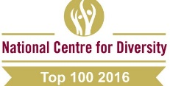**The HENLEY College**

**EQUALITY, DIVERSITY & INCLUSION (EDI) INFORMATION LEAFLET**

**ACADEMIC YEAR 2015-2016 SUMMER TERM ISSUE**

**COLLEGE AMNESTY INTERNATIONAL YOUTH GROUP WIN AWARD**

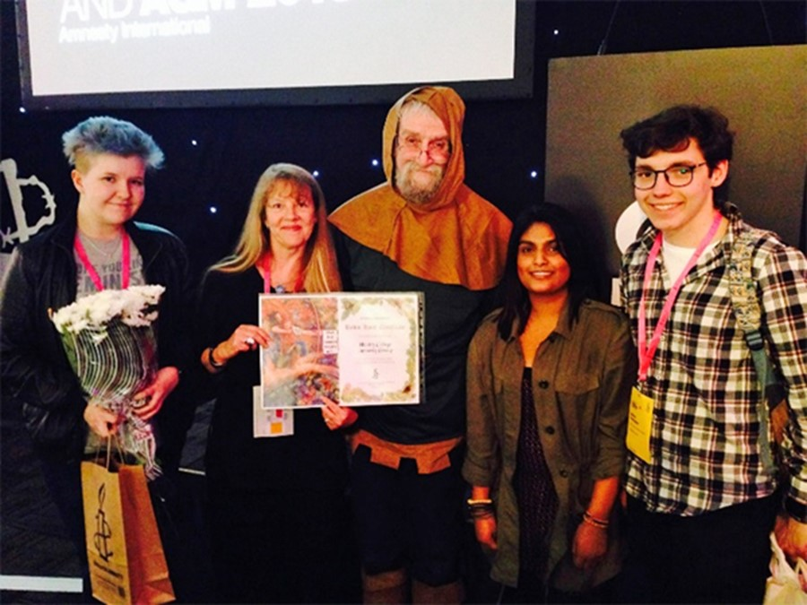The Henley College Amnesty International Youth Group won an award at the Amnesty International UK National Conference at Nottingham University in May. This is the second year running that the group has scooped a win for Outstanding Activism, a great achievement reflecting the work and commitment of the student members.

The award was received in recognition of the campaigning undertaken on behalf of Albert Woodfox, the longest-serving isolated prisoner in the US. He had endured 43 years in solitary confinement and on Friday 19 February 2016, on his 69th birthday, he was suddenly released. In December 2015, as part of Amnesty's ‘Write for Rights’ campaign, the students made beautiful handmade cards to send to Albert to show he had not been forgotten. They also held stalls around College and at the College musical, Our House, where staff, students and members of the public wrote messages of support in the cards.

**FUND RAISING FOR HEADWAY**

During Action for Brian Injury week the College supported Headway, a UK wide charity that works to improve life after brain injury.

[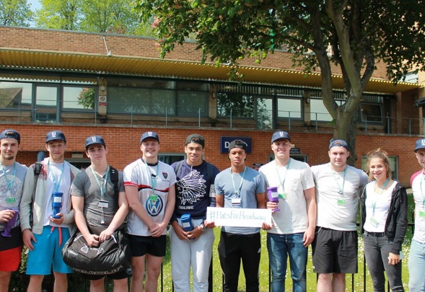](http://www.henleycol.ac.uk/media/1915/sports.jpg?width=800&height=550&mode=crop)On Thursday 12 May, students studying the Extended Diploma in Sport and Exercise Sciences and the Advanced Apprenticeship in Sporting Excellence (AASE) organised a well-attended Crossbar Challenge and Cake Sale. The following day staff and students wore hats for the day to mark the official Hats for Headway event and donations were collected across the campus totaling £213.

Extended Diploma student Benjamin Holt, also on the Elite Sports Programme in Rowing, commented: “We decided to support Headway as part of our course because head injury is a very prominent issue within sport and especially common in rugby which many of my course mates play and are passionate about.” He added: “The collection on Friday was very successful with everyone being extremely generous. The whole event showed the generosity of the students at The Henley College and we are very glad to have helped Headway.”

**PATHWAYS STUDENTS LEARN TO PLAY SINGING BOWLS**

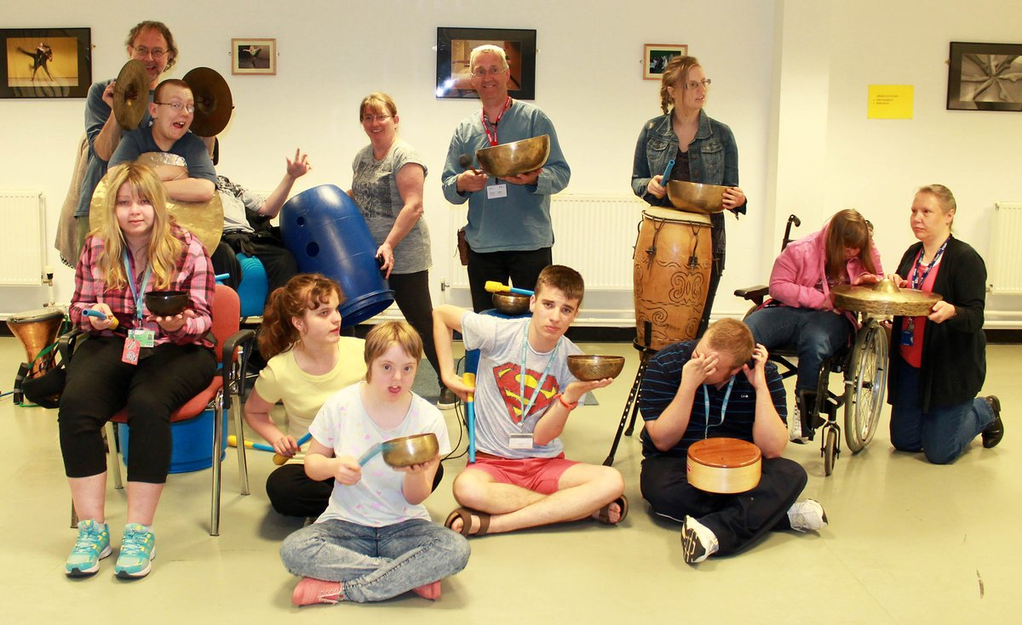Pathways students, with funding from the Rob Pilgrim Trust, have created their own music soundtrack to a Japanese Folk Tale. The Story Of Urashima Taro, is a legend about a fisherman who rescues a turtle and is rewarded by visiting the palace of a Dragon God under the sea. He stays there for 3 days and upon his return to his village, finds himself 300 years in the future. The students are narrating a film based on the story with a musical soundtrack they have created themselves and which they will be able to take home to share with their families.

**AMNESTY INTERNATIONAL YOUTH GROUP**

The Amnesty International Youth Group (AIYG) meets every Thursday lunchtime from 11.55 am to 12.55 pm in D132 and welcomes everyone. They have been raising funds to support Amnesty’s campaign against child marriage and FGM in Burkina Faso and Sierra Leone.

Adrian Rodriguez-Sobstel undertook a 10K sponsored run.

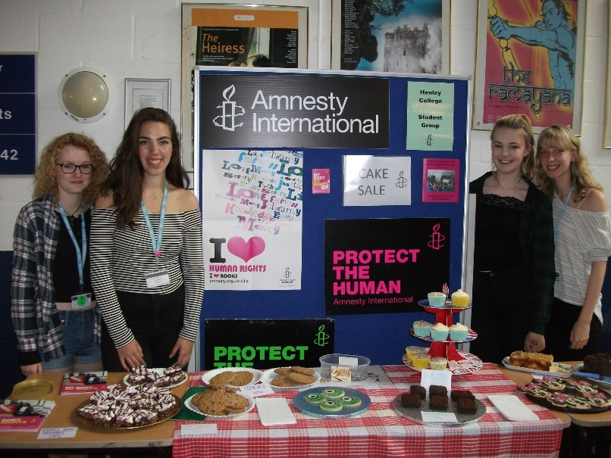

Other group members have organised a quiz, guess the number of sweets in the jar and a cake bake sale. Altogether, £287.54 was raised which will be doubled by the Government to a marvellous £575.08.

**CHRISTIAN UNION GROUP**

Every Thursday the Christian Union meets in D130 from 12.00 pm to 12.45 pm for discussions led by students and staff on topical, ethical issues with a Christian perspective or for bible studies. Sessions have included discussions on the meaning of life, if you only had 24 hours to live what would you do and how to be truly happy.

**INTERNATIONAL RELATIONS DISCUSSION GROUP**

The International Relations Discussion Group (IRDG) has met Friday from 12.10 pm to 12.45 pm in the Deanfield Meetings Room. The aim is to broaden students' knowledge and understanding of international affairs and provide an opportunity to express opinions and listen to the views of others. These sessions are particularly helpful for students applying for Politics, International Relations, Law and History at university. They are also valuable for all students as a form of educational enrichment in a democratic society.

During 2015-16, the discussions have included the Syrian crisis and the impact on the flow of refugees to Europe, the Presidential Elections in the USA in 2016, the threat from North Korea, relations between India and Pakistan, terrorism in Nigeria, the future development of the European Union and Putin's Russia.  On occasions, students have given presentations on topics in which they are particularly interested, with Hannah Meakes leading a session on China in the modern world, Adrian Rodriguez-Sobstel running a session regarding the elections in Poland and Kim Murphy covering current issues in Canada.

New students are very welcome to attend to broaden their knowledge of international affairs and improve their skills in public speaking. Please bring your lunch.

**LESBIAN, GAY, BISEXUAL AND TRANSGENDER GROUP**

The Lesbian, Gay, Bisexual and Transgender Group (LGBT) met regularly this academic year on Tuesday from 12.10pm to 12.45 pm in the Seminar Room. The group has one male student who has been trained as a Student Ambassador through Stonewall and three more students are currently being trained. Support U, a charitable organisation in Reading, providing a support service which specifically focuses on the inclusion of LGBT people, have been into College to talk to the LGBT Group.

Support U is based in Castle Street and is currently dealing with over 2,000 enquiries per annum. Several members of the LGBT Group are now attending the offices of Support U on a weekly basis to prepare the youth accommodation, The Loft, and to act as volunteers.

**EDI ACTION PLAN FOR THE PERIOD**

**11 APRIL 2016 to 15 JULY 2016**

|  |  |  |  |
| --- | --- | --- | --- |
| **ACTION** | **By Whom** | **By When** | **STATUS** |
| **EDI Calendar**  Publish EDI Calendar on a monthly basis | Library | Monthly | Incremental |
| **College EDI Poster**  To be redesigned and displayed in all classrooms | RVIT/FIBO  /KBOW | June 2016 | Ongoing |
| **D1 Corridor Display**  Display on the European Referendum on 23 June 2016 to decide if the UK should remain in the European Union or leave | Library | April 2016 | Completed |
| **LGBT Group**  Regular meetings of the LGBT Group | BRIC | Incremental | Incremental |
| **International Relations Discussion Group**  Regular weekly meetings of the International Discussion Group | JPAN | Incremental | Incremental |
| **Christian Union**  Regular weekly meetings of the Christian Union Group | AREI | Incremental | Incremental |
| **Amnesty International**  Regular weekly meetings of the College Amnesty International Group | SBIN | Incremental | Incremental |
| **EDI Steering Group Meeting**  Meeting of EDI Steering Group | EDI Steering Group | 20 April 2016 | Completed |
| **Inset Day**  EDI training with a teaching and learning focus | BRIC | 29 June 2016 | Competed |
| **EDI Event**  EDI Event to Welcome New Students | EDI Event Focus Group | 5 October 2016 |  |

EDI Leaflet: June 2016

Sue Deaville