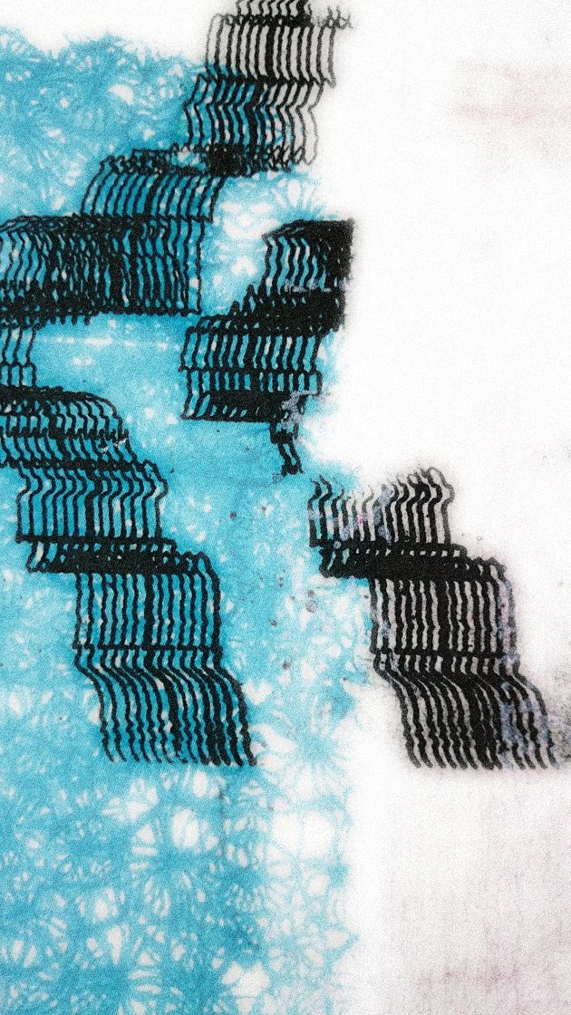
BTEC Foundation Diploma
Art & Design, Level 3
Transition Activity
Drawing Tools

Over the course of your holiday you should explore and play with making your own drawing tools.
You should complete three mark-making tools:
- Very big tool
- Medium tool
- Small or tiny tool
You should then produce a series of experimental drawings using your hand made tools. You can use any materials or media to do this, try to work on sheets of paper (various sizes). You can record and draw an object using your tools or you can explore the different marks they make – the rest is up to you!
Research at least 3 artists that explore experimental drawing tools and approaches to drawing. Artist hint: Rebecca Horn.
Bring your research, tools and drawings to your first Foundation session.

