The HENLEY College
EQUALITY, DIVERSITY & INCLUSION (EDI) INFORMATION LEAFLET
ACADEMIC YEAR 2015-2016 SPRING TERM ISSUE

TOP 100 INDEX
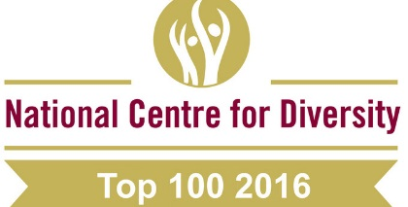
In January 2016 The National Centre for Diversity launched the Top 100 index as part of their 10 Year Anniversary celebrations.

This index highlights the very best of the UK across 600 organisations and the Henley College features at number 50 which is a fantastic endorsement of our commitment to Equality, Diversity and Inclusion and the excellent work undertaken across these areas by the College.
LIBRARY CHRISTMAS APPEAL
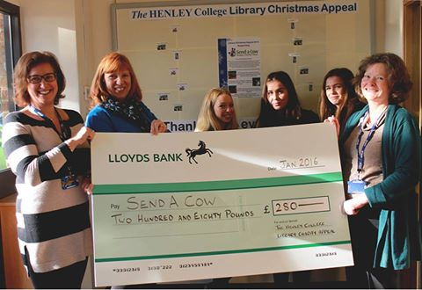
The Library’s Christmas Appeal in support of ‘Send a Cow’ to help African farmers out of poverty by providing livestock and equipment raised a fantastic £280 for seven clean latrines, four pairs of rabbits and seven keyhole gardens.

LGBT TRANSGENDER MONTH
In February there was a display in the D1 corridor put together by library staff detailing the movement of gender identity from the traditional binary (male/female) to a spectrum including gender fluidity, gender neutral and transgender.

ST MUNGO’S WOOLLY HAT / WEAR ORANGE DAY
On 29 January the College asked students and staff to wear a woolly hat or something orange to raise awareness of the homeless. A raffle raised over £100 in aid of St Mungo’s, a charity which provides a bed and support to over 2,500 people a night who are homeless or at risk.
PATHWAYS VALENTINE’S DAY POP UP SHOP
In the lead up to Valentine’s Day Pathways students ran a pop up shop selling handmade cards and gifts which raised over £100 for equipment.
FUND RAISING FOR SUE RYDER
The Level 3 Business students have been selling cakes and coffee around College, organised an auction and hosted a Bingo in the Barn evening in aid of Sue Ryder, a charity which provides compassionate care to people with end of life and long term needs.
SAFE PLACES
There are designated offices at the Deanfield and Rotherfield sites should any students need a safe place to go.
WOMEN’S HISTORY MONTH
In March the D1 corridor display marked Women’s History Month celebrating women who have achieved success after overcoming barriers. These include Elizabeth Garrett Anderson, the first woman doctor in Britain and France, Marie Curie, the first woman to receive a Nobel Prize and Helen Sharman, the first British person in space.
JOHN RENDEL LECTURE
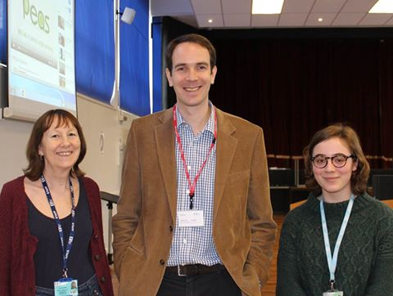
On March 23 2016 John Rendel, CEO of Promoting Equality in African Schools (PEAS), gave an inspirational lecture detailing how he founded the charitable organisation following a chance meeting in Uganda which highlighted the need for the provision of secondary school education.

John built the first school in Uganda by fund raising in the UK and was determined that the school should be financially sustainable to enable it to run dependency free for the long term. By adopting this SmartAid approach in just eight years PEAS have become one of the leading providers of non-state secondary education in Africa with a network of thirty sustainable schools providing secondary education to students in Uganda and Zambia.
MADE TRAINING
On 24 March MADE training came into College to help students prepare for the summer examinations by providing the skills to cope with stress and anxiety and build resilience and confidence.
PATHWAYS EASTER RAFFLE
In March Pathways students held a raffle and sold spring flowers in pots in aid of Whizz-Kidz, a charity which provides disabled children with the essential wheelchairs and other mobility equipment they need to lead fun and active childhoods.
AMNESTY INTERNATIONAL YOUTH GROUP
The Amnesty International Youth Group (AIYG) meets every Thursday lunchtime from 11.55 am to 12.55 pm in D132 and welcomes everyone.
Amnesty International asked the Henley College AIYG to be part of a pilot project for a selected few of the most active youth groups in the UK. The aim was to try and reach out to the whole college for the Write for Rights 2015 campaign.

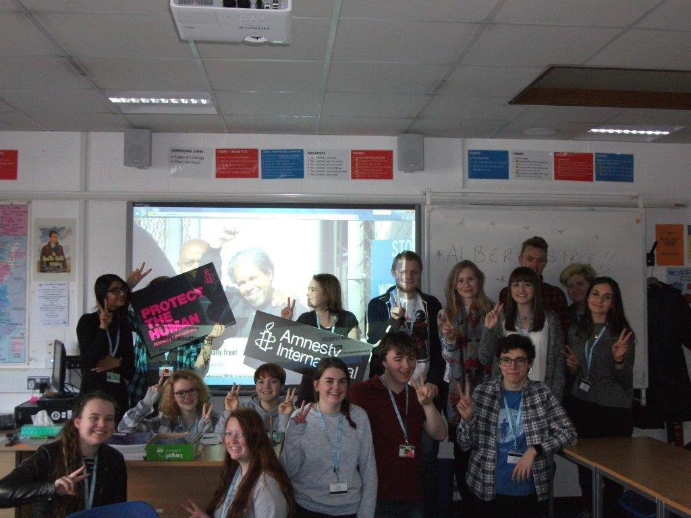
The AIYG came up with the ideas and set themselves a huge challenge. They rose to this admirably with a roaming team wandering around the college on 17 December 2015 to encourage students and staff to write messages of hope on fifty handmade cards for Albert Woodfox, the longest serving isolated prisoner in America. The general public were also involved through a stall at all six performances of the college musical, Our House, during December 2015. In February 2016 the Henley College Amnesty International Youth Group celebrated the release of Albert following the Write for Rights 2015 campaign.

During February 2016 the AIYG organised a petition to ask the UK to stop selling arms to Saudi Arabia. Missiles made in the UK have been used by Saudi Arabia to destroy a ceramics factory, a civilian target and many schools in Yemen in violation of UK domestic law, EU law and the Global Arms Trade Treaty.
CHRISTIAN UNION GROUP
Every Thursday the Christian Union meets in D130 from 12.00 pm to 12.45 pm for discussions led by students and staff on topical, ethical issues with a Christian perspective or for bible studies. Sessions have included discussions on the meaning of life, if you only had 24 hours to live what would you do and how to be truly happy.
INTERNATIONAL RELATIONS DISCUSSION GROUP
The International Relations Discussion Group (IRDG) meets on Friday from 12.10 pm to 12.45 pm in the Deanfield Meetings Room. The discussions have focused on topical international issues and events, with about 12-15 students attending regularly. The aim is to broaden students' knowledge and understanding of international affairs and give them an opportunity to express their own opinions and listen to the views of others.

Topics discussed include the Syrian crisis and the impact on the flow of refugees to Europe, the Primary Elections in the USA, the threat from North Korea, relations between India and Pakistan and Putin's Russia. On occasions, students have given presentations on topics in which they are particularly interested, with Hannah Meakes leading a session on China in the modern world and Adrian Rodriguez-Sobstel running a session regarding the elections in Poland.

New students are very welcome to attend to broaden their knowledge of international affairs and improve their skills in public speaking. Please bring your lunch.
LESBIAN, GAY, BISEXUAL AND TRANSGENDER GROUP
The Lesbian, Gay, Bisexual and Transgender Group (LGBT) meets regularly on Tuesday from 12.10pm to 12.45 pm in the Seminar Room. The group has one male student who has been trained as a Student Ambassador through Stonewall and three more students are currently being trained. Support U, a charitable organisation, providing a support service which specifically focuses on the inclusion of LGBT people, have been into College to talk to the LGBT Group.
Support U is based in Castle Street, Reading and is currently dealing with over 2,000 enquiries per annum. Several members of the LGBT Group are now attending the offices of Support U on a weekly basis to prepare the youth accommodation, The Loft, and to act as volunteers.

EDI ACTION PLAN FOR THE PERIOD
1 JANUARY 2016 to 11 APRIL 2016

ACTION | By Whom | By When | STATUS
EDI Calendar  Publish EDI Calendar on a monthly basis | Library | Monthly | Incremental
Faith and Belief Wall Chart  Publish Faith and Belief Wall Chart on an annual basis | Library | Annual | Incremental
College EDI Poster  To be redesigned and displayed in all classrooms | RVIT/FIBO  /KBOW | February 2016 | Ongoing
D1 Corridor Display  Display of winter festivals celebrated. | Library | January 2016 | Completed
D5 Foyer Display  Display marking LGBT transgender month exploring gender fluidity, gender neutrality and transgender. | Library | March 2015 | Completed
LGBT Group  Regular meetings of the LGBT Group | BRIC | Incremental | Incremental
International Relations Discussion Group  Regular weekly meetings of the International Discussion Group | JPAN | Incremental | Incremental
Christian Union  Regular weekly meetings of the Christian Union Group | AREI | Incremental | Incremental
Amnesty International  Regular weekly meetings of the College Amnesty International Group | SBIN | Incremental | Incremental
EDI Steering Group Meeting  Meeting of EDI Steering Group | EDI Steering Group | 20 April 2016
Student Ambassadors  One male LGBT Group member completed training through Stonewall. Three more students waiting to complete the training.  One female student has received event and conference experience with Amnesty International | EDI Steering Group/ BRIC/SBIN | Incremental | Ongoing
LGBT  The LGBT Group are in contact with Support U, Reading LGBT Group, to provide guidance for College students | LGBT Group | Incremental | Ongoing

EDI Leaflet: March 2016
Sue Deaville

