The HENLEY College
EQUALITY, DIVERSITY & INCLUSION (EDI) INFORMATION LEAFLET
ACADEMIC YEAR 2014-2015 SUMMER TERM ISSUE

NEPAL EARTHQUAKE APPEAL

Following the devastating earthquake in Nepal in April 2015 the Henley College set up an appeal to collect donations to help the victims of the earthquake. There are 22 Nepalese contract cleaners working at the College most of whom have families and know communities which have been devastated by the recent earthquake. The College collected in excess of 3,000 kilograms of blankets/sleeping bags/duvets, warm clothing, waterproof clothing/ponchos, tents, children/baby clothing/nappies/baby wipes, dry food, tinned food and LED torches from the College and local Henley community.
Suzanne Fahey baked cupcakes and together with the Chartwells Catering Team sold them in the Deanfield Refectory and raised £85 for the appeal. There have been further contributions made by the College’s Nepalese community.
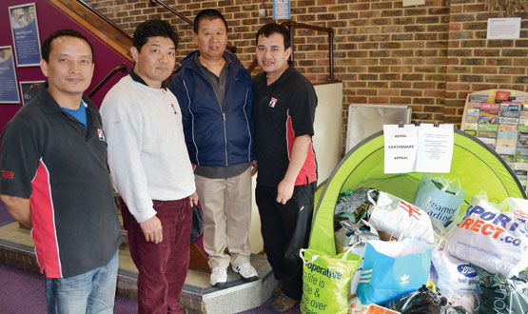

EDI DISPLAY

There is a display in the Rotherfield Reception celebrating the College’s EDI achievements and events.

MALALA YOUSAFZAI DISPLAY
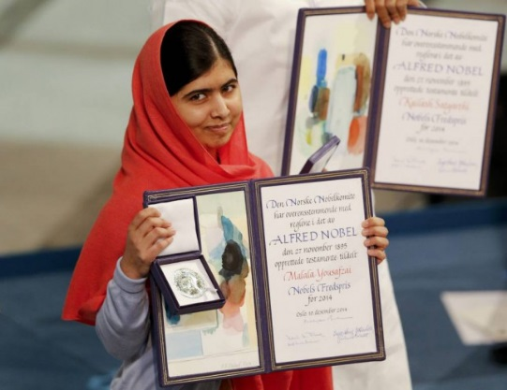
Malala Yousafzai became the youngest Nobel Peace Prize winner in 2014 at 17 years old. There is a display in the D5 foyer celebrating her life and achievements as a global advocate for millions of girls denied a formal education due to social, economic, legal or political factors. Malala’s advocacy has grown into an international movement and the Malala Fund has helped girls under threat of the Taliban in Pakistan, Syrian refugees in Lebanon and Jordan, girls affected by the Ebola crisis in Sierra Leone, girls kidnapped or under threat of Boko Haram in Nigeria and girls from rural areas and the slums in Kenya.
EDI STUDENT SURVEY

Student views are very important to us and in February 2015 there was an anonymous survey of the understanding, experience and views of students regarding Equality, Diversity and Inclusion at the Henley College. The results of this survey have been analysed and a report presented to the Governors. The EDI Steering Group discussed the report and made recommendations which will be implemented.

GENERAL ELECTION

In April and May there was a display in the D1 corridor cabinet about the main manifesto pledges of the Conservatives, Green Party, Labour, Liberal Democrats and UKIP regarding policies affecting young people such as the minimum wage, zero hours contracts and apprenticeships.
The display encouraged students to get involved noting that there are almost 200 swing seats which required less than a 5% swing to change hands. In all but 6 of these the number of students is larger than the swing required. If more young people vote parties will develop youth policies and this will improve their lives leading to a greater engagement with politics and therefore encouraging more young people to vote.
The Conservative, Green, Labour, Liberal and UKIP parliamentary candidates for the Henley Constituency held a questions and answers session at the College during April for staff and students over the course of a week.
AMNESTY INTERNATIONAL STOP TORTURE CAMPAIGN

On Thursday June 25th, the day before International Day in Support of Victims of Torture, there was a stall in the D5 foyer from 12 noon until 1 pm to raise funds for Amnesty’s work on human rights.

EDI ACTION PLAN FOR THE PERIOD
11th APRIL to 17 JULY 2015

ACTION | By Whom | By When | STATUS
EDI Calendar  Publish EDI Calendar on a monthly basis | Library | Monthly | Incremental
Malala Yousafzai Display  Display in the D5 foyer applauding the life and achievements of Malala Yousafzai, the youngest Nobel Peace Prize winner at 17 year old. | Library | March 2015 | Completed
EDI Display  Display celebrating the College’s EDI highlights in the Rotherfield Reception | SDEA | June 2015 | Completed
LGBT Group  Regular meetings of the LGBT Group | BRIC | Incremental | Incremental
International Relations Discussion Group  Regular weekly meetings of the International Discussion Group | JPAN | Incremental | Incremental
Christian Union  Regular weekly meetings of the Christian Union Group | AREI | Incremental | Incremental
Amnesty International  Regular weekly meetings of the College Amnesty International Group | SBIN | Incremental | Incremental
EDI Steering Group Meeting  Meeting of EDI Steering Group. | EDI Steering Group | 17 June 2015 | Completed
Amnesty International Stop Torture Campaign  Cake sale in the D5 foyer to raise funds for Amnesty’s work on human rights | Amnesty International Youth Group | 25 June 2015 | Completed
Student Ambassadors  LGBT and Amnesty International Student Ambassadors to be trained in autumn term | BRIC/SBIN | Autumn Term | Ongoing
Faith and Belief Ambassadors  Meeting regarding Faith and Belief Ambassadors following on from the visit by the Venerable Martin Gorick. | AREI/BRIC/SDEA | Autumn Term | Ongoing
EDI October Event  Annual EDI Event to be held | October Event Focus Group | 14 October 2015 | Scheduled

